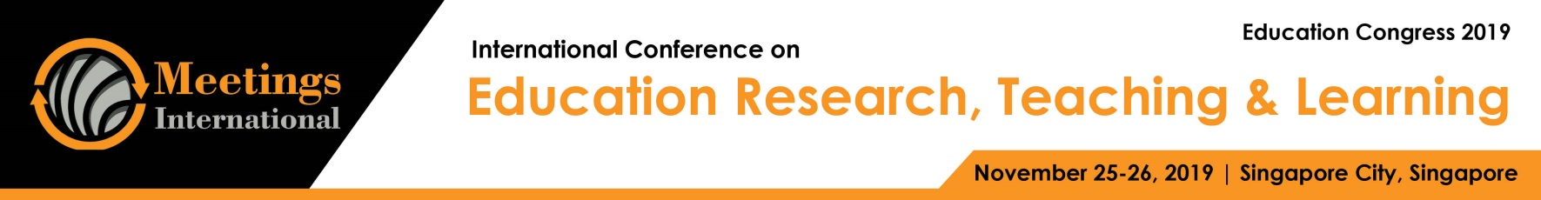

Abstract Template

Title: Investigations on Teachers’ Career Development to Achieve Sustainable Development Goals in the Context of Qatar.

Wadha Al-Thani 1, Dr. Muammer Koc1,
1 Division of Sustainable Development, College of Science and Engineering, Hamad Bin Khalifa University, Qatar.

Keywords: Sustainable Development Goals, Education for Sustainable development, Qatar National, Protein analysis, Teachers’ Career Development.

- Abstract:
Education is considered to be the main driver as well as one of the sustainable development goals (SDGs). Teachers are, on the other hand, are known as the key factor and enabler for a successful education system (ES). Hence, under the common study area of Education for Sustainability (EfS), research on teachers’ development have been conducted in various contexts as education systems are shaped and evolve by global, but mainly by local cultural, historical, social developments. In this study, teachers’ development issues starting from their professional preparation, recruitment, empowerment and assessment aspects are investigated within the context of Qatar and from its existing and potential role in achieving sustainable development goals set by UN and Qatar National Vision (QNV) 2030. Field studies based on qualitative research in various representative Qatar Education System (QES) elements are comparatively conducted to understand the teachers’ as well as other education system stakeholders’ understanding, roles, potentials and issues for EfS context. In summary, it is found that teachers and other stakeholders in QES are aware of SDGs, EfS and their ideal roles, but are in need of preparing and equipped with the right skills, tools, and empowerment to fully engage and implement with their students in their school and larger social environment.

Biography:
Mrs. Wadha Al-Thani was born in Doha, Qatar. She holds a bachelor degree of science in Electrical Engineering from Texas A&M, Qatar (TAMUQ). Then, she joint Qatar Foundation R&D and worked as a research associate for one year. After that, she worked as an STEM program specialist in the outreach department at TAMUQ. She is currently a MS candidate in the college of Science and Engineering at Hamad bin Khalifa University, Qatar. (Up to 100 words)

Presenting author details

Full Name: Contact number: Twitter account: Linked In account:
Session name/ number:
Category: (Oral presentation/ Poster presentation) Passport Number:



