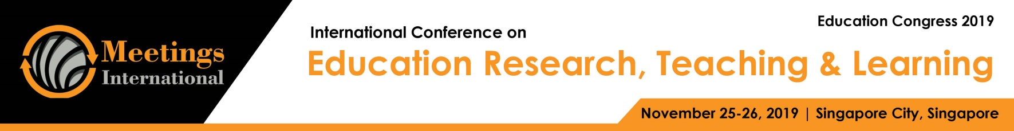

Abstract Template

Title: Project-Based Learning

Keywords: Project, Learning, PBL, Students, Teachers, Important Skills, 21st Century skills

- Abstract Body (up to 250words)
A dynamic approach to teaching in which students explore real-world problems and challenges, simultaneously developing 21st Century skills while working in small collaborative groups. Project Based Learning, or PBL, is an instructional approach built upon learning activities and real tasks that have brought challenges for students to solve. These activities generally reflect the types of learning and work people do in the everyday world outside the classroom. PBL is generally done by groups of students working together toward a common goal PBL teaches students not just content, but also important skills in ways students have to be able to function like adults in our society. These skills include communication and presentation skills, organization and time management skills, research and inquiry skills, self-assessment and reflection skills, group participation and leadership skills, and critical thinking. Performance is assessed on an individual basis, and takes into account the quality of the product produced, the depth of content understanding demonstrated, and the contributions made to the ongoing process of project realization. PBL allows students to reflect upon their own ideas and opinions, and make decisions that affect project outcomes and the learning process in general. The final product results in highquality, authentic products and presentations.

Image:


- 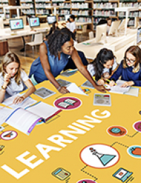
Reference:

- Computing Technology For Math Excellence http://www.ct4me.net/index.htm Online resources for teaching and learning mathematics (K-12 and calculus), technology integration, and the standards movement in education

- Educational Technology Panel http://www.ed.gov/offices/OERI/ORAD/Background Background paper describing the Educational Technology Panel, originally established to identify, evaluate, and recommend exemplary educational technology programs

- George Lucas Educational Foundation http://www.edutopia.org/project-based-learning Models of innovative practices in K-12 education which incorporate project-based learning

Biography:
Karine Kostanyan has completed her Master’s at the age of 23 years from Yerevan State Linguistic University after V.Brusov. She is a teacher in Yerevan N143 Basic School after M.Khorenatsi. She participated in different local and international trainings, conferences and seminars. She was speaker and presenter in many international conferences.

Presenting authordetails

Full Name: KarineKostanyan number: +37499580580
Session name/ number: Educational Technology/1
Category: Digital presentation
Passport Number:BA0756191



