

Abstract Template

TEACHERS’ PROFESSIONAL DEVELOPMENT IN SUB-SAHARAN AFRICA: A CASE OF SOUTH AFRICAN AND NIGERIAN SCHOOLS

Oluwatoyin Ayodele Ajani, (PhD)
Department of Curriculum and Instructional Studies, University of Zululand, South Africa

Keywords: classroom practices, perspectives, in-service professional development, continuity, appropriateness, regularity

- Abstract Body (up to 250 words)
Education is critical to development of any nation, and this is why most developing African countries have been striving to ensure quality education for all school age learners. Teachers are significantly important in education system, and they cannot be underestimated. The quality of teachers translates to the quality of the education system. Sub-Saharan African countries have been making significant impact in the professional development of teachers. This quantitative study explored the views of South African and Nigerian teachers on the professional development activities available to them. Adult learning theory was used as the theoretical framework for this study. Findings from both countries revealed that though there were professional development programmes for teachers, however they were in adequate and irregular to the teachers every term. The study therefore recommended appropriate professional development activities for teacher at least once a term. The study also recommended that these professional development activities should focus on classroom needs of the teachers. Data was collected from 80 teachers through questionnaire.

Image:
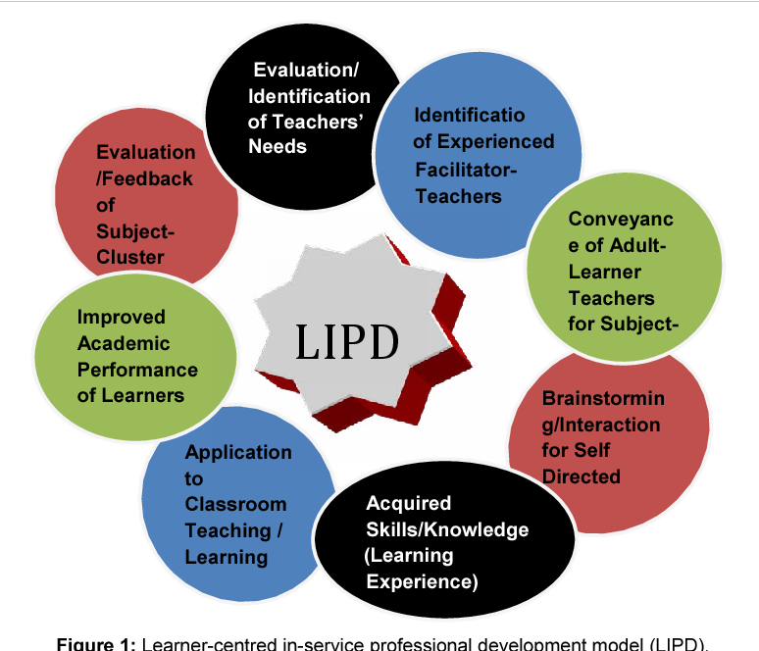
- Reference:

1. Mkhwanazi, S. (2014) Crossing the past political boundary: Teacher professional learning in South African Reform Context Mediterranean Journal of Social Sciences 5: 425-432.

2. Bantwini, B.D. (2009) District professional development models as a way to introduce Primary School Teachers to Natural Science Curriculum Reforms in one district in South Africa. Journal of Education for Teaching 35: 162-189.

3. Steyn, G.M. (2008) Continuing professional development for teachers in South Africa and social learning systems: Conflicting conceptual frameworks of learning Koers 73: 15-31.

4. Garet, M.S, Porter, A.C, Desimone L, Birman B.F, Yoon KS, et al. (2001) What makes professional development effective? Results from a national sample of teachers. American Educational Research Journal 38: 915-945.

5. Hirsh, S. (2005) Professional development and closing the achievement gap. Theory into Practice 44: 38-44.

6. Lee, H.L. (2005) Developing a professional development programme model based on teachers’ needs. The Professional Educator 27: 39-49.

7. Desimone, LM, Smith, T.M, Ueno, K. (2006) Are teachers who sustained content focused professional development getting it? An administrator’s dilemma. Educational Administration Quarterly 42: 179-215.

Biography:
Oluwatoyin Ayodele Ajani has completed his PhD from University of Zululand, South Africa. He is a lecturer at the Department of Social Science Education, University of Zululand. He has published more than 10 papers in reputed journals and has been serving as an editorial board member of repute. He has presented academic papers in different conferences.)

Presenting author details

Full Name: Oluwatoyin Ayodele Ajani
Contact number: 0359026998
Twitter account:
Linked In account:
Session name/ number:
Category: (Oral presentation)
Passport Number: A06650081



