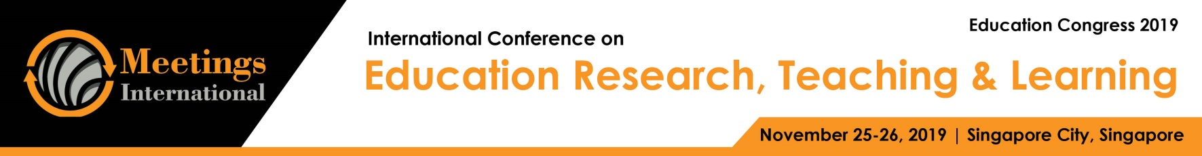

Abstract

Title: Development of the national curriculum for metallurgical engineering using Posner’s Model of Curriculum Analysis

EIGEN JOHN T. IGNACIO1
1College of Education, Mindanao State University – Iligan Institute of Technology, Iligan, Philippines

Keywords: Curriculum development, Philippines, Metallurgical engineering

- Abstract Body
This study traces the developmental history of the national curriculum for Metallurgical Engineering in the Philippines, represented by CHED Memorandum Order No. 11 series of 2008, in an attempt to uncover how it was developed. This study employed Posner’s model of curriculum analysis (2004), looking into the laws and government policies that form the backbone of the development process, the backgrounds and qualifications of the people involved in making curriculum decisions, the internal and external factors that influence their decisions, and the nature of the curriculum decisions themselves. Gathered curriculum documents were analyzed for changes and interviews used to understand the reasons for the changes identified. It was found that the development process revolved around Content and Sequencing, dictated by benchmarking with curricula from abroad as well as the demands of the metallurgy industry. The developers based their decisions primarily upon their experience as practitioners and instructors, intuition, and personal preference.
- Reference:

1 Carlgren, I., 1995. National curriculum as social compromise or discursive politics? some reflections on a curriculum-making process. Journal of Curriculum Studies, 27; 411, 430.

- Commission on Higher Education, 1996. New general education curriculum (gec). (CMO No. 59)

- Commission on Higher Education, 1997. Curricular guidelines for engineering education. (CMO No. 49)

- Commission on Higher Education, 2008. Policies and standards for the degree of bachelor of science in metallurgical engineering program. (CMO No. 11)

- Commission on Higher Education, 2012. Policies, standards and guidelines in the establishment of an outcomes-based education (obe) system in higher education institutions offering engineering programs. (CMO No. 37)

- Doll, R. C., 1996. Curriculum improvement: Decision making and process (9th ed.). Needham Heights, MA: Allyn & Bacon.

- Engineers’ Council for Professional Development, 1947. Canons of ethics for engineers. New York: Engineers’ Council for Professional Development.

- Latucca, L. R., and J. S. Stark, 2009. Shaping the college curriculum: Academic plans in context (2nd ed.). San Francisco, CA: Jossey-Bass.

- Levin, B., 2008. Curriculum policy and the politics of what should be learned in schools. In F. M. Connelly (Ed.), The sage handbook of curriculum and instruction (pp. 7 – 24). Thousand Oaks, CA: Sage Publications.

- Marshall, C., Mitchell, D., and F. Wirt, 1997. Culture and education policy in american states. Lewes, UK: Falmer.

- Professional Regulation Commission, 1980, June. Board of metallurgical engineering rules and regulations.

- Posner, G. J., 2004. Analyzing the curriculum (3rd ed.). New York: McGraw-Hill.

- Print, M., 1993. Curriculum development and design (2nd ed.). Sydney: Allen & Unwin.

- Saylor, J. G., and W. M. Alexander, 1954. Curriculum planning for better teaching and learning. New York: Rinehart & Company.

- Schubert, W. H. (1986). Curriculum: Perspective, paradigm, and possibility. New York: Macmillan Publishing Company.

- Schwab, J. J., 1971. The practical: Arts of eclectic. School Review, 79 (4), 493 – 542. Retrieved from http://www.jstor.org/stable/1084342

- Walker, D., 1971. A naturalistic model for curriculum development. School Review, 80 (1); 51 – 65.

Biography:
Eigen John T. Ignacio completed his Master of Education in Curriculum Studies at the age of 30 from the University of the Philippines Diliman and is currently a PhD candidate at the College of Graduate Studies and Teacher Education Research, Philippine Normal University, Philippines. He is an Assistant Professor at Mindanao State University – Iligan Institute of Technology.

Presenting author details
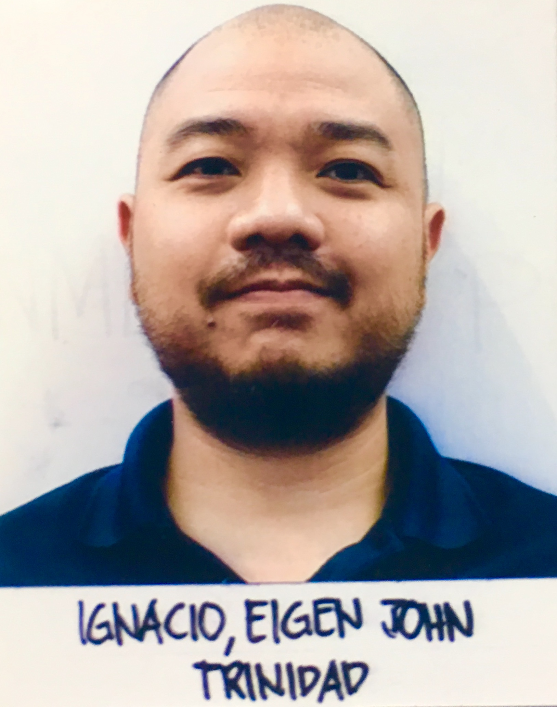
Full Name: Eigen John T. Ignacio Contact number: (02)8094656, (63927)5646944 Session name/ number: 3, Educational Systems and Policies
Category: Oral presentation
Passport Number: P1040656B



