

Abstract Template

- Title: Moral Education In Perspektive Sunan Kalijaga (Studies on the work of Suluk Daze)

Keywords: Moral Education in Perspektive Sunan Kalijaga.

(Studies on the work of Suluk Daze)

- Abstract Body (up to 240words)

Indonesian dictionary the word education is defined by "The process of changing attitudes and behavior of a person or group of people in an attempt to mature personality through the efforts of teaching or training". According to the Act - Law on National Education System, No. 20th 2003 is a conscious and deliberate effort to create an atmosphere of learning and the learning process so that learners are actively developing the potential for him to have spiritual powers, religious, self-control, personality, intelligence, noble character, and skills needed him and society. The truth of education is a necessity, because if people want to be happy in this world and in the hereafter then, he must have knowledge and it will not be in get if there is no education. As for the moral meaning of terms comes from the Latin language, mores is the plural of the word mos, which means custom. In dictionary Indonesian General said that morale is good-bad determination against doings. Furthermore, in the moral sense of the term is a term used to define the boundaries of nature, temperament, will, think or act that is reasonably can be said right, wrong, good, or bad. So Moral Education in Perspective Sunan Kalijaga (Studies on the work of Suluk Daze) is how to build morale with parents, foster moral with people who older, fostering moral with younger people, fostering moral with friends, and build morale with the Opposite Sex.

Image:
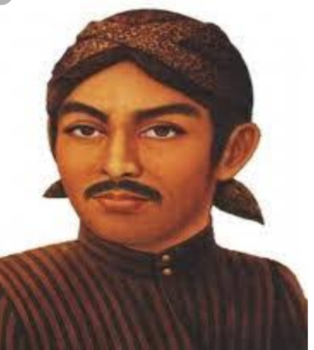
- Reference:

1 As’ary, Hasyim,.Adabul ‘Alim Wal Muta’allim, Jombang, Maktabah Turots Al Islami, 1415 H.

- Nata, Abudin, Dr. H. MA., Akhlaq Tasawuf, PT. Raja Grafindo Persada, Jakarta, 2000.

- Khafid Mohammad, Suluk Daze of Syaikh Melaya Sunan Kalijaga, Balai Pustaka, Jakarta, 2011.

Biography:
Fatchullah Zarkasi has completed his M. Pd ( Master of Education) at the age of 26 years from Jakarta Islamic University. He is the Teacher of Homeschooling Primagama, and a Lecturer not Permanent in University of Gunadarma Depok Indonesia and University of Pancasila Jakarta Indonesia. He was be a Youth of Asia Pasific Converence In Kualalumpur 2017.

Presenting authordetails

Full Name: Fatchullah Zarkasi Facebook: Fatchullah Zarkasi Instagram: fatchullah zarkasi
Session name/ number:
Category: Oral presentation
Passport Number:
B 5132475



