Abstract

Title: Explanation of all the geological processes on Earth. Creation of mountains and lakes. True origins of Volcanoes and Earthquakes, our Moon and planet Earth itself.

Amateur researcher

Keywords: Earth, ring of fire, Moon, mountain ranges, volcanoes, lakes, global floods etc.

- Abstract
The present study investigates all the geological processes on Earth which took place thousands of years ago during the moonless era. The study allows to reveal the cosmic appearance of all the celestial bodies in our Solar system.
Appearance of Ice Ages, their detailed explanation, circumstances of their appearance, consequences and impact on human civilizations. Appearance of one super ocean which influenced the following history of Earth and civilizations who lived during that period of time.
The birth of satellites, their catastrophic impact on Earth and following recovery of survived tribes.
Recurrent polar shifts, global floods and repopulation of the Earth.

- Image:

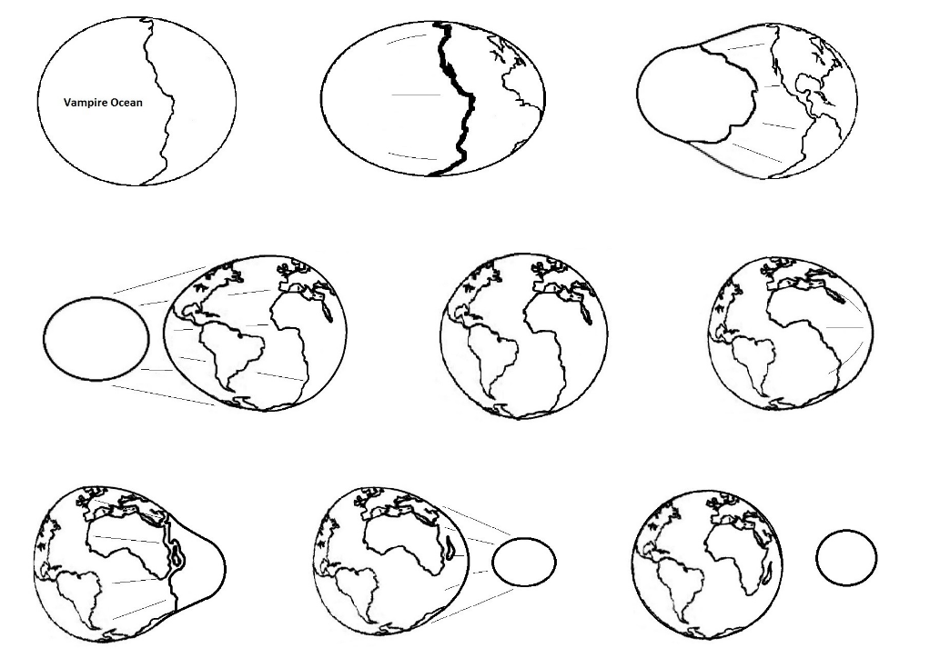

- Reference:
1. Hugh Auchincloss Brown "Cataclysms of the Earth" (1967)
- Immanuel Velikovsky "Worlds in Collision" (1950)
- Zecharia Sitchin "The 12th Planet" (1976)
- Hans Schindler Bellamy " Built before the Flood" (1943)
- Karl Brugger " The Chronicle of Akakor"(1977)

- Biography:
Simon Khachatryan graduated Yerevan Polytechnic Institute (Armenia) as engineer. Presently resides in Toronto, Canada.
- Presenting author details


Full Name: Simon Khachatryan
Contact number: (647)287-6378
Twitter account: -
Linked In account: -
Session name/ number: Earth's greatest mysteries revealed.
Category: (Oral-video presentation)
Passport Number:

