Vulnerability of Climate Change impact on rural people's Livelihood in Nepal
Basnet D, PhD, Tongji University, China

Abstract

Statement of the Problem: The adverse effects of climate change are seen in various sectors like human health and also agriculture where most of the rural people are dependent. However, its effect is varied among regions, and between different generations, income groups and occupations as well as between men and women. Several climate change events like fluctuation in precipitation pattern, more extreme weather resulting in natural disasters, and changes in air quality and food quality have a particular impact on people in their role as principal caregivers. Similarly rural people in developing countries are highly dependent on local natural resources for their livelihood, because of their responsibility to secure water, food and energy for cooking and heating. The effects of climate change, including drought, uncertain rainfall and deforestation, make it harder to secure these resources. The changes in ecosystems and loss of diversity that are leading to reduced agricultural output and increased food insecurity are bringing greater problems to rural people as food producers so rural people are more vulnerable to the effects of climate change. We can find that rural people are taking adaptation and mitigation measures into consideration to address the adverse effects of climate change but they are not sufficient enough to cope with it. So, it is necessary to understand their experiences regarding climate change events, their awareness and the adaptive measures they are practicing in their day to day life knowingly or unknowingly. The purpose of the study is to explore rural people’s meaning of climate change.
Methodology & Theoretical Orientation: I applied qualitative approaches in order to give an insight into how people construct discourses of understanding on climate change and their action against it. The study uses semi-structured interview as a tool to garner data from local level.
Findings: Most of the rural people were unable to comprehend the direct meaning of climate change. However they were experiencing the ongoing changes in climatic pattern.
Conclusion & Significance: The impact of climate change was felt in agriculture, livestock rearing, water resources etc. Amongst the climate change impact, agriculture sector was hardest hit.
Recommendations: As rural people are heavily dependent on agriculture, government should effort to stimulate structural transformation of agriculture sector from subsistence to commercial farming. In doing so, emphasis should be given to organic farming so that there will be win-win situation for both the agriculturalist and the environment.

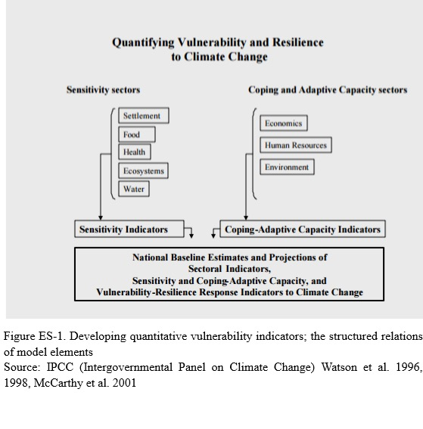
References
- Chaudhary, P. & Aryal K.P. 2009.Global Warming in Nepal: Challenges and Policy Imperatives. Journal of forest and Livelihood, 8(1) 4-13.
- Dessai & Vander Sluijs. (2014).Adapting to an Uncertain Climate: Background on Uncertainity Assessment Supporting Climate Adaption Decision- Making. Pp 17-40.
- IPCC. (2007). Climate Change 2007: Synthesis Report. Contribution of working groups I, II and III to the forth assessment report of the Intergovernmental Panel on climate change. Geneve: Switzerland. P. 204.
- Kates, R.W. (2000). Cautionary Tales: Adaptation and the Global Poor. Climate Change, 45(1), 5-17.
- GON. (2009). National Climate Change Policy. Government of Nepal, Ministry of Environment Kathmandu, Nepal.

Biography

Dipti Basnet as a NOMA scholar of the year 2010 studied Environmental Education and Sustainable Development at Kathmandu Univeristy, Nepal. She worked in Women Environmental Preservation Committee –NGOs in Nepal as a project coordinator for 3 years. Currently she is final year CSC student of Environmental Science and Engineering at Tongji University Shanghai, China. She was born on 26th January 1987 in Dulegaunda V.D.C -9 of Tanahun District, western part of Nepal. Her research of interests include Climate Change; sustainable forest management; environmental liability and the relationship between human rights and the environment; and conservation of biodiversity.

Date of Birth: 1/26/2087
Email: diptibasnet1@gmail.com
Telephone number: +8613052316293

