Geodynamic activity and seismotectonic deformations of neotectonic structures of the Arctic-Asian seismic belt
Imaeva L.P.¹, Imaev V.S^{1,2},, Koz’min B.M.²
¹Institute of the Earth’s crust, Siberian Branch of Russian Academy of Sciences (IEC SB RAS),
664033, Irkutsk, Lermontov st., 128, Russia (e-mail: imaev@crust.irk.ru)
²Diamond and Precious Metal Geology Institute, Siberian Branch of Russian Academy
of Sciences (DPMGI SB RAS),677891, Yakutsk, Sakha Republic (Yakutia), 39 Lenin Prospekt
Key words: Arctic-Asian seismic belt, regional segments, active faults, kinematic types, paragenesis of active structures, earthquake focal mechanism, seismotectonic deformation tensor, stress-strain regimes of the crust.

The present study is focused on determining regular patterns of seismotectonic destruction of the crust in the zone of interaction between the North American and the Eurasian lithospheric plates. We have analyzed a set of different parameters: structural-tectonic position, deep velocity structure, systems of active faults and tectonic deformation fields calculated on the basis of focal mechanism solutions of strong earthquakes and types of late Cenozoic folded and disruptive deformations. Average seismotectonic deformation tensors have been estimated from the data on focal mechanisms of strong earthquakes that together with structural-tectonic and geologic-geophysical data allowed us to reveal the areas with pure and combined regimes of the stress-strain field of the crust. Thus, we have determined that the investigated region is influenced by different geodynamic processes: rifting is observed along the spreading Gakkel ridge and throughout the territory of the Laptev Sea shelf, a suture of the midocean and continental structures of the crust (the Kharaulakh segment) is a transition zone, and a compression regime dominates in the Cherskiy seismotectonic zone.
This work was supported by the grant of the Russian Foundation for Basic Research (RFBR) No 19-05-00062 «Dynamics of modern structures in the continental shelf zone of the northeastern sector of the Russian Arctic», and also projects of Institute of Earth Crust and Diamond and Precious metalls Institute SB RAS ( N 346-2018-0001, N 0381-2616-0001).

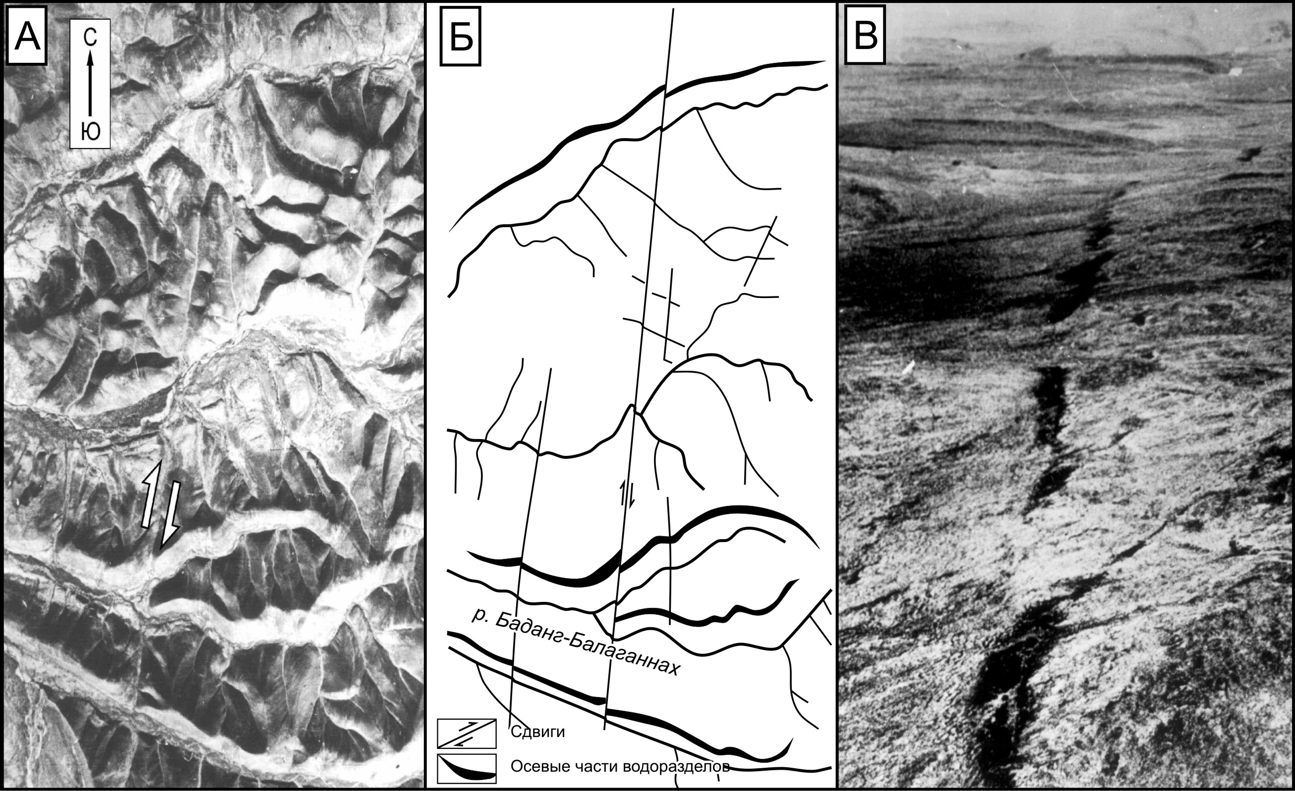
Fig.1. The active fault and open fissures as result of catastrophic earthquake ( about 3,5thousand years ago) near Arctic seashore in Yakutia.

Reference:
1.Imaeva L.P., Gusev G.S., Imaev V.S., Ashurkov S.V., Mel’nikova V.I., Seredkina A.I. Geodynamic activity of
modern structures and tectonic stress fields in Northeast Asia // Geodynamics & Tectonophysics (electronic journal), 2017. IEC SB RAS. V. 8. No. 4. P. 1–32 (in Russian).
2.Imaeva L.P., Gusev G.S., Imaev V.S., Mel’nikova V.I. Neotectonic activity and parameters of seismotectonic
deformations of seismic belts in the Northeast Asia // Journal of Asian Earth Sciences, 2017.V. 148. P. 254–264. http://dx.doi.org/10.1016/j.jseaes.2017.09.007.
3.Imaeva L.P., Koz’min B.M., Imaev V.S., Grib N.N., Ashurkov S.V. Seismotectonic destruction of the Earth’s
crust in the zone of interaction of the northeastern side of the Baikal rift and the Aldan-Stanovoy block // Journal of Seismology, 2017. Vol. 21. No 2. P. 385–410. DOI: 10.1007/s10950-016-9607-3.
4. The map of seismotectonic of Eastern Siberia ( Imaeva L.P.Kolodeznikov I.I. – Eds) Irkutsk,Russia,2016-215 p.
Biography
Imaev V.S. has completed his PhD at the age of 32 years from Moscow University and get rank professor of earth sciences in 2001 to Yakutian State University. Now he is the main researcher in the field of paleoseismology, styding of active faults and recent geodynamics of Eastern Siberia and Russian Arctic in the Institute of the Earth Crust Russian Academy of Sciences,Irkutsk.

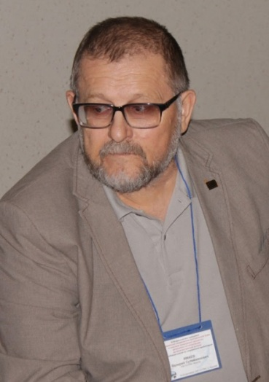
Valery S.Imaev ,e-mail: imaev@crust.irk.ru
Section: Geological Hazard Assesssment and Earthquake geology

