Title: An Empirical Assessment of Flood Disasters in Nigeria: A Case Study of Jibia Flood Disaster, Katsina State
Suleiman Iguda Ladan
Department of Basic and Applied Sciences, Hassan Usman Katsina Polytechnic, Katsina Nigeria
Key words: Empirical, Assessment, flood disasters, Jibia.

I. Abstract
Flood are the most universally experienced natural hazard particularly in settlements around water bodies and Nigeria, floods are common environmental problem which represent a major risk to river side populations and along flood plains. From the year 2010 to date series of flood disasters have occurred in different parts of the country. The floods in this year 2018 were devastating to the extent that the National Emergency Management Agency has declared a ‘national disaster’ after many people died as a result of floods across the country. This paper is undertaking an empirical assessment of the flood disaster that occurred at the border town of Jibia northern Nigeria. Data for the study were gathered through direct observational technique that involved field visits to the affected parts of the town and interview with the local people and the officials concerned. The results have shown that the floods were caused by unprecedented heavy rains, stream diversion and silting of stream pool, blockage of flood waters by River Jibia, silting of the Jibia dam, inadequate drainages and construction of houses close to the storm drainage. The impacts of the flood were devastating as 54 people died and 498 houses were damaged by the flood waters including house hold properties and items. A total of 2,604 persons comprising mainly children and women were displaced according to official figures. The disaster response measures taken by the Government include creation of camps for displaced persons, provision of relief materials, medical assistance and assessment of the disaster affected areas. This paper recommends prompt repairs of damaged infrastructures, dredging and de-silting of the Jibia dam and stream pool, construction of wider and deeper drainages and re-location of houses away from the storm drainage as flood disaster prevention measures.
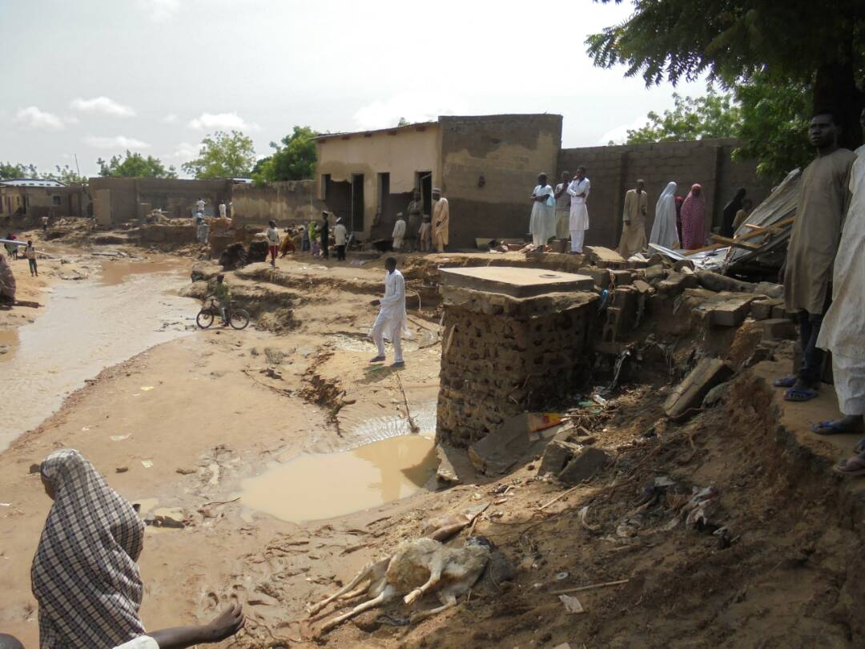
II Image

III References
Adedeji,O.H.,Odufuwa,B.O. and Adebayo,O.H.(2012)-Building Capacities for Flood disaster and Hazard Preparedness and risk reduction in Nigeria : Need for Spatial Planning and Land Management.Journal of Sustainable Development in Africa 14 (1) : 49-62.
Agbokhense, O., Agbokhense ,E.G., Aka, E.O. ,Jeo-Abaya,J., Ocholi,M. And Adekunle,A.(2014)-Flood Menace in Nigeria : Impacts, Remedial and Management Strategies Civil and Environmental Research 6 (4) : 32-40
Olabode, B.O., Elegbede, O.T., Babatunde,L.O. and Fasasi, A.B. (2013)-The Role of Government and Professionals in Disaster Management in Nigeria. Journal of Environmental Science and Resource Management 5 (2) : 147-155
IV. Biography
Suleiman Iguda Ladan has completed his Bahelors and Masters degree from Ahmadu Bello University Zaria and Bayero University Kano Nigeria respectively. He is a Chief lecturer at the Hassan Usman Katsina Polytechnic Katsina from the year 2015 to date. He has presented 53 papers at national in Nigeria and international conferences in Saudi Arabia, Morocco, India, UAE and Kenya. He has published 41 articles in reputed journals many of which are online. He has served as a Reviewer for 22 online journals and was recently appointed Academic Editor by Asian Journal of Geographical Research and Global Journal of Interdisciplinary Social Sciences all based online.

V. Presenting author details.

Full Name: Suleiman Iguda Ladan
Contact number: +2348169805626
Session name: Manifestations of climate change
Category of presentation: Oral presentation
Passport Number: A02019966

