Abstract
Title: Application of Life Cycle Assessment (LCA) in coal mines of MCL, CIL, India for sustainable
mining- a case study
D.K. Khanda¹, M.R. Mahananda²
¹ Sr. Manager(Mining), Safety & Rescue Department, Mahanadi Coalfields Limited, Sambalpur, Odisha, India
² Faculty, PG Dept. of Environmental Sciences, Sambalpur University, Odisha, India
India is richly endowed with many minerals. The minerals are basic and strategic materials for industrial and economic development. In mining, the possibilities of adverse effects on the environment are quite high if the adverse effects are not contained or reduced to minimum. The negative impact of mining could be controlled through the application of the concept and principles of sustainable development to mining operations. Sustainable mining is crucial for the promotion of inclusive growth. For sustainable mining, there is need of sustainable management. The important tool that is used to achieve sustainable development in mining is Life Cycle Assessments (LCAs).
The most important environmental requirement for a coal mining project is a comprehensive environmental impact assessment (EIA). Sustainability principles have application for all stages of mine life cycle – exploration, mine planning, construction, mineral extraction, mine closure and post-closure reclamation and rehabilitation. These principles include elements such as intra and inter-generational equity, the precautionary principle, scientific mining, management of environmental and socio-economic impacts, creation of substitute capital in the form of social and physical infrastructure and stakeholder engagement. In this paper, the authors make effort how Life Cycle Assessment (LCA) can be applied in coal mines of MCL for sustainable mining.
Key Words: Sustainable development, Sustainable Management, Life Cycle Assessment(LCA),
Environmental Impact Assessment(EIA), Sustainable Mining

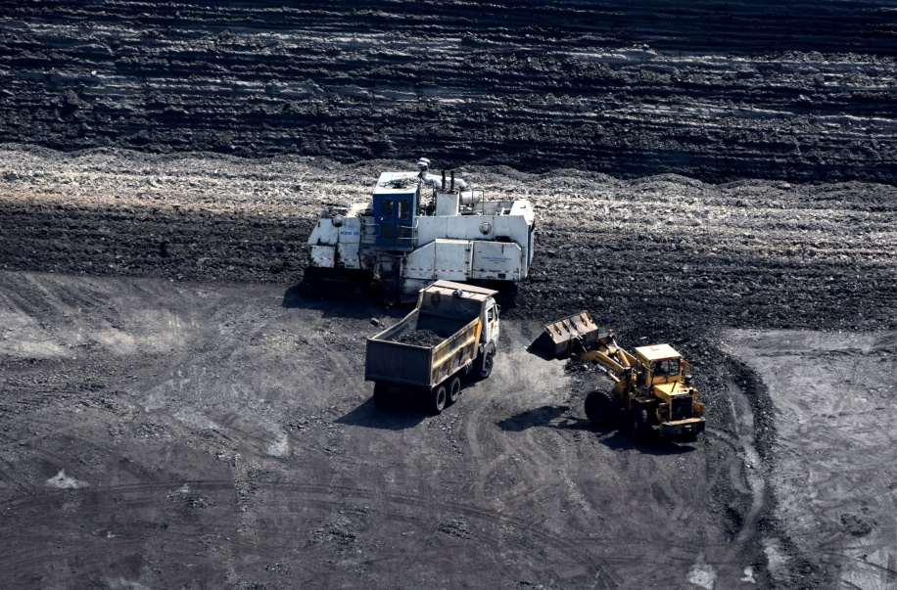
Coal Winning by Surface Miner

Reference:

- CSE. Meghalaya Governor releases CSE’s study on mining, people and environment. http://www.cseindia.org/node/395. Published October 20, 2008.

- Guha D. A case study on the effects of coal mining in the environment particu- larly in relation to soil, water and air causing a socio-economic hazard in Asansol Raniganj Area, India. Int Res J Soc Sci. 2014;3:39–42.
- Katoria D, Sehgal D, Kumar S. Environment impact assessment of coal mining. Int J Environ Eng
Manag. 2013; 4:245–250.
- Mishra N., Das N.,2017. Coal Mining and Local Environment: A Study in Talcher
Coalfield of India. Air, Soil and Water Research Volume 10: 1–12
- Mahanadi Coalfields Limited (MCL). http://www.mcl.gov.in/Welcome.php. Published 2014. 25.

- MoEF. Comprehensive environmental assessment of industrial clusters. http://www.indiaenvironmentportal.org.in/content/294336/comprehensiveenvironmental-assessment-of-industrial-clusters/. Accessed May 10, 2015. 20.

7. Singh G. Impact of coal mining on mine water quality. Int J Min Water. 1998;7:49–59. 26. Reza R,
Singh G. Heavy metal contamination and its indexing approach for river water. Int J Environ Sci Te.
2010; 7:785–792.
Biography
- D.K. Khanda has passed FCC(Coal) in 2007 from DGMS, Dhanbad, India and completed his M.Tech.(Environmental Science & Engineering) in the year 2009 from Sambalpur University, India and M. Phil (Environmental Science) from TGOU, Nagaland, India and is doing research work at present in environmental engineering. He is the Senior Manager (Mining) of M/s Mahanadi Coalfields Limited, the second highest coal producing company of Coal India Limited. He has published more than 30 papers in reputed International/National Congress/Conference/Seminar/Symposium proceedings and journals and has been serving as an editorial board member of repute. He is a Life Member of MGMI, IICM, IMMA and Fellow Member of ICER, ICCE, ISCA, MEAI and Corporate Member of Institution of Engineers(India).He is a Chartered Engineer of Institution of Engineers (India). He is the recipient of Rastriya Gourava Award from IIFC, Delhi.

- M.R. Mahananda has completed his M.Sc., M. Phil, Ph. D and M. Tech (Env. Sc. & Engg.). He is a Faculty in Post Graduate Department of Environmental Sciences of Sambalpur University. He has published more than 40 papers in Journal and Seminar/Conference proceedings of repute. He is supervising many a Research scholars.

Presenting author details
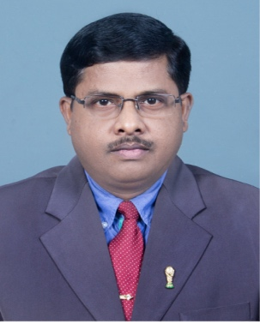
Debendra Kumar Khanda
Full Name: Debendra Kumar Khanda¹
Contact number:+91 9437249367
Twitter account:
Linked In account:
Session name/ number: Sustainability and Climate Change
Category: (Oral presentation/ Poster presentation): Oral Presentation
Passport Number:H 9312832(of Debendra Kumar Khanda)
E-mail Id: dkkhanda@yahoo.com

