Abstract
Title: Evaluation of change in ecosystem of Ib Coalfield of M/s Mahanadi Coalfields Limited and its impacts on climate change due to coal mining.
D.K. Khanda,¹, S.Roy Choudhury ², A.Apat ³
¹ Sr. Manager(Mining), Safety & Rescue Department, Mahanadi Coalfields Limited, Sambalpur, Odisha, India
² General Manager(Mining), Safety & Rescue Department, Mahanadi Coalfields Limited, Sambalpur, Odisha, India
³ Manager(Geology), Safety & Rescue Department, Mahanadi Coalfields Limited, Sambalpur, Odisha, India
Keywords: Coal Mining, Land reclamation, Ecosystem, Climate change, Coal processing
The present study investigated three major opencast coal mine projects, i.e. Samaleswari Opencast Project, Lakhanpur OCP and Kulda Opencast Project of M/s Mahanadi Coalfields Limited (A subsidiary Company of Coal India Limited) and collected data of rainfall, temperature including pre-mining, post mining data and land reclamation data thereof. In the course of study, primary as well as secondary data on geology, method of mining, coal processing, and other ancillary activities were collected to interpret and evaluate the change in ecosystem in Ib Coalfield spreading in Jharsuguda and Sundargarh districts of Odisha, India. We documented the data and relevant documents and compared considering mine closure plan, evaluated and interpreted and found that there is significant improvement/restoration of damaged ecosystem in the post-mining phase of surface coal mining after technical and biological reclamation with massive plantation. Subsequently, a comparison of both pre-mining and post-mining meteorological data of the area of mining was made to depict the changes/impacts leading to climate change.

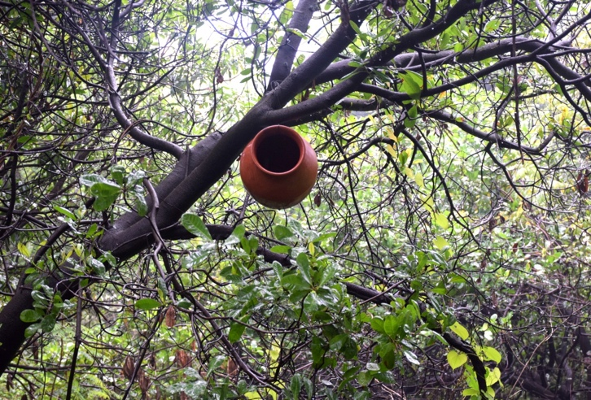
Effort of eco-restoration in Samaleswari Opencast Project
Reference:
- Katoria D, Sehgal D, Kumar S. Environment impact assessment of coal mining. Int J Environ Eng
Manag. 2013; 4:245–250.
- Mishra N., Das N.,2017. Coal Mining and Local Environment: A Study in Talcher
Coalfield of India. Air, Soil and Water Research Volume 10: 1–12

- Mahanadi Coalfields Limited (MCL). http://www.mcl.gov.in/Welcome.php. Published 2014. 25.
- MoEF. Comprehensive environmental assessment of industrial clusters. http://www.indiaenvironmentportal.org.in/content/294336/comprehensiveenvironmental-assessment-of-industrial-clusters/. Accessed May 10, 2015. 20.
5. Singh G. Impact of coal mining on mine water quality. Int J Min Water. 1998;7:49–59. 26. Reza R,
Singh G. Heavy metal contamination and its indexing approach for river water. Int J Environ Sci Te.
2010; 7:785–792.
Biography
- D.K. Khanda has passed FCC(Coal) in 2007 from DGMS, Dhanbad, India and completed his M.Tech.(Environmental Science & Engineering) in the year 2009 from Sambalpur University, India and M. Phil (Environmental Science) from TGOU, Nagaland, India and is doing research work at present in environmental engineering. He is the Senior Manager (Mining) of M/s Mahanadi Coalfields Limited, the second highest coal producing company of Coal India Limited. He has published more than 30 papers in reputed International/National Congress/Conference/Seminar/Symposium proceedings and journals and has been serving as an editorial board member of repute. He is a Life Member of MGMI, IICM, IMMA and Fellow Member of ICER, ICCE, ISCA, MEAI and Corporate Member of Institution of Engineers(India).He is a Chartered Engineer of Institution of Engineers (India). He is the recipient of Rastriya Gourava Award from IIFC, Delhi.
- S. Roy Choudhury has completed his B.Tech.(Mining Engineering) in the year 1982 from Indian School of Mines [Presently IIT(ISM)], Dhanbad, India and passed FCC(Coal) from DGMS, Dhanbad, India. He is the General Manager(Mining) of M/s Mahanadi Coalfields Limited, the second highest coal producing company of Coal India Limited. He has vast experience in coal mining placed in different positions in different subsidiary companies of Coal India Limited. He is a Life Member of MGMI.
- Ava Apat has completed her M.Sc.Tech.(Applied Geology) in the year 2009 from Indian School of Mines [Presently IIT(ISM)], Dhanbad, India. She has served in CMPDIL, a R&D Institute of CIL for seven and half years. She is now working as Manager(Geology) in M/s Mahanadi Coalfields Limited, the second highest coal producing company of Coal India Limited and well associated in Corporate Geo-Technical Cell of the company being placed as Nodal Officer.
Presenting author details
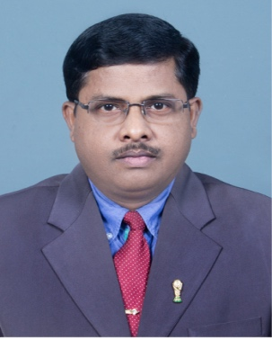
Debendra Kumar Khanda
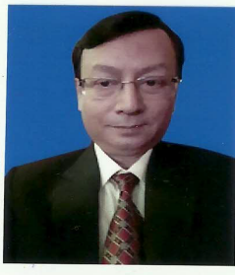
Sujit Roy Choudhury
Full Name: Debendra Kumar Khanda¹ and Sujit Roy Choudhury² and Ava Apat³
Contact number:+91 9437249367
Twitter account:
Linked In account:
Session name/ number: Pollution & Climate Change
Category: (Oral presentation/ Poster presentation): Oral Presentation
Passport Number:H 9312832(of Debendra Kumar Khanda)
E-mail Id: dkkhanda@yahoo.com

