Stratigraphy and Structural analysis of areas within Hazara Kashmir Syntaxis, North Western Himalayas, Pakistan
Muhammad Yasin Khan, Institute of Geology, University of Azad Jammu and Kashmir, Muzaffarabad, 13100, Pakistan
Majid Farooq, Institute of Geology, University of Azad Jammu and Kashmir, Muzaffarabad, 13100, Pakistan

Abstract (300 word limit)
The Paleocene-Eocene sedimentary rocks with unconformable contact with underlying Late Cambrian Abbottabad Formation and disconformable contact with overlying Miocene Murree Formation are exposed within a regional geological structure recognized as the Hazara Kashmir Syntaxis (HKS) in North Western, sub Himalayas, Azad Jammu and Kashmir, Pakistan. The area is highly deformed by the folds and faults owing to tectonic activities. The Chalpani anticline, Patikka syncline, Patikka anticline, Panjgran syncline, Panjgran anticline, Devlian anticline, Balgran syncline and Nauseri anticline are the intraformational folds within Murree Formation.
The Yadgar-Back Thrust, Ghori-Back Thrust, Chalpani fault, Devlian fault and Main Boundary Thrust (MBT) are the emergent faults of the area. The Yadgar-Back Thrust is reverse in nature and marked in Margala Hill Limestone. The Ghori-Back Thrust is a northeast-southwest trending fault within Murree Formation. This fault is a back Thrust which is reverse in nature. The Chalpani fault is a northwest-southeast trending fault within Murree Formation. The Devlian fault within Murree Formation is marked on the basis of shearing, crushing, breccia, tilted or uplifted terrace and offset of river. The Main Boundary Thrust (MBT) is a northwest-southeast trending regional structure between Miocene Murree Formation and Panjal Formation in which Panjal Formation is thrusted over the Murree Formation. The MBT and Panjal thrust are folded around the syntaxis.

Image
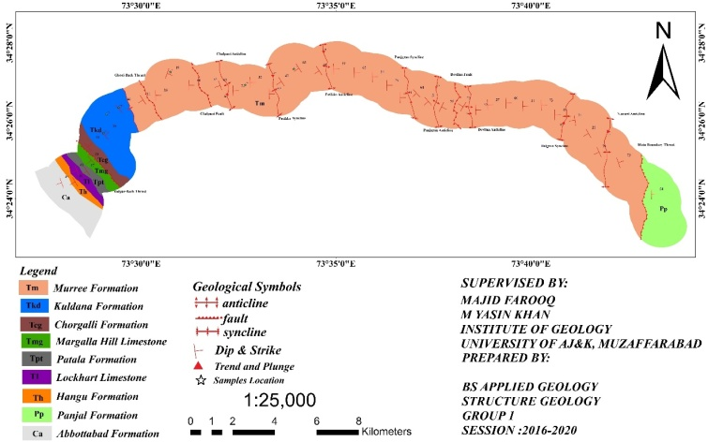
Recent Publications (minimum 5)
- Abid IA, Abbasi IA, Khan MA, Shah MT (1983) Petrography and geochemistry of the Siwalik sandstone and its relationship to the Himalayan orogeny. Geological Bulletin University of Peshawar 16: 65-83.
- Basharat M, Rohn J, Baig MS, Khan MR (2014) Spatial distribution analysis of mass movements triggered by the 2005 Kashmir earthquake in the Northeast Himalayas of Pakistan. Geomorphology 206:203-214.
- Mughal SM, Zhang C, Du D, Zhang L, Mustafa S, Hameed F, Khan MR, Zaheer M, Blaise D (2018) Petrography and provenance of the Early Miocene Murree Formation, Himalayan Foreland Basin, Muzaffarabad, Pakistan: Journal of Asian Earth Sciences162:25–40. https://doi.org/10.1016/j.jseaes.2018.04.018
- Wadia DN (1931) The syntaxis of the NW Himalayan. Rec. Geological Survey of India 65 (2): 189–223.
- Bilal, A., Yasin. M., Ali. A., (2017). The geology and structure of Neogene rocks in Dadyal and adjacent areas, in the sub-Himalayas, Azad Jammu and Kashmir, Pakistan. Earth Science Malaysia1(1): 15-20.

Biography (150 word limit)
Muhammad Yasin Khan has pursued his own studies in the field of Geology at the Institute of Geology, University of Azad Jammu and Kashmir, Muzaffarabad, Pakistan. He has his expertise in the field of Structure Geology, Neotectonics, Petrology, Stratigraphy and Sedimentology. He has also carried out various field excursions across Indo-Pakistan plate and Eurasian plate, Himalayas as well as in salt range and adjacent areas of Pakistan. He has several publications in various National and International Journals having citations in reputed journals. At present time he is serving as the Research Associate in the Department of Geology, University of Azad Jammu and Kashmir, Neelum Campus, Athmuqam.

Contact Details:
Email: Yasin.khan@ajku.edu.pk
Contact Number: +92355-6211384
Linked In/twitter Account Id: https://www.linkedin.com/in/muhammad-yasin-khan-a608aa90/
Facebook profile: https://www.facebook.com/muhammadyasin.khan.3114
Session:
Presentation Category: Oral/poster/Video Presentation/E-Poster

Notes/Comments

