Abstract Template

Title: Environmental Monitoring of Methane (CH4) emissions to the atmosphere from landfills at Tenerife (Canary Islands) in Spain

Doro NIANG¹, Laura ACOSTA^{2,3,5}, Briana JAEGER⁴,Cecilia AMONTE^{2,5}, Maria Asensio RAMOS¹ and Nemesio M. PEREZ^{2,3,5}
¹Departement de Géologie, Université Cheikh Anta Diop de Dakar-SENEGAL
² Instituto Volcanologico de Canarias (INVOLCAN)
³ Instituto Technologico y de Energias. Renovables (ITER) of Tenerife, Canary Islands (Spain)
4 Department of Geoscience, West Chester University in West Chester, Pennsylvania 18414
⁵ Agencia Insular de la Energia de Tenerife (AIET), Granadilla de Abona, Tenerife, Canary Islands, Spain

Keywords: Emissions; greenhouse gas ; biogas; methane; micro chromatography; climate change ; Involcan; GeoTenerife

- Abstract Body (up to 250 words)
The present study investigated Environmental monitoring of greenhouse gas emissions (methane, CO2, volatile organic compounds, etc.) in the atmosphere at ARICO landfill in Tenerife (Canary Islands) with Involcan, ITER and GeoTenerife.
Methane (CH4), the second largest anthropogenic greenhouse gas after carbon dioxide (CO2), accounts for over one-third of anthropogenic climate forcing. Methane is considered a "short-lived climate forcing agent". Although methane remains in the atmosphere for a shorter period of time than CO2 and is emitted in smaller amounts, its "global warming potential" is 21 times higher than that of CO2.
The main objective of this study is the promotion of green energy with the development of biogas so that public and private structures can take ownership but also allow better management of solid waste by minimizing air pollution.
As part of the research methodology, field and laboratory work is carried out. Thus, a spatio-temporal distribution of the study area has been carried out notably at the level of the environmental complex of Tenerife with 444 landfill gas collection points that are formed during the decomposition of organic matter in landfill sites, solid urban waste.
The collection, processing and analysis of data are carried out by fairly powerful tools and equipment such as the NDIR ; microchromatography ; the sequential Gaussian Simulations.
The results of the various studies are convincing, thus enabling a better understanding of methane emissions in landfills and capturing this gas for energy conversion in the context of biogas, also resilience and adaptation to climate change.
- Image:
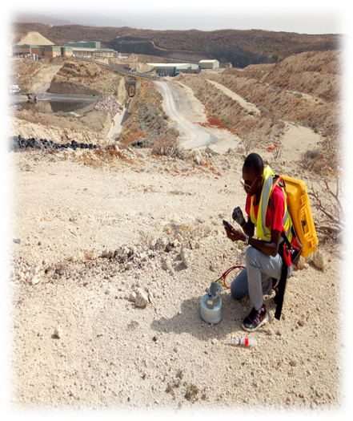
Figure : Methane and CO2 sampling at Arico landfill in Tenerife
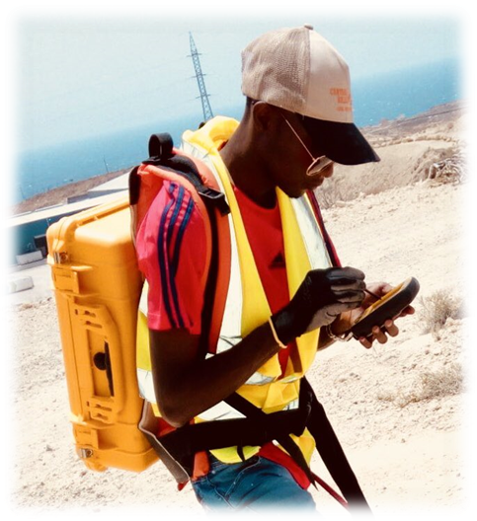

- Reference:
- Bogner, J; and E.Matthews, Global methane emissions from landfills : New methodology and annual estimates 1980-1996, Global Biogeochemical Cycles. 2003.17(2), 1065.
- Acosta, L; Gooderham,C; Withoos, W; Amonte, C; Ramos, M.A; Melian, G.V; Hernandez, P.A; and Perez, N.M. Monitoring fugitive CH4 and CO2 emissions from closed landfills : the case of Arico’s landfill, Tenerife, Canary Islands; abstract
- Ramos, M.A;Acosta, L;Randazzo, A; Amonte, C; Rodriguez, F;Barrancos, J; Melian, G.V; Padron, E; Calvo, D; Perez, E; Tassi, F; Raco, B; Lopez, D; Pedro, A; Hernandez, P.A; and Perez, N.M. Assessing the estimated methane emission into the atmosphere by landfills in Spain.
- Biography:
Doro NIANG Environmental Geologist and Geotechnician
PhD student at Université Cheikh Anta Diop de Dakar (UCAD), President of the Association of Young Geologists and Environmentalists of Senegal (West Africa).Doro has completed his Master degree in 2016 in Geosciences at the Geology department of UCAD.

- Presenting author details

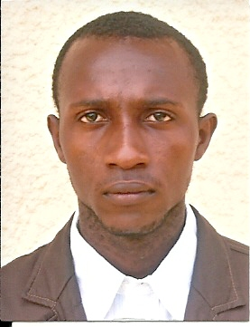
Full Name: Doro NIANG
Contact number: +221777212632
Twitter account: @rodompcl (Doro NIANG)
Linked In account: https://www.linkedin.com/in/doro-niang-90955487/
Session name/ number:
Category: Poster presentation
Passport Number: A01845768

