Petrochemistry as a tool for determination of the petrogenesis and geotectonic setting of Enderbite-Charnockite Association in Obudu Plateau, Southeastern Nigeria

Ukaegbu, V. U.
Department of Geology, University of Port Harcourt, Port Harcourt, Nigeria
Tel: +2348037025850; E-mail: victor.ukaegbu@uniport.edu.ng

Keywords: Petrology, Geochemistry, Petrogenesis, Geotectonic setting, Enderbite-charnockite association, Obudu Plateau, Southeastern Nigeria | Reference  - Ekwueme, B. N., 1990. Petrology of Southern Obudu Plateau, Bamenda Massif, S. E. Nig. In: G. Rocci and M. Deschamps (Co. ed), Recent Data in African Earth Sciences CIFEG Publ. Vol. 22 pp. 155-158.  - Olarewaju, V.O., 2006. The charnockitic intrusive of Nigeria.. In Oshin, O. (Ed.), The Basement Complex of Nigeria and its Mineral Resources. Akin Jinad and Coy, Ibadan, Nig.  - Ukaegbu, V. U. and Beka, F.T. 2006. Petrochemistry and Geotectonic significance of Enderbite-Charnockite Association in the Pan-African Obudu Plateau, Southeastern Nigeria. Journ. Min. and Geol. Vol. 43 (1), pp.1-14.  Biography  Victor Uchechi Ukaegbu holds B.Sc. (Geology) from University of Port Harcourt, Nigeria; M.Sc. (Mineral Exploration and Mining Geology) from University of Jos, Nigeria and Ph.D. (Geology with specialization in Petrology and Geochemistry) from University of Port Harcourt, Nigeria.  He has been a lecturer for 36 years and is Professor Geology (Petrology and Geochemistry). He has been Head of Department of Geology and Dean of Faculty, University of Port Harcourt.  He is the Associate Editor, Journal of Mining and Geosciences - a Journal of the Nigerian Mining and Geoscientists Society, of which he is a member. He is also a member of Geological Society of Africa. He has published 60 articles in reputable Journals and 4 books.

Abstract

The petrogenesis and geotectonic setting of enderbite-charnockite association in Obudu Plateau were determined using petrology and geochemistry. Field relations show that the rocks are structurally-controlled in a regional N-S to NE-SW trend of the host gneiss-schist complex. The main mineral phases are quartz, feldspars and pyroxene, while the subordinate minerals include hornblende, biotite and magnetite. Field relations, modal mineral distribution and chemical characteristics show the association classifying into charnockites and enderbites, which originated from two different phases of fractional crystallization of dry lower crust, subsequently contaminated by wet partial melt of the upper crust during crustal collision processes. This is supported by the depletion in many large ion lithophile elements (LILE). However, similar REE patterns showing wider range of REE fractionation, more pronounced negative Eu anomaly, higher contents of LREE and lower contents in HREE in the charnockites than the enderbites indicate two different phases of fractionation from the same source under similar conditions. Field relations indicated by xenoliths in the charnockitic rocks, admixture of the association with granites and decreasing CaO, TiO₂, P₂O₅, Sr with increasing SiO₂ contents, plot of the rocks within i-type igneous field and chemical similarities of the association with igneous charnockites elsewhere support that the charnockites and enderbites of Obudu Plateau are of igneous origin. Discrimination diagrams and other geochemical characteristics show that the charnockites are syn-collisional while the enderbites are late-orogenic to post collision uplift granitoids, emplaced at the convergent plate boundary between the West African and Congo-Gabon cratons during the Pan African orogeny.
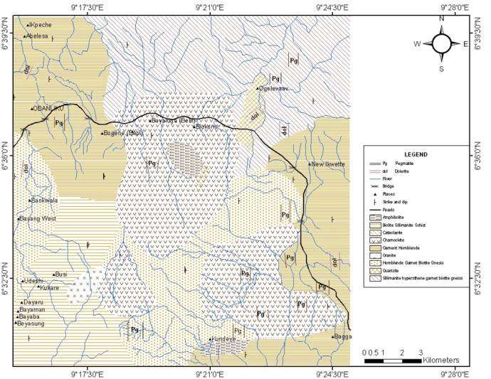
Presenting author details


Full Name: Prof. Victor Uchechi Ukaegbu
Contact number: +2348037025850
Linked In account: Victor Ukaegbu,
Email: victor.ukaegbu@uniport.edu.ng
Mobile: +2348037025850
Professor of Geology at University of Port Harcourt
Session name/number:
Category: Oral presentation

Passport Number:A08423126

