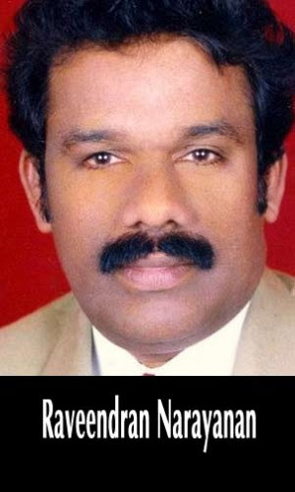
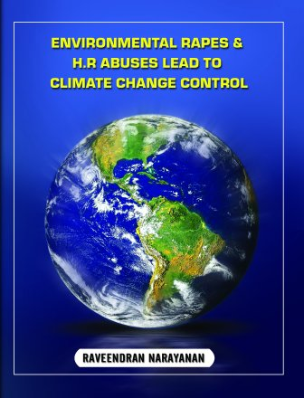
“AIR CONDITIONING THE MOTHER EARTH”
Raveendran Narayanan,(Indian Citizen with U.S. Green Card), Sea Water Desalination Researcher, Creator of “SARVA KALA VALLABHAN GROUP” ( SPECIALISED IN MANY ARTS), Human Right Activist and the creator of Climate Change 3rd Group ” AIR CONDITIONING THE MOTHER EARTH “ is declaring that CARBON DI OXIDE (CO2) is NOT changing the climate.
$89Trillions (Dollars Eighty nine trillions) is NOT necessary to correct the climate, but with streakiest Regulations and streakiest Enforcements we can correct the climate.
http:joannenova.com.au/2015/05/nobel-chutzpah-prize-2015-un-world-bank-need-89-trillion/I am humbly requesting to Nominate me for INTERGOVERNMENTAL PANEL ON CLIMATE CHANGE (I.P.C.C.) CHAIRMAN due to the following grounds:
- 53 (Fifty three) pages MANIFESTO “Connections of mushrooming of desalination systems in the Middle East and Environmental disasters around the World” un published paper Dubrovnik – 2009 Conference is hereby attaching for your attention and action.
- I.P.C.C. Fifth Assessment Report : cast strophic impacts, sea level raises to twenty feet, wild fires & temperature raises to 5°C, starvation and hunger are scaring tactics by Ex IPCC Chair Dr. Rajendra Pachauri.
- Carbon capture technology in the Gulf of Mexico failed and cast strophic environmental disasters and Tornadoes happening since then.
- During 2009, while I requested for Oceans and Seas Analysis reports to World’s Oceans Organizations like NOAA (National Oceanic and Atmospheric Administration ) & Nuclear Regulatory Commission but non of them had in their data bases. It is knowing from I.P.C.C.s Fifth Assessment Report dated December 2014 that IPCC is starting to investigate about Oceans and Seas which is too late but my Research and Development paper will solve it like Temperature 3°C down, Stop DE-ICING of ice shelves, Stop sea level raise, Stop intensities of Hurricanes, Stop escaping of Methane from ice shelves, Stop Ozone Holes , more veggies and food & World Peace —>>>>>. ” AIR CONDITIONING THE MOTHER EARTH”
- Before the Climate March of 2014, TWENTY THREE WILD FIRES WERE INTENTIONALLY SET BY CO2 GROUP and US Federal Investigators are investigating those in California State.
- “Air Conditioning The Mother Earth” ( Climate Change Control 3rd Group) : Raveendran Narayanan: http://youtu.be/Te9jtgRVsbYn
- “AIR CONDITIONING THE MOTHER EARTH” https://www.facebook.com/Air-Conditioning-the-Mother-Earth-186829931365261/timeline/?ref=hl
- “STOP SEA RAISE NOW” https://www.facebook.com/stopsealevelraise
- Melting and DE-ICING are two separate process. Concentrated DE-ICIRS bringing by Hurricanes are DE-ICING ice shelves even during WINTER.
- IPCC, Intergovernmental Panel on Climate Change is NOT an Economic Organization, but most of the Speakers and Assessment Groups are talking about Economic situations of countries. INTERNATIONAL MONETARY FUND, WORLD BANK and International Economic Development Corporations are doing their jobs very perfectly.
- WHO WILL WIN THE CLIMATE WAR? The Climate War will be won by those who are having the Oceans & Seas analysis since 1980. So by strictest regulations and strictest enforcement CAPTURE Concentrated DEICERS by erecting ZERO DISCHARGE SYSTEMS ( Z.D.S.) in Desalination Systems and build more ice masses & glaciers –>>>> ONE SHOT MANY BIRDS —->>>>> 3° C TEMPERATURE REDUCTION IS POSSIBLE + NO MORE ESCAPING OF METHANE FROM ICE SHELVES + NO MORE OZONE HOLES + NO MORE SEA RISE + NOT MUCH STRONGER HURRICANES, TYPHOONS, CYCLONES + NOT MUCH CALAMITIES+ NO MORE EXTREME WEATHER + PLENTY OF DRINKING WATER FROM SEA WATER + MORE FOOD & VEGGIES + WORLD ECONOMY WILL BE GOOD –>>>>> ” AIR CONDITIONING OF MOTHER EARTH ” = WORLD PEACE.
- $89Trillions (Dollars Eighty nine trillions) can be use for other HUMANITARIAN ACTIVITIES WORLD WIDE.
- ” AIR CONDITIONING THE MOTHER EARTH “ ( Climate Change 3rd Group) https://raveendrannarayanan.wordpress.com/…/…/nominate-for-i-

