Title: Glacial Lake Lowering and Early Warning System to save lives and livelihood of the Nepal Himalaya communities: A Case Study of Imja and Tsho Rolpa Glacial Lake of Nepal

Deepak KC, United Nations Development Programme in Nepal, deepak.kc@undp.org

Keywords: Climate Change Adaptation, Multi - hazards Risk Assessment, Glacial Lakes Outburst Floods, Hydro-met stations, Early Warning System, Community Based DRM, Mainstreaming DRM, Resilient Development, Nepal Himalayas
- Abstract Body (up to 250 words)
Nepal, a mountainous country, is experiencing multiple disasters, majority of which are induced by Climate Change. Erratic rainfall, extremely high temperature, cold waves are some phenomenon impacts of climate and weather variability. Nepal will experience the impacts of climate change through an increase in temperature, more frequent heat waves and shorter frost durations in the future (5AR IPCC). Nepal is witnessing the increased maximum temperature of 0.56ºC per decade, higher than the global average (DHM,2017) and the increment of the temperature is even higher in the mountain region (ICIMOD 2011). One of the major impacts of Climate Change among others, is glacier retreat and Glacial Lake Outburst Floods (GLOFS). Nepal has already experienced more than 24 GLOFS (ICIMOD 2011), originated both from Nepal and China.

Based on the detail assessment, the GLOF risk reduction initiative including GLOF Early Warning System was carried out in two high risk Glacial Lakes namely; Tsho Rolpa and Imja, among six potentially dangerous glacial lakes of Nepal and to establish community based Early Warning System to link upstream and downstream communities using state of the art technologies. By Lowering the lake by 3.4 metres which was 149 metre deep, situated in an altitude of 5010 metre in the Mt. Everest region in the Nepal Himalaya, benefited thousands of people in the downstream.

Evidence based advocacy with strengthening the capacity of federal, province and local government and communities build the foundation for mainstreaming DRM in the regular planning and implementation for sustained and resilient development.

- Image:
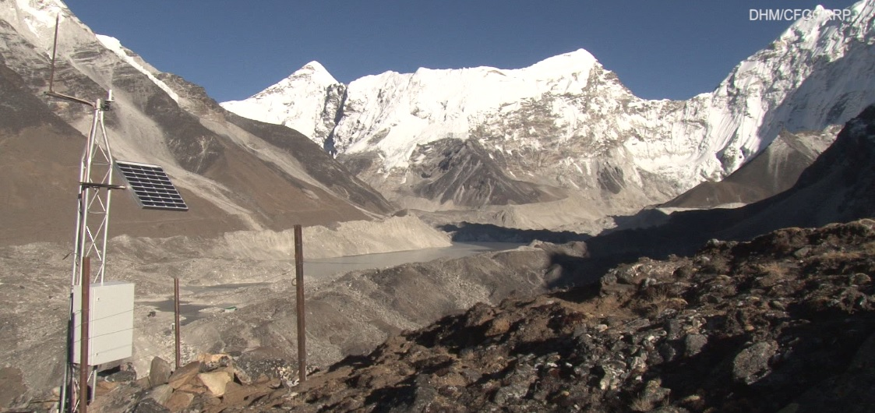
Radar Sensor for Automatic Weather Station for EWS in Imja, Glacial Lake

- Reference:
- Glacial lakes and glacial lake outburst floods in Nepal Kathmandu: ICIMOD 2011
- UNDP Annual Report 2016
- Nepal Disaster Report 2017
- Project Completion Report, CFGORRP 2017
- Biography:
Deepak KC holds a Master's Degree in Environmental Science (M.Sc), graduated from The University of Tokyo with more than 15 years of professional working experience in programme design, planning, and implementation in the themes of climate change, environment conservations/management, multi-hazards risks assessment, particularly integrated climate risk management through the UN Development Programme, I/NGO, NGOs and academic institutions. Currently, Mr. KC is working as Senior Programme Officer- CCA and DRR in UNDP Nepal, responsible for project formulation for GCF and GEF. Mr. KC has presented a number of papers at both national and international workshops and seminars on various themes. (Up to 100 words)
- Presenting author details

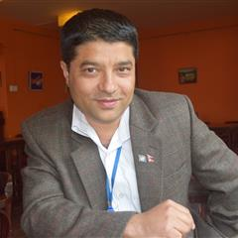
Full Name: Deepak KC ( Mr)
Contact number:977 9751009294/9841867986
Twitter account: https://twitter.com/TUNZAINUS
Linked In account: https://www.linkedin.com/in/deepak-k-c-b52a0240/
Session name/ number: Natural Hazards and Disaster Management
Category: Oral presentation
Passport Number:05956872, Nepal

