Title: Climate change influences on the braided bars of the Jamuna River: A case study from the Sonatala and Sariakandi Upazilas of Bogura District, Bangladesh
Rajib Kumar Saha¹
¹Geological Survey of Bangladesh, 153 Pioneer Road, Segunbagicha, Dhaka-1000, Bangladesh

Key Words: Stable Bar, Migratory Bar, Erosion, Rainfall, Climate Change

- Abstract
The study area covers the Jamuna River and its numerous braided bars from Sonatala and upper part of Sariakandi Upazila, Bogura District, Bangladesh. The investigated area mainly covered by the Holocene sediments which formed through fluvial process. It has been studied with the aid of satellite images, available maps then geological units have been demarcated by field checking and re-examined with different GIS tools for conformation. The sediments of the area consists mainly admixture of clay, silt and fine sand to very fine sand. The geological units namely: (a) Longitudinal bar deposit (b) Lateral bar deposit and (c) Transverse bar deposit. From the study area eight (8) longitudinal bars have been identified, five (5) transverse bar and two (02) lateral bars have also been demarcated. On the basis of contextual elements like texture, tone, association, shape, size and pattern of each unit features in aerial photographs and various bands and band combination study of remote sensing imagery and after the field checking this area can be subdivided into two distinct geomorphic units such as stable bar and migratory bar. Stable bars have been continuously being enriched by heavy silts deposited by rivers during the rainy season. Migratory bar has been influence by single flood cycle sedimentation, river bank erosion tendency and submerging nature during high tide and monsoon. This research is a partial attempt for establishment of a relationship between erosion of the stable bars and migratory bars of the Sonatala and Sariakandi Upazila as well as the influence of climate changes on river morphology. From the study it can be evident that stable bars remain static for several monsoons and inundated during full stage of bank. Whereas migratory bars have been prone to submerge by highest peak of monsoonal discharge and peripheral lobe of the bars has been eroded during monsoon. Landsat and Rapid Eye Image data has inferred that the changes of bar morphology due to annual water discharge. However, ongoing climate change induced heavy rainfall and flash flooding on the upstream of the Jamuna River creates change in its natural course as well as its river bank and bars area. Rapid intense rainfall in the Jamuna River catchment area accelerates the erosion of the stable bars of the study area. To recapitulate, it can be suggested that, erosional hazards of the Sonatala and upper part of the Sariakandi Upazila area can be minimized by taking planned dredging action on the actual and natural course of the Jamuna River.

- Images:

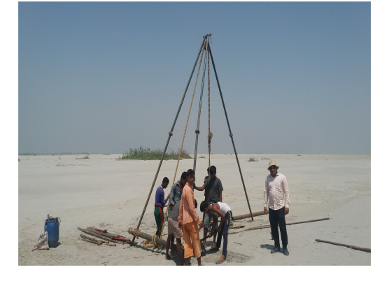
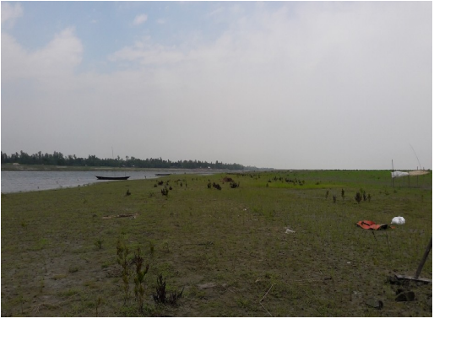

Plate 2: Photographs showing migratory bar of the Jamuna River, Sariakandi Upazila, Bogura

Plate 1: Photographs showing stable bar of the Jamuna River, Sonatala Upazila, Bogura

- Reference:
- Kamrul, A., Huque, A., Arifuzzaman, M., Saha, R.K., 2014. Geological Report on the Mineral Deposits of the Old Brahmaputra River Sands, Unpublished Geological Report of the Geological Survey of Bangladesh, Energy and Mineral Resources Division, Ministry of Power, Energy and Mineral Resources, Government of the People’s Republic of Bangladesh, 1-62.
- Coleman J.M., 1969. Brahmaputra River: Channel Process and sedimentation, Sedimentary Geology, 3 (213):129-239.

- Seijmonsbergen, A.C., 1998. The influence of neo-tectonics on river patterns in Bangladesh: a preliminary study based on Landsat MSS imagery, Geologie En Mijnbouw, 77(2):129.

Coleman J.M., 1969, Brahmaputra River: Channel Process and
- Biography
Rajib Kumar Saha has completed his M.S. degree in Geological Sciences at the age of 26 years from Dept. of Geological Sciences, Jahangirnagar University, Bangladesh. He is the Assistant Director (Geology) of Geological Survey of Bangladesh, a premier Geo-scientific Government national organization of Bangladesh. He has published more than 4 papers in reputed journals and has been serving as a promising geoscientist in the field of Geomorphology, Quaternary Geology and Petrology & Mineralogy.

- Presenting author details



Full Name: RAJIB KUMAR SAHA
Contact number: +8801711119417
Twitter account:
Linked In account: Rajib Kumar Saha
Session name/number:
Category: (Oral presentation)
Passport Number:

