A Comparative study of stack emissions from Straight Line and Zigzag Brick kilns in Nepal

Sangeet Nepal¹, Prakash Sharma¹, Sujan Shrestha³, Sagar Adhikari², Kundan Lal Shrestha¹, Siva Praveen Puppala²,
¹Department of Environmental Science and Engineering, Kathmandu University, Dhulikhel, Kavre, Nepal
²International Center for Integrated Mountain Development (ICIMOD), Kathmandu, Nepal
³Department of Environmental Science, Baylor University, Waco, Texas, USA

Keywords: Brick kiln, Emission factors, Induced draught, zigzag kilns, Straight line kilns, Gaseous pollutants, Particulate pollutants

- Abstract Body
The brick kiln industry is one of the largest and fastest growing industries in Nepal. Every year thousands of tons of biomass fuels such as coal, saw dust and rice husk are used to produce fired clay bricks. The combustion activity emits harmful gaseous pollutants like CO₂, CO, SO₂, NO_{x}, VOCs and particulate pollutants like black carbon and PM_{2.5}. For this study, these pollutants were measured at seven Fixed Chimney Bull’s Trench brick kilns of Nepal, of which three used Induced Draught Zigzag (IDZZ) kilns and four used Straight Line (SL) kilns. Then the emission factors (EFs) of these pollutants were calculated by the carbon balance method, which is based on fuel feed, brick production, and energy consumption. In IDZZ kilns, the EFs of CO, PM_{2.5}, SO₂ and BC were estimated as 27.5173±4.89, 3.8067±0.88, 26.17±5.91 and 0.229413±0.38 grams per kilogram of fuel feed, respectively. For SL kilns, EFs of CO, PM_{2.5}, SO₂ and BC were estimated as 27.864±17.44, 5.05±5.08, 31.92±15.56 and 0.902±1.34 grams per kilogram of fuel feed, respectively. In summary, our study finds that pollutants, particularly CO, PM_{2.5} and black carbon, are higher in SL than IDZZ. We estimate that IDZZ can reduce 40% of CO₂ every operating season for all SL kilns be replaced by IDZZ kilns. The parallel energy monitoring conducted during emission measurement shows improved air to fuel ratio, complete fuel combustion and engineered kiln design are key factors for lower emissions. Adopting more efficient design will lower emissions and make more optimal use of energy.
- Image:
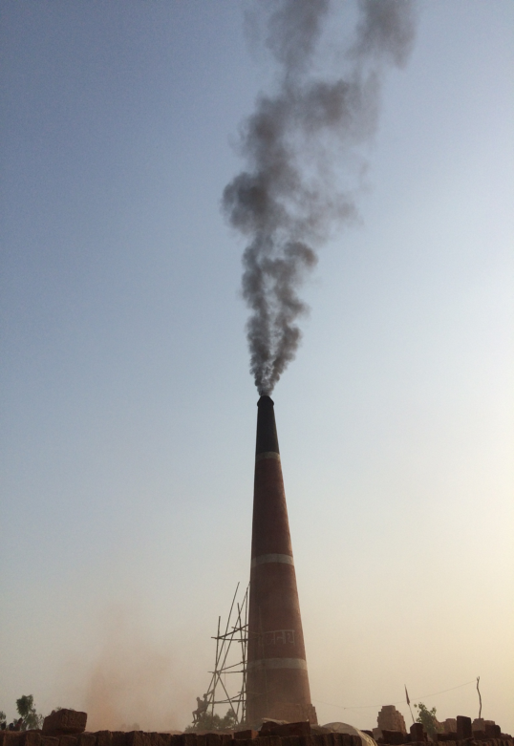

- Reference:
- Weyant, C., Athalye, V., Ragavan, S., Rajarathnam, U., Lalchandani, D., Maithel, S., Baum, E. and Bond, T.C., 2014. Emissions from South Asian brick production. Environmental science & technology, 48(11), pp.6477-6483.
- Rajarathnam, U., Athalye, V., Ragavan, S., Maithel, S., Lalchandani, D., Kumar, S., Baum, E., Weyant, C. and Bond, T., 2014. Assessment of air pollutant emissions from brick kilns. Atmospheric environment, 98, pp.549-553.
- Zavala, M., Molina, L.T., Maiz, P., Monsivais, I., Chow, J.C., Watson, J.G., Munguia, J.L., Cardenas, B., Fortner, E.C., Herndon, S.C. and Roscioli, J.R., 2018. Black carbon, organic carbon, and co-pollutant emissions and energy efficiency from artisanal brick production in Mexico. Atmospheric Chemistry and Physics, 18(8), pp.6023-6037.
- Biography:
Sangeet has completed his Bachelor’s degree in Environmental degree at a age of 22 years from Kathmandu University.
He has conducted stack emission measurement of seven brick kilns in Nepal. He is currently a prospective student for higher studies and research in the relevant field.

- Presenting author details


Full Name: SANGEET NEPAL
Contact number: +9779843022662
Twitter account: @Sangeet85826727
Linked In account: www.linkedin.com/sangeetnepal
Session name/ number:
Category: Oral presentation/ Poster presentation
Passport Number: 10669914

