RESEARCH PROPOSAL


MINERALOGICAL, GEOCHEMICAL AND ENVIRONMENTAL ASSESSMENT OF COAL MINES/SOILS IN MAKARWAL AREA, PAKISTAN

SUBMITTED BY SHEHZAD ALI
(M.S SCHOLAR)
RESEARCH SUPERVISOR DR. LIAQAT ALI
NCE IN GEOLOGY, UNIVERSITY OF PESHAWAR
CO-SUPERVISOR DR. SEEMA ANJUM KHATTAK
NCE IN GEOLOGY,
UNIVERSITY OF PESHAWAR

GRADUATE STUDIES COMMITTEE
___________________________
Prof. Dr. Nimat Ullah Khattak
(Director/Convener)
_________________ _____________________ (Member) (Member)
Dr. RubinaBilqees Dr. Muhammad Hanif
Professor Associate Professor
NCE in Geology, UoP NCE in Geology, UoP

_________________ _____________________
(Member) (Member)
Dr. Sajjad Ahmad Dr. Suleman Khan
Associate Professor Assistant Professor
Department of Geology Department of Geology
University of Peshawar University of Peshawar

NATIONAL CENTRE OF EXCELLENCE IN GEOLOGY UNIVERSITY OF PESHAWAR
(Session 2015-2016)
Introduction
Coal is demarcated as a readily burnable rock that comprises more than 70% by volume of carbonaceous solid as well as intrinsic moisture formed by compaction and indurations of various altered plant leftovers, the type of plant material, degree of metamorphism, and range of impurities illustrate coal (Bates and Jackson, 1980).
Mining for the coal deposit is the major source for the energy sector; however the environmental impacts of mining cannot be ignored which contributes extensively to environmental pollution. Naturally occurring elements in coal are in the range of 76 to 92 and have hazardous effects if their concentration exceeds the permissible limits either in ground water or agricultural soil. These poisonous constituents are discharge through weathering or deep chemical leaching, burning and triggering environmental pollution (Finkelman et al., 2002). In extensive mining areas ground water is susceptible to various pollutants, which is evident from high concentration of heavy metals in the ground water (Garbarinoet et al., 1995). There are also examples of both the surface and ground water, during discharge from mining area which contaminated the medium of water and have higher concentration of the Total Dissolved Solids (TDS), Total Suspended Solids (TSS) and heavy metals (Tiwary, 2000).
Soil pollution by heavy metals in mining areas can cause direct threat to the persons involved in mining industry as well as indirectly by contaminating the food chain from soil to crops, fodder, fruits and vegetables to those living in the most severely polluted regions (Li et al., 2014). Due to mining activities the damage caused to a particular medium i.e either water or soil can be measured by using single element indices and multi element indices in order to evaluate environmental problems in that particular area ( Zhuang and Gao, 2014).
Trans-Indus ranges of Pakistan lies west of the Salt Range and Indus River are a group of arcuate mountains and distinct ranges include the Surghar, Shinghar, Marwat, and Khisor ranges at about 50 km south of the Kohat. The Makarwal coal field is in the Surghar Range, a well-defined series of ridges bounded by a prominent escarpment facing the Indus River (Ali, 2010). Coal resources in the Trans-Indus Mountains were first reported by Wynne (1880). Coal between the Kalabagh and Makarwal areas were reported by Simpson (1904). Gee (1938) described in detail the geology and coal occurrences in the vicinity of Kalabagh and Makarwal. Mining related water problems were first reported by Coulson (1938) in the Makarwal area and recommended that the water related issues be solved.
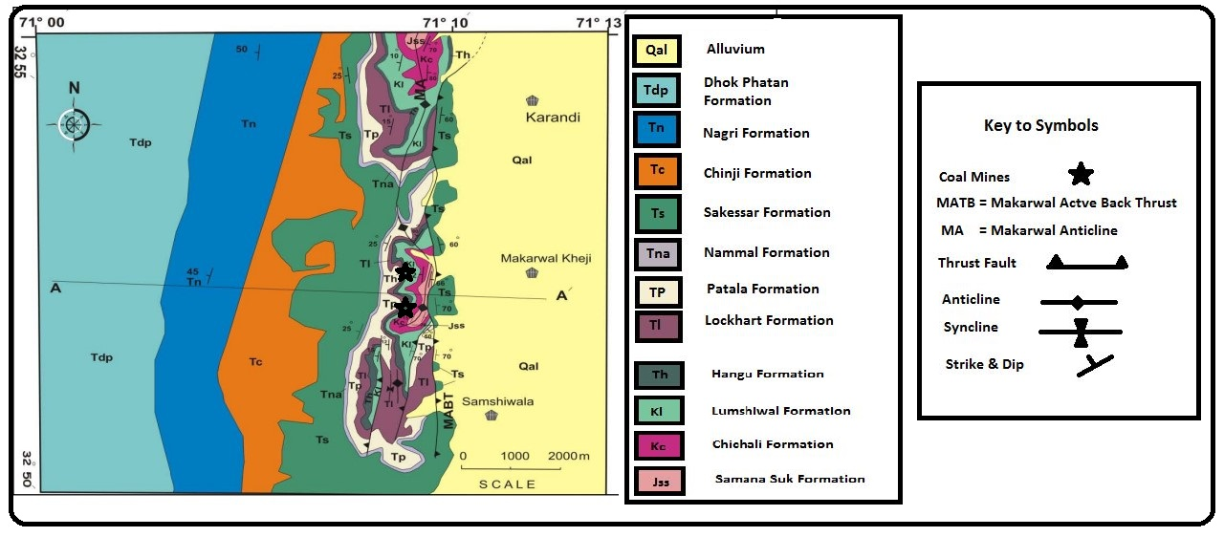
Figure 1: Regional map showing the geographical and geological location of Paleocene succession in Surghar Range (modified after Ali et al., 2014).
The concentration of toxic elements like S, Cr, Cd and Pb from Makarwal coalfield were determined by Qureshi et al. (1994) and they recommended the environmental survey to be conducted in the area. Shah (2016) determined the concentration of minor elements like Cu, Fe, Ni, As, Cd, Co, Cr, Pb and Zn and physicochemical analysis like temperature, PH, electrical conductivity, salinity etc, from the water samples of Makarwal and Cherat. High concentration of toxic elements in water samples from Makarwal includes Cd, Cr, Fe, Ni, Pb and Zn and Cd, Cr, Ni, Pb, Zn from Cherat area, thereby clearly indicating the influence of coal mining on water quality of the area (Shah, 2016). Therefore, it is expected that coal mining will have profound environmental impacts on soils of the area. The current study is proposed to account for the environmental problems with special emphasis on soils of Makarwal with following aims and objectives.
Aims and Objectives
To achieve this aim the following objective will be carried out
- To determine Mineralogical control of various mineral Phases (Sulfides, Clays and Carbonate etc.) using SEM – EDS analyses that may cause potential environmental issues.
- To determine major and trace elements in coal and soils.
- To determine major elements in water samples.
- To account for environmental impacts (ecological risk) of coal mining on the locality.
- To prepare geochemical concentration map of the area in GIS
Significance
Worldwide, coal is used for the electricity generation to be used in industries and household. The coal is vital source of coke for steel manufacturing, pharmaceuticals, chemicals, and even fragrances. It is also an economic source of various mineral commodities. The thorough and actual use of coal as a natural resource needs enhanced understanding of the geochemistry of coal, the carbon-based and mineralogical features of the coal that control its technological performance, by-product characteristics, and ecological and human health impacts. Therefore, the current study will be significant as it accounts for coal characterization (quality, grade, geochemistry and mineralogy) and related ecological contamination to the nearby soils and water. Hazard map will be develop in the Arc GIS software and zones of high ecological risk will be defined. This data will be shared with Government and other organization for socio-economic uplift and public awareness. Results of the current research work will be published in local / international journal.
Plan of work
The strategy for this research work is as under.
Tasks |  | 1st Quart | 2nd Quart | 3rd Quart | 4th Quart
Review of Literature along with field work
Preparation and processing sample
Geochemical work
Writing of thesis
Submission of thesis

Methodology
Method of this research work comprises of field-work in Makarwal and its surrounding area and laboratory analysis of the samples.

Field Work
Existing geological maps are used to locate coal bearing areas and to identify feasible location for the collection of samples (coal and soils). This will be accomplished by geo-referencing maps and overlay with layer of coal prospect in the area. The field work for the collection of the different types of the samples in the Makarwal will be carried out. Coal, water and soil samples will be collected in the vicinity of mines and also from background area for mineralogical / geochemical analysis. The samples of Coal, Soil and Water will be appropriately numbered, located and packed in sample bags for carrying to the concerned laboratories in NCE in Geology, University of Peshawar. Appropriate methods will be applied to process and preserve samples for geochemical analysis.

Laboratory Analysis
The physio-chemical parameters of water and soil samples will be analyze by different equipment’s/machines in the Geochemistry laboratory of NCE in Geology. Major and trace elements (As, Na, K, Ca, Mn, Mg, Fe, Hg, Pb, P, Zn, Co, Ni, Cd and Cr) will be determined in coal and soil samples through Perkin Elmer 700 Flame atomic absorption spectrometer (FAAS). If required Elemental Analyzer (Euro EA-3000) will be used to determine carbon, hydrogen, nitrogen and sulfur in coal samples. The impurities in coal such as silicates, carbonates and sulphides will be studied using SEM – EDS and backscattered images of various minerals in coal will be taken. The mineralogical composition and geochemical composition will be compared to evaluate the Makarwal coal. In order to evaluate the trace elements contamination in the soil single element indices like geo-accumulation index, the enrichment factor (EF), the contamination factor (CF), and ecological risk (Ei); and multi element indices such as the pollution load index (PIL) and the degree of contamination (Cd), will be used. After the complete analysis of samples, hazard maps for toxic heavy metals will be prepared using GIS software. Statistical packages including SPSS and other graphic tasks will be done in Corel Draw.
References
Ali, A. Structural Analysis Of The Trans-Indus Ranges: Implications For The Hydrocarbon Potential Of The Nw Himalayas, Pakistan, University Of Peshawar, Peshawar, PA, 2010.
Ali, F.; Khan, M. I.; Ahmad, S.; Rehman, G.; Rehman, I.; Ali, T. H. Range front structural style: An example from Surghar Range, North Pakistan. Journal of Himalayan Earth Science 2014. 47(2): 70-78.
Bates, R.L.; Jackson. J.A.Glossary of Geology. American Geological institute Falls Church Virginia 1980, 15, 40-46.
Coulson, A. L.; The water supply of the Isa Khel and Mianwali Tehsils of the Mianwali District, Punjab. Geological Survey of India 1938, 72, 4, 440-446.
Finkelman, R.B.; Orem, W.; Castranova, V.;Tatu, C.A.; Beklin, H.E.; Zheng, B. S. Health impacts of coal and coal use, possible solutions. Int. J. of Coal Geol. 2002, 50, 425-443.
Garbarinot, J. R.; Hayes, H.; Roth, D.; Antweider, R.;Brinton, T. I.; Taylor, H. Contaminants in the Mississippi River US Geological survey circular. Virginia USA 1995, 30, 11-33.
Gee, E. R. The economic geology of the northern Punjab withnotes on adjoining portions of the North-West Frontier Province:India Mining Geol. Metall. Inst. Trans. 1938, 33, 3, 263-350.
Li, Z.; Ma, Z.; van der Kuijp, T. J.; Yuan, Z.; Huang, L. A review of soil heavy metal pollution from mines in China: pollution and health risk assessment. Science of the Total Environment 2014, 468, 843-853.
Qureshi, R.; Hassany, S.; Javed, T.; Sajjad, M.; Shah, Z.; Rehman, H. Isotopic Chemical Characterization of Coal in Pakistan. Gov. Reports Announcements and Index 1994. (22): 44-55.
Simpson, R. R., 1904, Report on the coal deposits of Isa Khel Mianwali Punjab. Geological Survey 0f India. 1904, 31, (1) 4-9.
Shah, I. Environmental aspects of some selected heavy and trace metals of Cherat and Makarwal coalfields. Unpublished M.Phill Thesis, National centre of Excellence in Geology University of Peshawar, Peshawar, 2016.
Tiwary, R. K. Environmental impact of coal mining on water regimeand its management. Water, Air, and Soil Poll. 2000, 132, 185–199.
Wynne, A. B. On the Trans-Indus extension of the Punjab Salt Range. Geological Survey of India. 1880, 17, 2-95.
Zhuang, W.; Gao, X. Integrated assessment of heavy metal pollution in the surface sediments of the Laizhou Bay and the coastal waters of the Zhangzi Island, China: comparison among typical marine sediment quality indices. PLoS One 2014, 9(4): 94-145.

