Abstract Template

Title: Identification of new alleles in salinity tolerant rice local cultivars through phenotypic and genotypic screening

XXXX L¹, XXXXX ES¹, XXXX ALD^{1, 2},
¹Department of Crop Improvement, International Rice Research Institute, Manila, Philippines
²Department of Genetics and plant Breeding, National Rice Research institute, Osaka, Japan

Keywords: SHEFROL, Oil and grease, Microbial studies, Aspergillus Niger, Physical
absorption, Salvinia molesta, Eichhornia crassipes.

- Abstract Body (up to 250 words)
he present study was carried out to improve the efficiency of SHEFROL (SHEet Flow
ROot Level) wastewater treatment plant located behind canteen-II which treats wastewater
generated form the cafeteria. SHEFROL is one among the natural wastewater treatment
system, which developed at “Centre for Pollution control and Environmental Engineering”,
Pondicherry University by Professor S.A.Abbasi and his coworkers was proved appropriate
as a substitute for decentralized domestic wastewater treatment. By using different
macrophytes as bioagents, and at different hydraulic retention time the treatment efficiency
of the SHEFROL was found satisfactory.
It was found that the existing plant at canteen-II was inefficient to control highly increasing
flow rate, solids content and removal of oil/grease. Changes were made at all units of the
plant to tackle frequently occurred issues encountered during plant operation and
maintenance. To control oil and grease, jute bag placed below the secondary filtration unit
which was found to trap 50% of oil and grease from the wastewater. Alterations were done
to maintain flow discontinuous as possible. A new settling tank was mounted and above
that secondary filtration unit set up kept with fine screen to collect fine solids to be
composed for further use as fertilizer.
COD of the cafeteria wastewater is very high due to presence of oil and grease. To control
and remove it to a higher extent, lab scale trials was taken for bio-degradation by fungi and
also by physical absorption. Microbial studies done to find out proficient fungi which can
degrade oil and grease under specific environmental condition. Physical absorption studies
done on various biomass to find out proficient oil and grease filter which can soak up oil
and grease form wastewater.
With the average flow rate of 0.312 m3/hr, the physico-chemical analysis was carried out
in terms of pH, EC, COD, BOD5, TKN, TP, TS, TDS and TSS three times per day and the
reduction of pollutant was found to be a significant level. Oil and grease was controlled
from influent up to 50% by using jute bag as absorbent. The lab scale microbial test shows
that Aspergillus Niger is one of the proficient fungi which can be degrade oil and ghee to a
greater extent with 5-days of incubation period. From lab scale physical absorption test, it
was found that Salvinia Molesta and Eichhornia crassipes are most efficient absorbent and
these can trap O & G to an extent of 90.19% and 83.26 % respectively.
- Image:

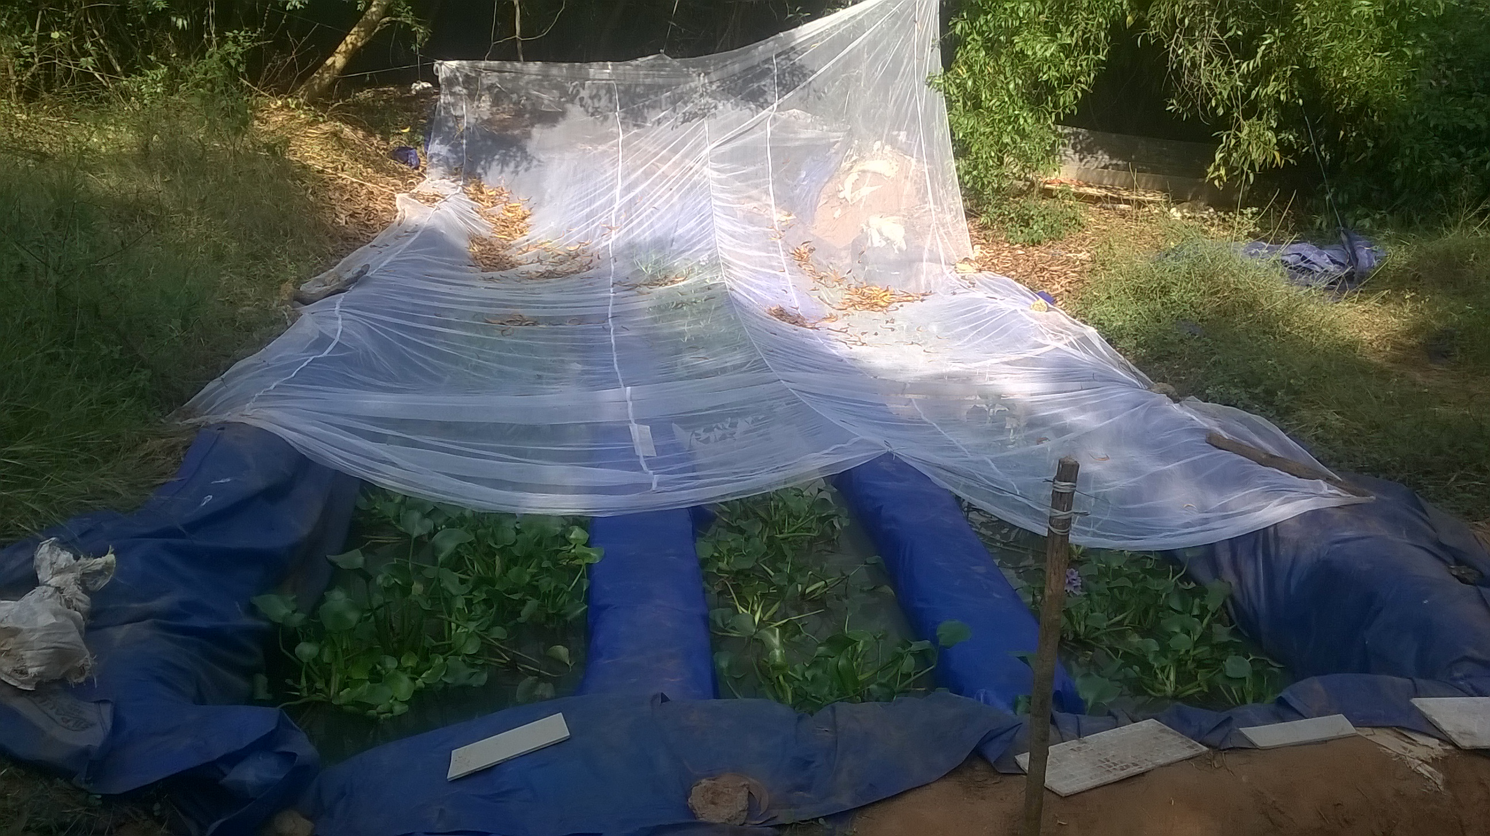

- Reference:
- Adhikari, U., Harrigan, T., Reinhold, D.M. 2014. Use of duckweed-based constructed
wetlands for nutrient recovery and pollutant reduction from dairy wastewater.
Ecological Engineering.
- Dallas, S., Scheffe, B., Ho, G. 2004. Reedbeds for greywater treatment - Case study in
Santa Elena-Monteverde, Costa Rica, Central America. Ecological Engineering,
23(1), 55-61.
- Debusk, T.A., Peterson, J.E., Reddy, K.R. 1995. Use of aquatic and terrestrial plants for
removing phosphorus from dairy wastewaters. Ecological Engineering, 5(2-3),
371-390.
- Idris, S., Jones, P., Salzman, S., Croatto, G., Allinson, G. 2012a. Evaluation of the giant
reed (Arundo donax) in horizontal subsurface flow wetlands for the treatment of
dairy processing factory wastewater. Environmental Science and Pollution
Research, 19(8), 3525-3537.
- Biography:
This is Pradip Kumar Mishra, an environmental professional with specialized in water pollution and resource management with hand-holding experience in environmental management and sustainable development. Professional experience with more than 5 years which includes 3.6 years in the development sector and 1.8 years of industrial experience. I have working experience with various UN-funded projects such as UNICEF and UNDP which foster towards the development of sustainable practices and awareness at communities and other stakeholders level such as policy makers and implementers to promote the successful implementation of the developmental work without compromising at environmental dimension which is in line with UN goal for sustainable development (SDG). My job profile includes strategy framing, development of various scientific tools, modeling and information, education and communication (IEC) to reduce carbon and water footprint which helps to implement cleaner and safer policies and practices for natural resources. I am associated with various state and central govt. authorities, technical institutions, civil society, industries and other national-international bi/multilateral to conduct the process innovation, model development and foster implementation at the ground.

Presenting author details


Full Name: Pradip Kumar Mishra
Contact number: 07065801787
Twitter account:-
Linked In account: Pradip Kumar Mishra
Session name/ number:
Category: (Oral presentation/)
Passport Number:

