ABSTRACT TEMPLATE
Effects of Climate Change and Policy Recommendation.
Climate change may refer to a change in the average weather condition or in the time variation of weather within the context of longer term average condition. Climate change is caused by factors such as biotic processes, variations in solar radiation, and other human activities that have been identified as primary causes of ongoing climate change, often referred to as global warming.
There is no doubt that the impact of climate change are beginning to manifest on the entire globe and more particularly on the developing nations. Climate change and climate variability may pose serious challenge to national development.
Government and other state agencies have adopted measures to minimise the impact of climate change due to its threat to global development and effort to end poverty. Without urgent action, climate impact could push an additional 100 million people into poverty by 2030.
Climate change has a number of issues which has been discussed below,
- Agricultural Issues.
Climate change is a major issues that affect farmer’s especially rural farmers within our communities. Farmer’s alreadystruggle to get a fair price for their goods, safe guard against weather and pest to stay in business. The impact of climate change is poised to make matters worse for young farmers. This is because there would be a lowin production pattern due to higher temperature. This low production pattern as a result of climate change have negative consequences on our farmer’s income.
- Environmental Issues
Environmental issues is one major issues caused by climate change. The impact of climate change has led to the various erosion caused either by human activities or natural disaster. Human activities such as sand winning and illegal mining has a negative consequence on our environmental landscape such as erosion. Natural environmental issues such as volcanic reaction also has negative impact on the environment.
- Economic Issues
One other issue of climate change is economic issues. The economy is likely to setback if agricultural sector that contributes tremendously to the Gross Domestic Product is affected by climate change. This is possible because when there is a change in temperature and farmers yield declined, thisdecline have negative impact on the performance of the economy.
- Settlement Issues
Many communities will be force to move as they are exposed to rising sea levels, drought etc as a result of climate change impact.
- Social Impact.
Communities are also susceptible to the health concern associated with climate change such as heat related ailmentfrom higher temperature, malnourishment due to increase strain of food.

The regulatory environment are the various institutions with the mandate to regulate, conserve and protect the environment. The regulatory environment has been given the necessary resources and power to ensure that the environment are put into proper use. Example of this regulatory body in Ghana are the environmental protection agency, the forestry commission, the ministry of environment science and technology among other agencies.
These regulatory agencies are to work together to ensure the environment are not degraded, polluted and are put into judicious use for the wellbeing of the citizenry. These regulatory agencies are to propose policies that would ensure strict and efficient use of the environment through science and technology.
Some of the policy recommendation include but not limited to the following,
1 Public Education and Awareness Program
Government should implement policies that would ensure that the public are educated about the negative impact of climate change and the need to conserve and protect the environment. This policies can be achieve through town hall meeting and education in the various district on the importance of the environment.
When this policy are adhere strictly either quarterly, semi-annually or annually, the public would be educated someway somehow to ensure that the environment is well protected and preserve.
2 Enforcement of Laws
Government must ensure strict adherence to laws. This laws should be apply in the national interest without political intervention. The laws must be punitive enough to serve as deterrent to other prospecting people. When this laws are pass and adhere to, people would be mindful of their daily activities as a way of preserving and conserving the environment.
3 Joint Institutional Task Force
There should be a joint institutional task force whose mandate is to ensure the preservation and conservation of the various water bodies and forestry. This task force should be station at almost all various water bodies and forestry and they should be permanent just as police and military to ensure the environment is preserve. If government knows the important of environment this policy should be strictly adhere to. The task force should be given the powers to prosecute people who fall foul to this measure.
4 Reduction of Employment and Poverty.
One other policy the government should implement is the provision of jobs and the reduction of poverty. Most of the illegal lumbering and illegal mining comes as a result of unemployment and poverty. So when government is able to provide employment and jobs for the citizenry, then the focus would change and that would help to protect our environment at large.
With the implementation of these policy guidelines, climate change would have positive effects on our lives rather than negative effect, because it is not always the case that climate change has a negative effects it also has a positive effects.
References
- Gillis, Justin( 2015-11-28) short answers to hard questions about climate change
- Talk of the nation, American fail the climate quiz
- Gillis, justin ( 2017-26-06) carbon in Atmosphere is rising, even as emission stablises
- Climate change evidence, How do we know. Climate change, vital signs of the planet
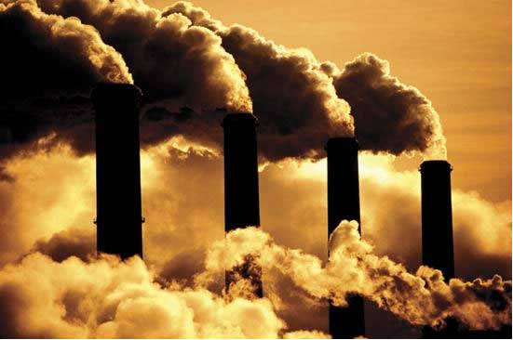

YAKUBU MUNTAKA MUSAH
University of Professional Studies, Accra- Ghana



BIOGRAPHY
Yakubu Muntaka Musah is my name, MBA student reading Petroleum Accounting and Finance at the University of Professional Studies, Accra. I completed my Bachelor Degree at the same University in August 2013 with distinction. A few years after my completion, i engaged in many academic activities including attending a Bio plastic conference in 2017, in Paris, France and gave an oral presentation, to which i was Awarded the Student Ambassador for the conference. As an ardent and disciplinary student, my vision is to encourage the young generation to succeed in their attempt to climb the academic ladder, hence my award as the student facilitator in the just ended Biofuel conference in Edinburg, Scotland.
EMAIL. muntakamusah11@yahoo.com

Name ; YAKUBU MUNTAKA MUSAH
Contact; 00233249406833
Passport Number, G1364194
Mail ID
.
Category; Oral Presentation

