Nanosuspension coating: An efficient technique for designing of Controlled porosity osmotic drug delivery systems (CPOPs).

Javad Shokri*, Professor of Pharmaceutics, Tabriz University of Medical Aciences (TUOMS), Tabriz, Iran

Maryam Shamsedini Lori. Pharm.D. Dermatology & Dermopharmacy research Team (DDRT), Iran

Abstract
Oral osmotic drug delivery system have been focused by many researchers in recent years due to their advantages such as independency of drug release to pH, presence of food and other physiological factors over traditional dosage forms. Controlled porosity osmotic pump (CPOP) is one of the most practical and efficient types of osmotic pumps. In CPOPs, hydrophilic materials or polymers are used for producing of microscopic pores in semipermeable membrane (SPM) acts as drug release ports after exposing of system to aqueous medium of gastro intestinal tract. An important challenge in formulation of CPOPs is finding a single solvent(s) system with a capability to dissolve both film former (hydrophobic) and pore former (hydrophilic) simultaneously in coating liquid. Therefore, the aim of the present investigation was to tackle the issue associated with CPOP system using nano-suspension coating method. By using of this technique, we can use of very highly water-soluble pore formers in the form of nanoparticles in SPM formulation. In the present study 4-Amino pyridine was used as a highly water soluble drug. In this method, a hydrophilic pore former (sucrose or mannitol) in nano-range was suspended in polymeric coating solution using ball-mill. The performance of the prepared formulations was assessed in terms of D_{12h}(cumulative release percent after 12 h), Dev_{zero}(mean percent deviation of drug release from zero order kinetic), t_{L}(lag time of the drug release) and RSQ_{zero order}. The results revealed that gelling agent amount (HPMC _{E15LV}) in core and pore former concentration in SPM had crucial effect on SPM integrity. All the optimized formulations showed a burst drug release due to fast dissolving nature of the pore formers. Results obtained from scanning electron microscopy demonstrated the formation of nano-pores in the SPM where the drug release takes place via them. Nano suspension coating method can be introduced as novel method in formulation of CPOPs.

Image
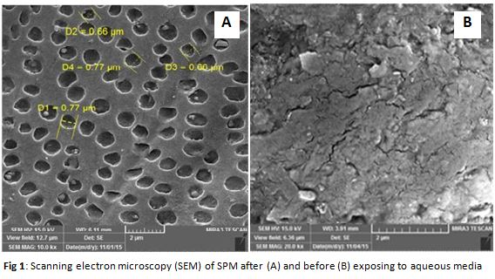
Recent publications
- R. Verma, B. Mishra, S. Garg, Drug Dev. Ind. Pharm. 26 (2000) 695–708.[3] R.K. Verma, D.M. Krishna, S. Garg, J. Controlled Release 79 (2002) 7–27.
- J. Shokri, M.H. Zarrintan, S. Ghanbarzadeh, Z. Arash, A. Farahani, K. Adibkia,Drug Res. 63 (2013) 414–419.
- F. Theeuwes, J. Pharm. Sci. 64 (1975) 1987–1991.
- J. Shokri, J. Hanaei, K. Adibkia, M.H. Zarrintan, M. Mehrpouya, Pharm. Sci. 1(2004) 75–86.
- H.P. Thakkar, N. Pancholi, C.V. Patel, AAPS PharmSciTech 17 (2015) 1–13.
- J. Shokri, P. Ahmadi, P. Rashidi, M. Shahsavari, A. Rajabi-Siahboomi, A.Nokhodchi, Eur. J. Pharm. Biopharm. 68 (2008) 289–297.
- A. Nokhodchi, M.N. Momin, J. Shokri, M. Shahsavari, P. Rashidi, Drug Deliv. 15(2008) 43–48.
- J. Shokri, K. Adibkia, Cellulose-Medical, Pharmaceutical and ElectronicApplications, in: Theo Van De Ven, Louis Godbout (Eds.), InTech, 2012.
- K. Adibkia, J. Hanaee, S. Ghanbarzadeh, R. Bahrami, J. Shokri, Drug Res. 64(2014) 203–237.


Biography
Javad Shokri has a PhD degree in Pharmaceutics from Tehran University of Medical Sciences (TUMS, 2001). He has published two scientific books and over 50 indexed research articles in novel drug delivery systems, Transdermal Drug delivery and cosmeticology. He acts as the Head of the Dermatology and Dermopharmacy Research Team (DDRT) at Tabriz University of Medical Sciences (2013-presnt) and editorial board of BioImpacts Journal. His present position is full professor in pharmaceutics department in Tabriz University of Medical Sciences (TUMS), Tabriz, Iran.
Email: shokri.j@gmail.com,

Notes/Comments:

