Webinar Submission - Janine Regan-Sinclair
Abstract: Post Traumatic Stress Disorder in the Military – A Different Approach.
Post-Traumatic Stress Disorder (PTSD) is a silent psychological wound and is a major problem for veterans and active servicemen and women alike. The sufferer battles with a sense of identity loss that can leave them angry, depressed, emotionally imbalanced and often empty inside. With an average of 20 veterans committing suicide daily, there is room for improvement in the way treatment is offered to them (Office of Public and Intergovernmental Affairs, 2016). In a digital world, we need to move with the times and offer digital therapy, so easy to access that victims need only pick up their cell phone to help themselves. Conventional treatment methods focus on the mind-body connection, which is only a part of the solution; a critical factor in healing PTSD is the damage caused to the human spirit or psyche, which is described in this paper as ‘soul fragmentation’. This is where the saying ‘beside myself’ comes from, as victims often feel a sense of disassociation or feeling like they are disorientated in some way even though they are still functioning; therefore a new approach needs to be taken if we are to recover the victim’s missing identity. This paper explains a new treatment for Post-Traumatic Stress Disorder and Traumatic Brain Injury, incorporating the new science on the block, ‘The Science of Consciousness’. The system includes a four-step Post-Traumatic Growth program that combines a combination of techniques, referred to as ‘Crystal Ki Healing’, the brainchild of Janine Regan-Sinclair – The Consciousness Architect. This article illustrates how a set of digital audio programs are a simple cost-effective solution and a 21st Century approach to treating Post-Traumatic Stress Disorder (PTSD) and Traumatic Brain Injury (TBI).
Recent Published Article: https://www.academia.edu/43109850/Healing_PTSD_and_TBI

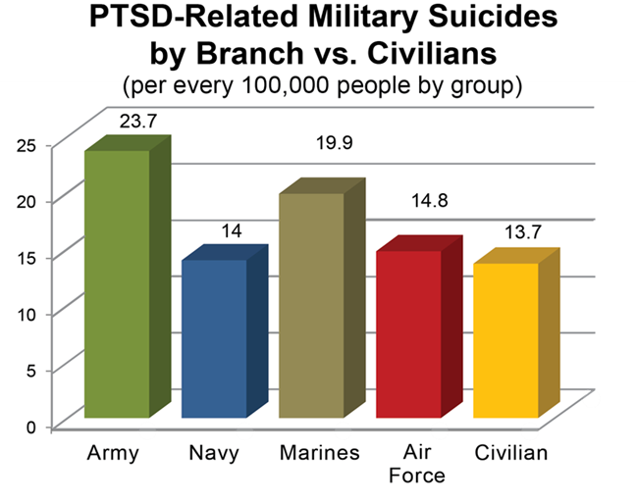
(“Worthy Warriors”, n.d.)
Bio:
Janine Regan-Sinclair, The Consciousness Architect is a certified Hypnotherapist & Counsellor, NLP Practitioner and Energy Healer. For almost 2 decades she has been a pioneer working to reprogram the consciousness of the DNA. She believes mental health issues in particular need her holistic approach in order to help people recover fully. She has worked with US military and civilians internationally regarding PTSD amongst other trauma issues. Her self-help digital audios have a significant impact on PTSD and Traumatic Brain Injury; as one of her audios repairs and rewires pathways In the brain. She is convinced that her brain repair audio would also help many brain issues such as Parkinson’s Disease, Dementia, Sports Injuries and CTE in footballers, if used after each game they play. Her testimonials speak for themselves.
Email: info@crystalki.com

