Why is Holistic Health so important for future?
Karuna Jain, MS (Physics), Certified Life Coach, Hypnotherapist, Energy Healer, USA.

Abstract (300 word limit)
Statement of Problem:. Nearly 70 percent of Americans are on at least one prescription drug, and more than half take two, Mayo Clinic and Olmsted Medical Center researchers say. Antibiotics, antidepressants and painkilling opioids are most commonly prescribed, their study found. Twenty percent of patients are on five or more prescription medications, according to the findings, published online in the journal Mayo Clinic Proceedings.These numbers are staggering. Our perspective on health is very limiting. The worldwide wellness industry is a $4.2 trillion market and rapidly growing. The future of health lies in becoming aware of health that takes into account body, mind and soul. We are not just flesh, bones, blood put in a body. We have emotions, thoughts, values, memories and more. These affect health. In a simple model, we can say we have four bodies, one seen and three unseen. These are physical body, emotional body, mental (thoughts) body, spiritual (values) body. All of these bodies have to be healthy for a person to enjoy good health. Stress, Pain, Depression some of the leading health issues are related to our thoughts, emotions and values. To get to the root cause you have to go beyond the physical body and look at the other bodies. Most disease first show up in the unseen bodies and when we ignore it, they manifest in the physical body. Learning to take care of all of your bodies will result in preventative care, focusing on health and wellness vs disease and sickness. One cannot rationalize emotions, thoughts. Hence different approaches are required to take care of these bodies. Great strides have been made in complementary therapies such as energy healing. In the talk today, I shall go into greater depth to gain a new perspective on health connecting findings from science and spirituality.

Image:
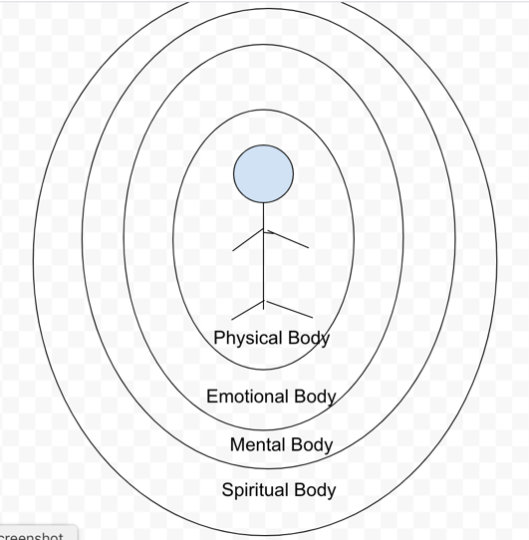

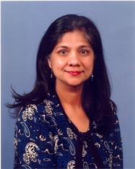 Biography (150 word limit)
Karuna Jain is certified Life Coach, Hypnotherapist, Energy Healer, Past Life Regression therapist based in California, USA. She has a Masters in Physics. She combines science and spirituality together in her work. She is a Holy Fire Usui Reiki Master, Advanced Pranic Healer and has her own very powerful healing modality called Compassion Healing. Besides sessions, she conducts classes in various topics. Her clients are around the world. She is into metaphysics, multi-dimensional realities, consciousness expansion, reincarnation, soul integration, meditation. She is very passionate about empowering people to take care of their own health. Teaching and sharing knowledge is her major life mission. Her emphasis is on healing mind and body through Universal Compassion. Her Mission: To assist her clients reach their goals in a loving, compassionate, non-judgmental environment using the best of eastern and western methods of natural mind body healing modalities.

http://www.karuna-healing.com, info@karuna-healing.com

