Multimorbidity and Polypharmacy; Current and future perspectives on the management of Polypharmacy by Fixed-dose Combination therapy

Alireza Nateghi Baygi, Pharm.D, Digestive Disease Research Institute, Iran
Helia Nateghi Baygi, Pharm.D, Eastern Mediterranean University, Cyprus

Abstract
Statement of the Problem: By empowerment of medical science, the mortality rate has been decreased significantly and population has aged. Therefore the co-existence of 2 or more chronic disease has become prevalence in this population. This condition can increase the complexity of therapeutic management for both health care professionals and patients. The use of multiple medications known as Polypharmacy is common in elderly population. For instance, one third of all deaths globally are as a result of cardiovascular disease. Lately, by increasing number and diversity of pharmacologic agents available, health care professionals have a lot of medications options, which can lead to Polypharmacy. Although Polypharmacy is inevitable in most common morbidity cases but it can increase the chance of drug-drug interactions, drug-disease interactions and medical costs. One potentional solution to manage this issue is the use of fixed‐dose combination (FDC) agents, in which two or more drugs are present in a single pill or capsule known as Pollypil.
Methodology & Theoretical Orientation: The study aimed to assess the effectiveness and safety of a four-component polypill including aspirin, atorvastatin, hydrochlorothiazide, and either enalapril or valsartan for primary and secondary prevention of cardiovascular disease. This study was a two-group, pragmatic, cluster-randomised trial nested within the Golestan Cohort Study (GCS), a cohort study with 50 045 participants aged 40–75 years from the Golestan province in Iran.s.
Findings: The PolyIran study showed that the use of polypill resulted in around a 40% reduction in the risk of major cardiovascular events in individuals without a history of cardiovascular disease (primary prevention) compared with 20% in those with previous cardiovascular diseases (secondary prevention).
Conclusion & Significance: Use of polypill was effective in preventing major cardiovascular events. Medication adherence was high and adverse event numbers were low. The polypill strategy could be considered as an additional effective component in controlling cardiovascular diseases, especially in LMICs

Image
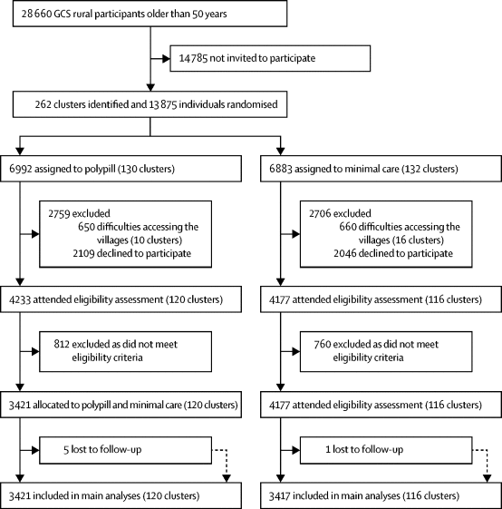
Figure 1. Trial Profile
Recent Publications (minimum 5)
- Roshandel G, Khoshnia M, Poustchi H, et al. Effectiveness of polypill for primary and secondary prevention of cardiovascular diseases (PolyIran): a pragmatic, cluster-randomised trial. Lancet. 2019;394:672-683.
- Patel AA, Huffman MD. Progressing polypills beyond concepts to outcomes. Lancet. 2019;394:617-
- Sanz G, Fuster V. Prevention: Polypills for cardiovascular prevention: a step forward? Nat Rev Cardiol. 2013 Dec;10(12):683-4. doi: 10.1038/nrcardio.2013.157. Epub 2013 Oct 8. PMID: 24101102.
- Chow CK, Meng Q. Polypills for primary prevention of cardiovascular disease. Nat Rev Cardiol. 2019 Oct;16(10):602-611. doi: 10.1038/s41569-019-0209-y. PMID: 31150009.

- Polypill for prevention of cardiovascular disease in an Urban Iranian population with special focus on nonalcoholic steatohepatitis: A pragmatic randomized controlled trial within a cohort (PolyIran - Liver) – Study protocolMerat, S., Poustchi, H., Hemming, K.,
(Nateghi, A.,(…)., Marshall, T., Malekzadeh, R. 2015 Archives of Iranian Medicine 18(8),pp. 515-523

Biography
Alireza Nateghi Baygi is a researcher in Digestive Disease Research Institute. His creative perspective in designing new drug developments such as new drug combinations or dosage forms for clinical trials leads to creation of PollyIran and SOVODAK. He is a CEO of knowledge based pharmaceutical company which is based on research and scientific methods and is in collaboration with research institutes.
Email: anateghi2002@gmail.com

Notes/Comments:

