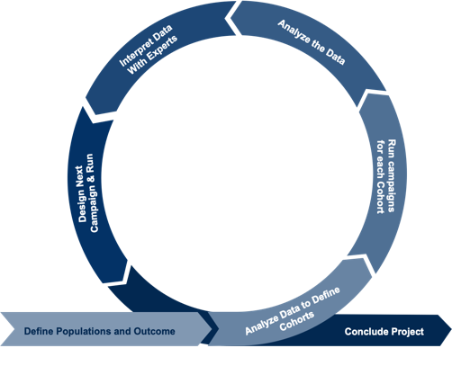
Intro: The efficiency and accuracy with which we can disseminate important information regarding the COVID-19 virus, public health measures, and the information on the vaccine became one of the focuses of healthcare systems during the height of the COVID-19 pandemic. After the vaccine rollout began, data began to emerge suggesting that there were disparities in vaccination rates among different communities. When we looked closer to home, we found similar significant disparities in vaccination rates among different communities within Sacramento. Understanding that widespread vaccination is one of the best public health measures we can take in reducing the burden of COVID 19 on our hospitals and communities, UC Davis Health wanted to ensure that we connected our patients to relevant and engaging vaccine information. We began investigating different ways that we could reach our patients and deliver vaccine information to them “meeting them where they are at” targeting a digital means of information delivery. Recent studies have shown that text message nudges with messaging specific to ownership over both the COVID-19 and flu vaccine increased vaccination rates and appointment attendance rates. From this we understood that not only was the appointment reminder important but these studies demonstrated the vast difference in efficacy of different message wording (Milkman et al. #)(Dai et al. #). Interesting to us was that these studies used broad messaging that was uniform to all recipients and was not tailored in any way to those who were receiving the text message pushes. An additional study has also shown that when patients identified in an EMR system as being at high risk for cardiovascular disease (CVD) were sent handwritten letters from their providers encouraging them to schedule appointments to discuss their CVD risk, this personalized messaging effort resulted in a two fold increase in the number of CVD at risk patients who were started on a lipid lowering agent. This demonstrated that patient tailored messaging significantly increases the desired outcome. (Aral)

Here we aimed to first identify populations within the Sacramento community that were vaccine hesitant and had vaccination rates under 50%. We did this through an integration built between the UC Davis EMR and the California Vaccine Registry System, CAIRS. This allowed us to securely identify patients within the UC Davis EMR who were unvaccinated. We then consulted with community advocates, public health experts, physicians, and community members to create messaging trees that were specific to those populations. The messages were first tested in focus groups representative of the members of the population to receive specific messaging and then revised multiple times before roll out. The messaging trees were extensive and interactive, allowing patients to receive information if requested, be directed to websites with videos and educational information delivered in their primary language, and be offered the opportunity to connect with the vaccine appointment system at UC Davis health should they decide they wanted to schedule an appointment. Subsequently, we wanted to test if this EMR data driven patient tailored messaging would increase vaccination rates and information disbursement to our more vaccine hesitant and vulnerable communities in Sacramento.

Methods: UC Davis Health IT engineers built integrations between the California CAIR system and the UC Davis EMR to identify patients that are unvaccinated and which demographic group these individuals belong to. Patients are confidentially contacted via automated chatbots either through text or portal that choose which messaging a patient receives based on which demographics they identify with. For example, a young pregnant person would receive messaging surrounding the safety of the COVID-19 vaccine for young individuals of reproductive age. We then began to look at those in the EMR who had been vaccinated but not yet received their booster and designed messaging tailored to this population to encourage them to make a booster appointment. We used A/B testing to revise the messaging to each population, improving the message trees each time to achieve the desired outcome of increased vaccination.

Results: We are currently running the campaigns and expect that the results will show an improvement in the desired outcome, vaccination or booster, with each iteration of the campaign.
- Will evaluate the success of each message tree
- Will amend the messages for the next campaign to include only the messages that had the highest success rate.
- Will then run the campaign again with a different cohort of patients from the same subgroup

Conclusions: Leveraging EMR data to drive demographic-specific educational messaging has the power to connect communities with relevant information surrounding public health initiatives, in this case COVID-19 vaccination, and can be used in the future to drive messaging for initiatives such as providing education to patients identified to have hypertension or type 2 diabetes to increase health compliance and overall patient well-being.

References

Aral, Sinan. “Op-Ed: Emphasize vaccine acceptance, not hesitancy.” Los Angeles Times, 23 February 2021, https://www.latimes.com/opinion/story/2021-02-23/vaccine-hesitancy-public-health-message. Accessed 1 February 2022.
Dai, Hengchen, et al. “Behavioral Nudges Increase COVID-19 Vaccinations.” Nature, vol. 10, no. 1038, 2021, p. 8. Naturehttps://www.nature.com/articles/s41586-021-03843-2_reference.pdf.
Milkman, Katherine L., et al. “A megastudy of text-based nudges encouraging patients to get vaccinated at an upcoming doctor’s appointment.” PNAS, vol. 20, no. 118, 2021, p. 20, https://www.pnas.org/content/118/20/e2101165118.

