Transarterial Chemoembolization in Patients with Hepatocellular

Carcinoma: Study of Different Outcomes and Their Predictive Factors

Mahmoud Elkadeem. PhD Department of Tropical Medicine, Tanta University, Tanta, Egypt.

Abstract
Background: Hepatocellular carcioma is one of the leading causes of cancer deaths worldwide. Transarterial chemoembolization (TACE) is a standard therapy for intermediate stage of liver cancer. However, It may have a risk of mortality and morbidity. Many factors other than radiological response determine TACE outcomes.
Aim: To analyze the outcomes after transarterial chemoembolizaton (TACE) including radiological response and liver decompensation, and their predictive factors.
Methods: Sixty two hepatocellular carcinoma patients underwent transarterial chemoembolizaton. Laboratory data, tumor criteria, and Child-Pugh score were recorded baseline and at one month post-procedure. Tumor response according to Modified Response Evaluation Criteria in Solid Tumors was evaluated.
Results: Twenty five patients (40.3%) showed complete response, 15 patients (24.2 %) showed partial response, 2 patients (3.2%) showed stable disease, and 20 patients (32.3%) showed progressive disease. Significant difference was detected in patients with different radiological responses as regards tumor criteria (size, invasion of portal vein, Barcelona Clinic Liver Cancer stage), and technique of TACE. Thirty six patients (58%) had liver decompensation after TACE. Tumor criteria, serum bilirubin, AST, INR, Model for End Stage Liver Disease, and low platelet count were detected to be predictors of as radiological response and liver decompensation after TACE.
Conclusion: Radiological response cannot be considered alone to determine the outcomes after transarterial chemoembolization. Also, tumor criteria, liver functions, and platelet count are predictors of the outcome.
Keywords: Hepatocellular carcinoma, Modified Response Evaluation Criteria in Solid Tumors Transarterial chemoembolization.

Image
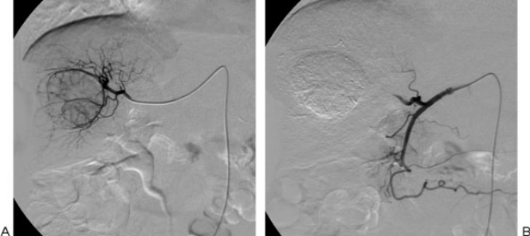

Conventional transcatheter arterial chemoembolization. (A) Following superselective catheterization of the hepatic arterial branch feeding the tumor, doxorubicin-in-oil emulsion is administered, followed by gelatin sponge particles. (B) Angiographic image obtained after the procedure shows absence of residual tumor vascularity
Recent Publications
[1] Omata M, Lesmana L A, Tateishi R, Chen PJ, Lin SM, Yoshida H, et al (2010): Asian Pacific Association for the Study of the Liver consensus recommendations on hepatocellular carcinoma. Hepatol Int; 4 (2): 439-474.
[2] Raoul JL, Sangro B, Forner A, Mazzaferro V, Piscaglia F, Bolondi L, et al (2011): Evolving strategies for the management of Intermediate-stage hepatocellular carcinoma: available evidence and expert opinion on the use of trans-arterial chemoembolization. Cancer Treatment Reviews; 37 (3): 212-220.
[3] Garwood ER, Fidelman N, Hoch SE, Jr. Kerlan RK, and Yao FY (2013): Morbidity and mortality following transarterial liver chemoembolization in patients with hepatocellular carcinoma and synthetic hepatic dysfunction. Liver Transplantation; 19 (2): 164-173
[4] Chan AO, Yuen MF, Hui CK, Tso WK, and Lai CL (2002): A prospective study regarding the complications of transcatheter intraarterial lipiodol chemoembolization in patients with hepatocellular carcinoma. Cancer; 94 (6): 1747-1752.
[5] Vogl TJ, Naguib NN, Nour-Eldin NE, Rao P, Emami AH, Zangos S, et al (2009): Review on transarterial chemoembolization in hepatocellular carcinoma: palliative,combined, neoadjuvant, bridging, and symptomatic indications. Eur J Radiol; 72 (3): 505-516.

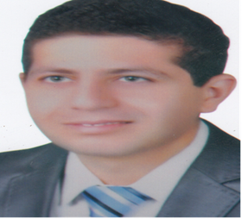
Biography:
Mahmoud Elkadeem. Lecturer of Tropical Medicine & Infectious Diseases, Faculty of Medicine, Tanta University, Tanta, Egypt since 30/4/2017. Birth date 21/11/1984. Married. Egyptian. M.B.,B.Ch.B: November 2007, Excellent With Honor Degree. Master: of Tropical Medicine & Hygiene, 11/7/2012. Very good. Ph.D.: of Tropical Medicine & Hygiene, 26/3/2017. Has experience in the field of gastroenterology and hepatology. Tel: +20-1123657915
Email:mahmoud.elkadeem@med.tanta.edu.eg

