Angiogenin promotes colorectal cancer metastasis via tiRNA production
Muxiong Chen^{1,#}, Siqi Li^{1,#}, Xiaoliang Shi^{1,#}, Ningqin Xu⁵, Desen Sun¹, Rongpan Bai¹, Haiyan Chen⁴, Kefeng Ding⁴, Jinghao Sheng^{1,2,3,*}, and Zhengping Xu^{1,2,3,*}
1. Institute of Environmental Medicine, and Cancer Center of the First Affiliated Hospital, Zhejiang University School of Medicine, Hangzhou, 310058, China;
2. Collaborative Innovation Center for Diagnosis and Treatment of Infectious Diseases, Zhejiang University, Hangzhou, 310003, China;
3. Program in Molecular and Cellular Biology, Zhejiang University School of Medicine, Hangzhou, 310058, China;
4. Department of Surgical Oncology, the Second Affiliated Hospital of Zhejiang University School of Medicine, Hangzhou, 310058, China;
5. Clinical Medicine Class 2017-03, Karamay College of Xinjiang Medical University, Karamay, 830011, China.
# This authors contributed equally to this work
* Correspondence to Dr. Zhengping Xu: zpxu@zju.edu.cn; Tel.: +86-571-88208008; and Dr. Jinghao Sheng: jhsheng@zju.edu.cn; Tel.: +86-571-88208164.

Abstract (300 word limit)
Colorectal cancer (CRC) is one of the most common malignancies worldwide, as well as a major cause of cancer-related deaths. Despite considerable improvement in the therapeutic modalities, over 50% of CRC patients eventually developed recurrent disease and metastasis leading to death within 5 years of diagnosis. To date, the mechanisms that cause CRC metastasis are not fully understood. Angiogenin (ANG), a member of the ribonuclease A superfamily, not only activates endothelial cells to induce tumor angiogenesis, but also targets tumor cells to promote cell survival, proliferation, and/or migration. However, its clinical significance and underlying mechanism in CRC metastasis are still largely unknown. Here, we found that both RNA and protein levels of ANG were upregulated in CRC tissues. Statistical analysis indicated that higher ANG expression was strongly associated with metastasis in CRC patients. We then revealed that ANG enhanced CRC growth and metastasis both in in vitro and in vivo systems. Intriguingly, the ANG rescue assay suggested that its ribonucleolytic activity was crucial in promoting CRC metastasis. Indeed, a bunch of tRNA-derived stress-induced small RNAs (tiRNAs), produced through ANG cleavage, was enriched in both CRC tumor tissues and highly metastatic cells. Further studies confirmed that these tiRNAs promoted CRC cell migration and invasion and functioned in ANG-promoted CRC metastasis. Moreover, higher serum 5'-tiRNA-Val level was observed in CRC patients and was correlated with the serum ANG level. Taken together, we propose that a novel ANG-tiRNAs-cell migration and invasion regulatory axis promotes CRC metastasis, which might be of potential for developing new measures for CRC diagnosis, prognosis, and treatment.

Image
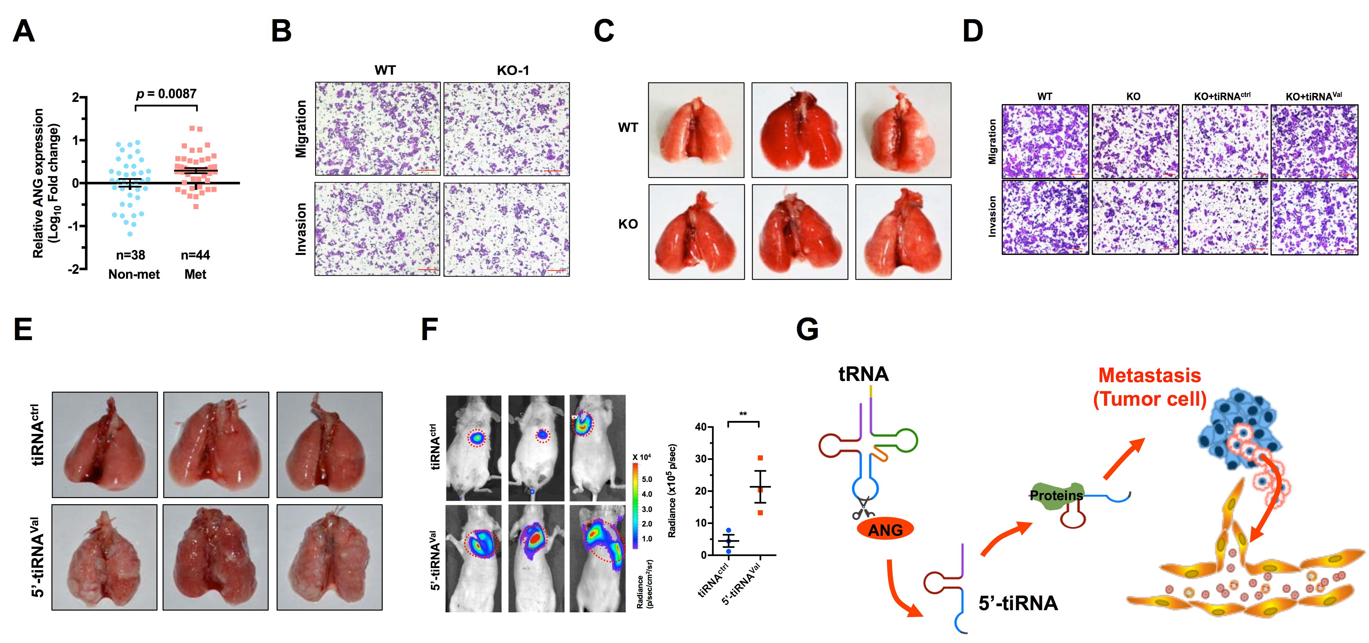
Figure. 1 ANG is associated with CRC metastasis (A), and promotes CRC cell migration and invasion in vivo (B) and in vitro (C). ANG-cleavage specific tiRNA (5'-tiRNA-Val) can rescued the impaired cell migration and invasion of the ANG KO cell in vitro (D), as well as increased metastatic colonization in vivo (E and F).
Recent Publications (minimum 5)
1. Arnold, M., et al., Global patterns and trends in colorectal cancer incidence and mortality. Gut, 2017. 66(4): p. 683-691.
2. Atreya, C.E., R. Yaeger, and E. Chu, Systemic Therapy for Metastatic Colorectal Cancer: From Current Standards to Future Molecular Targeted Approaches. Am Soc Clin Oncol Educ Book, 2017. 37: p. 246-256.
3. Etoh, T., et al., Angiogenin expression in human colorectal cancer: the role of focal macrophage infiltration. Clin Cancer Res, 2000. 6(9): p. 3545-51.
4. Ivanov, P., et al., Angiogenin-induced tRNA fragments inhibit translation initiation. Mol Cell, 2011. 43(4): p. 613-23.
5. Sheng, J. and Z. Xu, Three decades of research on angiogenin: a review and perspective. Acta Biochim Biophys Sin (Shanghai), 2016. 48(5): p. 399-410.

 Biography (150 word limit)
Muxiong Chen, Ph.D student, biochemistry and molecular biology, Zhejiang University School of Medicine. Muxiong focuses on the new functions and mechanisms of angiogenin, a tumorigenesis and angiogenesis factor. He is now interested in the roles of angiogenin in the colorectal cancer metastasis.
Email: mxchen92@163.com

Notes/Comments:

