Macrophage-derived angiogenin maintains epithelial barrier integrity to prevent colitis
Desen Sun¹, Rongpan Bai^{1,2}, Wei Zhou³, Muxiong Chen¹, Xiaoliang Shi¹, Liang Luo⁴, Zhengrong Yao¹, Xiangwei Gao¹, Guo-fu Hu⁵, Jinghao Sheng^{1,2,6}, Zhengping Xu^{1,2,6}
¹Institute of Environmental Medicine, and Cancer Center of the First Affiliated Hospital, Zhejiang University School of Medicine, Hangzhou, 310058, China;
²Collaborative Innovation Center for Diagnosis and Treatment of Infectious Diseases, Zhejiang University, Hangzhou, 310003, China.
³Department of General Surgery, Sir Run Run Shaw Hospital, Zhejiang University School of Medicine, Hangzhou, 310058, China.
⁴Department of Gastroenterology, Sir Run Run Shaw Hospital, Zhejiang University School of Medicine, Hangzhou, 310058, China.
⁵Molecular Oncology Research Institute, Tufts Medical Center, Boston, 02111, USA.
⁶Program in Molecular and Cellular Biology, Zhejiang University School of Medicine, Hangzhou, 310058, China

Abstract (300 word limit)
Statement of the Problem: Communications between macrophages and epithelium play critical roles in maintaining epithelial barrier integrity. Macrophages orchestrate intestinal epithelial cell (IEC) homeostasis by producing various mediators. Current challenges faced in inflammatory bowel disease (IBD) treatment suggest the existence of new mediators. Angiogenin (ANG) is a secreted ribonuclease and participates in cell-cell crosstalk and promote cell growth and survival. We aimed to determine the protective role of macrophage-derived ANG in IBD.
Methodology & Theoretical Orientation: We characterized ANG expression in IBD patients and in dextran sodium sulfate (DSS)-induced colitis mice. The functional role of ANG in intestinal inflammation was addressed in the experimental colitis model with wild-type, Ang-deficient or bone marrow reconstituted mice. The underlying mechanism was investigated at animal and cellular levels by administrating ANG protein and its enzymatic or receptor-binding site variant, by blocking its interaction with receptor plexin B2 (PLXNB2) or by knocking down PLXNB2.
Findings: Expression of ANG was significantly down-regulated in IBD patients and in colitis mice. Functional studies showed that deficiency of Ang in myeloid cells caused high susceptibility to DSS-induced experimental colitis and impaired epithelial barrier integrity. Mechanistically, macrophage-derived ANG promoted IEC survival and proliferation through Plxnb2-mediated tRNA-derived stress-induced small RNA (tiRNA) production, and ribosomal RNA (rRNA) transcription, respectively. Importantly, treatment with recombinant ANG significantly attenuated the severity of mouse experimental colitis.
Conclusion & Significance: We have, for the first time, identified macrophage-derived ANG as a contributor in maintaining epithelial barrier integrity during intestinal inflammation, suggesting that ANG may serve as a new preventive or therapeutic target for IBD.
Image
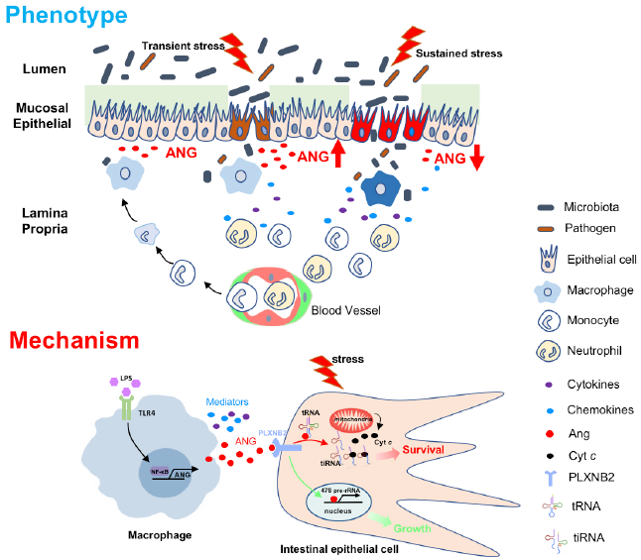
Recent Publications (minimum 5)
- Grainger JR, Konkel JE, Zangerle-Murray T, et al. Macrophages in gastrointestinal homeostasis and inflammation. Pflugers Arch 2017;469(3-4):527-39.
- Luissint AC, Parkos CA, Nusrat A. Inflammation and the Intestinal Barrier: Leukocyte-Epithelial Cell Interactions, Cell Junction Remodeling, and Mucosal Repair. Gastroenterology 2016;151(4):616-32.
- Sheng J, Yu W, Gao X, et al. Angiogenin stimulates ribosomal RNA transcription by epigenetic activation of the ribosomal DNA promoter. J Cell Physiol 2014;229(4):521-9.
- Ivanov P, Emara MM, Villen J, et al. Angiogenin-induced tRNA fragments inhibit translation initiation. Mol Cell 2011;43(4):613-235.
- Yu W, Goncalves KA, Li S, et al. Plexin-B2 Mediates Physiologic and Pathologic Functions of Angiogenin. Cell 2017;171(4):849-64 e25.

 Biography (150 word limit)
Desen Sun, Ph.D student, biochemistry and molecular biology, Zhejiang University School of Medicine. Desen focuses on using the molecular and cellular tools and experimental animal models to study the pathogenesis of intestinal diseases. He is also interested in the roles of antibacterial peptides in maintaining the intestinal microbiota and protect against inflammatory bowel disease.
Email: sdscm2510@zju.edu.cn

Notes/Comments:

