Effect of Fermentation Time and Mixture Ratio on Improving the Nutritional Quality of Shameta: A Traditional Cereal-Based Fermented Porridge to Enhance Nutritional Status of Lactating Mothers
Daniel A. Kitessa^{1,3}, Ketema Bacha², Yetenayet B. Tola³, Mary Murimi⁴
¹Department of Food Science and Nutrition, Wollega University, Shambu Campus, P.O. Box: 38 Shambu, Email: daniasfaw10@gmail.com
²Department of Biology, College of Natural Science, Jimma University, P.O. Box: 378
Email: ketemabacha2002@yahoo.com
³Department of Postharvest Management, College of Agriculture and Veterinary Medicine, Jimma University, P.O. Box: 307, Jimma, Email: yetenayet@gmail.com; yetenayet.bekele@ju.edu.et;
⁴Department of Nutritional Sciences, College of Human Science, Texas Tech University, and P.O. Box: 41270 Texas, Email: Mary.Murimi@ttu.edu
Abstract
Women’s nutritional status during pregnancy and breastfeeding is not only critical for her health and sustainability of future generations. The studies showed that Ethiopia is one of the countries with highest level of lactating mother’s malnourishment in sub-Saharan Africa. Therefore, the aim of this study is to determine the effect of fermentation time and mixture ratio on improving the nutritional quality of Shameta in order to enhance nutritional status of lactating mothers. Completely randomized design (CRD) with a 3×4 factorial experiment with three replication was implemented. Results showed that the mixture ratio affect the pH, titratable acidity, proximate compositions, minerals content, anti-nutritional factors and antioxidant activity of porridge (unfermented Shameta). Except fiber contents, all proximate compositions, minerals content and antioxidant activity increased through fermentation time, however phytate and tannin decreased by 70.83 and 77.17%, respectively. Present finding revealed that the highest crude protein was observed in Maize-Barley-Faba bean with ratio of 90:10:15 fermented for 12 days (16.56 g/100g), while the highest crude fat (13.23 g/100g) were found in Maize-Barley-Faba bean with ratio of 90:5:5 fermented for the same days. The highest minerals content were observed in Maize-Barley-Faba bean with ratio of 90:10:15 fermented for 12 days, while the lowest phytate and tannin were observed in Maize-Barley-Faba bean with ratio of 90:5:5 fermented for the same days. Present finding confirmed that composite Shameta made of Maize-Barley-Faba bean with ratio of 90:10:15 fermented for 8, 10 and 12 days improved the crude protein and mineral contents with low anti-nutritional factors and good antioxidant activities. Therefore, lactating mothers should composite locally available cereals and legumes to nourish improved protein and minerals. However, researchers can be improved beyond this finding through blending ratios and fermentation conditions with appropriate starter culture.
Key words: Fermentation time, Lactating mothers, Mixture ratio, Shameta
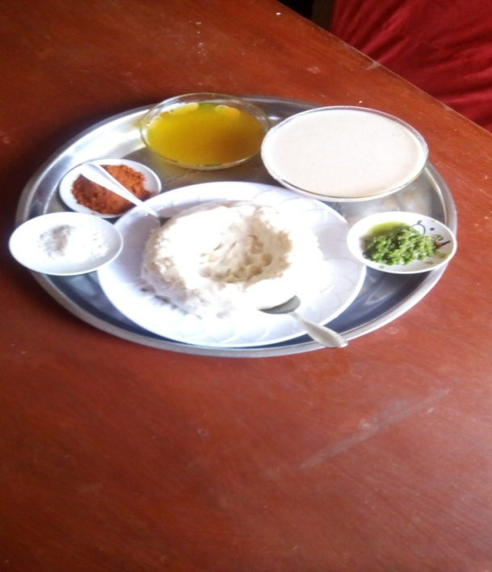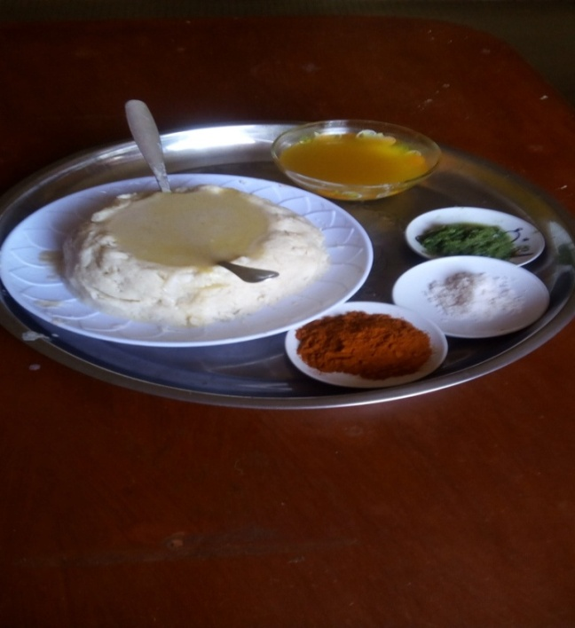
B
A

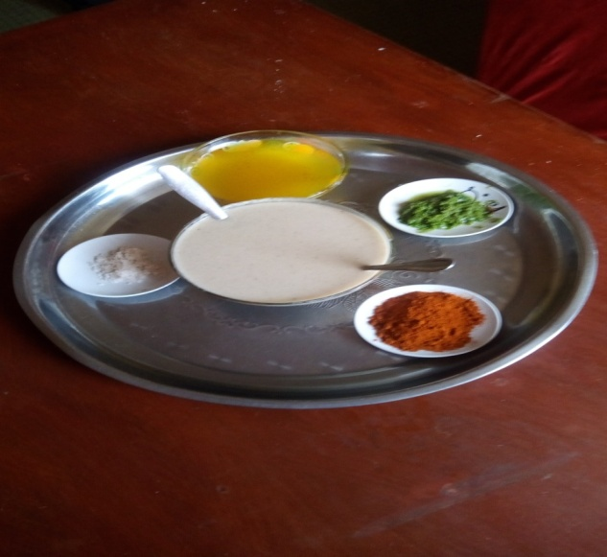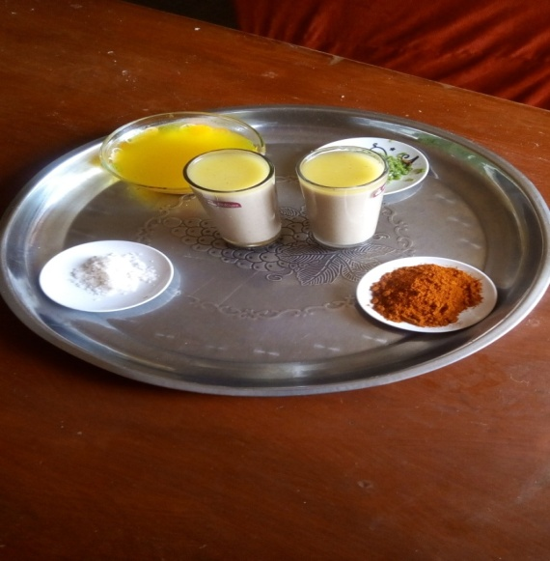
D
C
Figure 1. Serving types of Shameta: A and B showed that as stew with fresh porridge (the most common one), C and D showed that as a form of porridge and gruel, respectively.
References
- Alemayehu, M., Argaw, A., & Mariam, A. G. (2015). Factors Associated With Malnutrition Among Lactating Women In Subsistence Farming Households From Dedo and Seqa-Chekorsa Districts, Jimma Zone, 2014. Developing Country Studies, 5(21):117-118
- CARE. (2016). Emergency Nutritional Assistance. Addis Ababa, Ethiopia, CARE International.
- Blandino, A. - Al-Aseeri, M. E. - Pandiella, S. S. - Cantero, D. - Webb, C., 2003. Cereal-based fermented foods and beverages. Food Research International, 36, 527-543.
- Jouanne, M.; Oddoux, S.; Noël, A.; Voisin-Chiret, A.S., 2021 Nutrient Requirements during Pregnancy and Lactation. Nutrients, 13, 692. https://doi.org/10.3390/nu13020692
- Kejela, G., Gebremeskel, F., Hassen, H., Shewangizaw, M., &Desalegn, M. (2020) Under Nutrition and associated factors among lactating mothers in Southern Ethiopia: Institution Based Cross-sectional study.
Biography
Daniel Asfaw Kitessa is lecture at Wollega University in department of Food Science and Nutrition. He specialize his MSc. degree in Food Science and Technology at Haramaya University. Now time he is doing his PhD at Jimma University in Food Science and Technology. His future research interest is food fermentation/biotechnology, food safety, improving nutritional composition of food products for pregnant, lactating mothers, infants and children, especially through fermentation and formulations using locally available raw materials.

