Anthropometric parameters regarding the Nutritional
Status of schoolchildren
Sierra-Carrero LL, MD, Universidad del Norte, Colombia
Carrero-Gonzalez CM, PhD, Universidad Simón Bolívar, Colombia

Abstract

Objective. This study assesses the anthropometric parameters concerning the nutritional status of and establishes the prevalence of excessive weight, obesity, and malnutrition among schoolchildren in an educational institution on Colombia’s northern coast.

Materials and methods. A quantitative correlational research was conducted. The sample included 556 children aged between 6 and 11 years (310 boys and 246 girls). Their weight, height, BMI, and nutritional status were evaluated, and the BMI/age variable (Z-score) was studied to determine the nutritional categories of underweight, normal, and excess weight (overweight and obese) through a descriptive analysis and analysis of variance (ANOVA) using an unbalanced factorial design.

Results. Thinness and obesity cases were reported, with 21.43% (119/556) of the students experiencing some kind of nutritional disorder. Although no statistically significant differences were observed between the gender factor levels, ANOVA showed that male students tend to move farther from the expectedZ-scores.

Conclusion: The average Z-score of young students is usually closer to the expected score, whereas that of older students is farthest from expectation, in addition to showing greater variability between measures.
Image
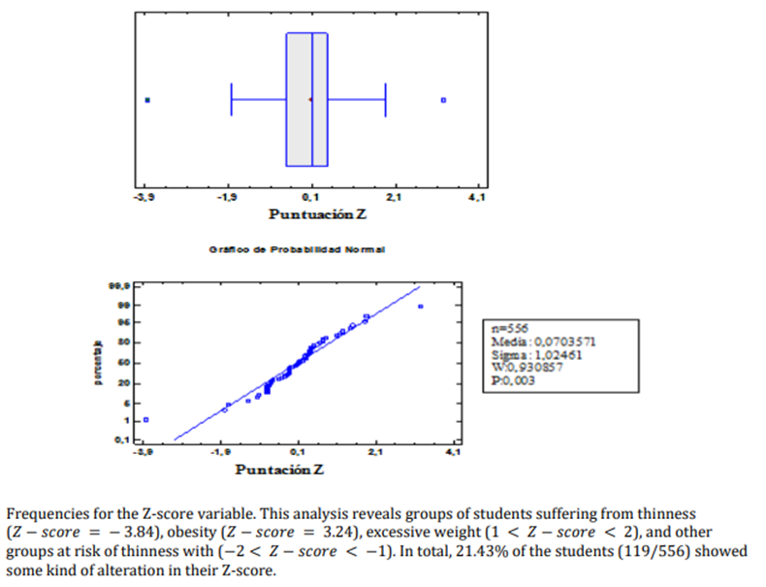
Recent Publications (minimum 5)
- Sierra Carrero LL, Carrero CM, Martínez JC, Orostegui MA, Montenegro C, Navarro EA, Pájaro MC, Prada SJ (2021) Overweight or Obesity: Serum Lipids in a University Population of Barranquilla Colombia. EEO. 20(4): 105-119.
- Martinez J, Pulido A, Maury S, Carrero CM, Orostegui MA, Pájaro MC, Sierra Carrero LL, Marín J, Prada SJ, Plaza K, Segura S (2021) Anthropometric Parameters regarding the Nutritional Status of Schoolchildren. EEO. 20(4): 882-891
- Carrero CM, Lastre-Amell G, Martínez J, Duncan K, Bolaño NE, Reales LC, González LF, Oróstegui MA, Sierra Carrero LL, Prada SJ, Pájaro MC. Overweight in schoolchildren and nutrient intake. EEO. 2021; 20(4): 91-104.
- Carrero CM, Navarro EA, Lastre-Amell G, Oróstegui MA, González GE, Sucerquia A, Sierra Carrero LL (2020). Dyslipidemia as a cardiovascular risk factor: use of probiotics in nutritional therapeutics. Archivos Venezolanos de Farmacología y Terapéutica 2020 Feb; 39(1): 126-1395.
- Carrero CM, Leal J, Ortega P, Parody A, Montilla M, Sierra Carrero LL, Viloria A, Borrero T, Varela N (2018) Effect of Vitamin A, Zinc and Multivitamin Supplementation on the Nutritional Status and Retinol Serum Values in School-Age Children Springer International Publishing. 2018; 748 –758

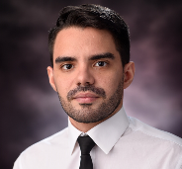Biography (150 word limit)
Leandro Luis Sierra Carrero is a medical doctor who has all his expertise focused on the development of a program of malnutrition recovery in non-developed countries. His investigation group is one of the better established in the northern region of Colombia, where malnourishment is the biggest concern of the country, with research and evaluation of the population, the cause has been discovered, a model has been generated and a greater future is destined for new generations. This approach would help the world see how children are growing in underdeveloped countries, and take a new perspective about nutrition and nourishment methods.
Email: lcarrero@uninorte.edu.co

Notes/Comments:

I will be waiting for your response. Thank you.

