

Abstract Template

Title: Using Artificial Intelligence and Machine Learning to predict glucose levels for managing Diabetes in Humans

- Abstract Body (up to 250 words)
Humans suffering with Diabetes should monitor their blood glucose levels every often and have their insulin doses adjusted to keep blood glucose levels to normalized quantities. In case of deviations, patient may suffer consequences in the form of complications to other bodily organs.

Predictive models that can automatically warn patients of future changes to glucose levels in the blood will immensely help them take corrective actions and prevent a risky increase. This paper presents a scientific proposition using a common physiological model of glucose dynamics to create informational artifacts for a regression model that is modeled on specific patient information. This model uses concepts from machine learning and artificial intelligence to outperform clinical experts at predicting glucose levels and can be utilized to predict nearly 25% of hypoglycemic occurrences fifteen minutes early. Although this precision rate is 63% currently, most false positives in hypoglycemic and nearby regions are therefore for patients responding to these hypoglycemia alerts, and would not be adversely affected by the preventative act.

Image:
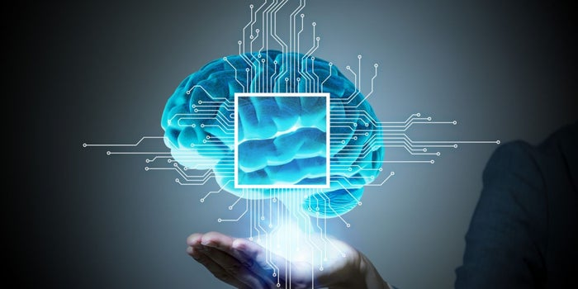

Biography (Up to 100 words)
Anuj Mathur has completed his PhD at the age of 42 years from Ohio University, USA, and is involved in leading pioneering research in the area of artificial intelligence and its applicability to clinical studies, with a focus on Diabetes.

Presenting author details

Full Name: Anuj Mathur
Email:anujm2000@gmail.com
Category: Oral Presenter
Passport Number: M9215821



