

Abstract Template

Title: Current Ideas in diabetes after 100 years of insulin discovery: Irisin as a promising target molecule in diabetes metabolism.

Radha Shantaram Bane1, Manjula Mathur2
1Department of Information Technology, Bhartiya Vidya Bhavan’s College, Mumbai, India
2Molecular Biology Division, Bhabha Atomic Research Center, Mumbai, India

- Abstract Body (up to 250 words)
Insulin discovery formed the base of classical thinking of diabetes treatment mechanism. The classical model divides diabetes into two types IDDM (Insulin Dependent Diabetes Mellitus) and NIDDM (Non-Insulin Dependent Diabetes Mellitus). As a result, clinical practices in diabetes became insulin centric and focused on quantitatively controlling the blood glucose levels by medications. However, research advances in last few decades in fields like molecular biology, genomics, proteomics, immunology, endocrinology and systems biology generated new knowledge in Life Sciences. The new advances in systems biology and pathways analysis are indicating the presence of other factors which could be new targets for diabetes treatment. These players not only contribute to the treatment of diabetes but also makes way for its reversibility through neuro-endocrine pathways. Computational Biology helps us to carry out the in-silico studies of these factors which further helps in the drug discovery process. One of the key molecules in this pathway is myokine called irisin. Through computation we have made an attempt of basic scientific study of the role of irisin in diabetes.

Biography (Up to 100 words)
Radha S Bane is working as an Assistant Professor of Information Technology in Bhartiya Vidya Bhavan’s College, Mumbai pursuing her PhD at the age of 34years from JJT University, Churu, India.
Manjula Mathur is completed her PhD from Homo Bhabha National Institute, Mumbai. She was a Scientific Officer in the Molecular Biology Division of BARC, Mumbai. She is 63 years old and published more than 15 papers in reputed journals and worked in different fields

Presenting author details
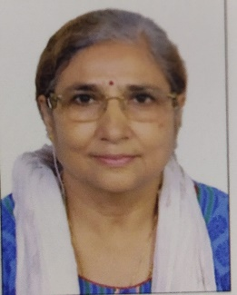
Full Name: Manjula Mathur Contact number: +919833871749 Twitter account: Linked In account: https://in.linkedin.com/in/manjulamathur
Session name/ number:
Category: Oral presentation
Passport Number: L6121112



