Cardiovascular and renal protective effects of sodium-glucose cotransporter 2 inhibitors
Hidekatsu Yanai, MD, PhD, National Center for Global Health and Medicine Kohnodai Hospital, JAPAN

Abstract (300 word limit)

The sodium-glucose cotransporter 2 inhibitors (SGLT2i), suppress renal tubular glucose reabsorption and reduce plasma glucose, in an insulin-independent manner.¹ For the treatment of diabetes, in addition to glucose control, the management of coronary risk factors is crucial. First, I systematically reviewed published articles about the possible anti-atherosclerotic effects beyond glucose lowering of SGLT2i, and found that SGLT2i are proved to be significantly associated with weight loss and reduction of blood pressure by a relatively large number of studies.² Second, we retrospectively picked up patients who had been continuously prescribed SGLT2i by a chart-based analysis, and compared the data before the SGLT2i treatment with the data at 1, 2, 3 and 6 months after the SGLT2i treatment started, and found that SGLT2i significantly reduced HbA1c and body weight and improved liver function.³ Further, I found a significant difference in hypoglycemic effect between canagliflozin with a low potency to inhibit SGLT1 and tofogliflozin which is a highly selective SGLT2 inhibitor.⁴ As the key to resolve this issue, a different distribution between SGLT1 (intestine) and SGLT2 (kidney) came to my mind. SGLT2i with potency to inhibit SGLT1 may be more effective to lower glucose as compared with highly selective SGLT2i, in patients with renal insufficiency. To understand an influence of the estimated glomerular filtration rate (eGFR) on improvement in metabolic parameters by SGLT2i, we sub-analyzed our study and discovered that body weight decreased by SGLT2i, independently of eGFR, however, the changes in HbA1c and liver function depended on eGFR.⁵ Recently, Sano reported that elevation of hematocrit by SGLT2i may be a surrogate marker for recovery from reversible tubulointerstitial injury,⁶ which made me found out that elevated erythropoietin may be one of renal protective effects of SGLT2i.⁷

Image
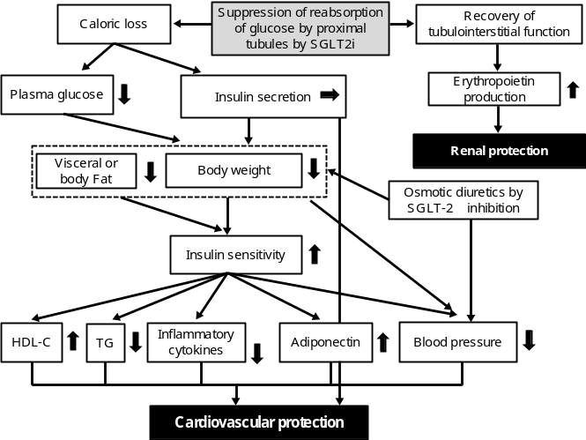
Figure 1. Cardiovascular and renal protective effects of SGLT2i
Recent Publications (minimum 5)
- Jabbour SA, Goldstein BJ (2008) Sodium glucose co-transporter 2 inhibitors: blocking renal tubular reabsorption of glucose to improve glycaemic control in patients with diabetes. Int J Clin Pract 62: 1279–1284.
- Yanai H, Katsuyama H, Hamasaki H, Adachi H, Moriyama S, Yoshikawa R, Sako A (2016) Sodium-Glucose Cotransporter 2 Inhibitors: Possible Anti-Atherosclerotic Effects Beyond Glucose Lowering. J Clin Med Res 8: 10-14.
- Katsuyama H, Hamasaki H, Adachi H, Moriyama S, Kawaguchi A, Sako A, Mishima S, Yanai H (2016) Effects of Sodium-Glucose Cotransporter 2 Inhibitors on Metabolic Parameters in Patients With Type 2 Diabetes: A Chart-Based Analysis. J Clin Med Res 8: 237-243.
- Yanai H (2015) A Significance of Sodium-Glucose Cotransporter 1 (SGLT1) Inhibition by SGLT2 Inhibitors. Int J Diabetes Clin Diagn 1:102.
- Katsuyama H, Yanai H (2016) An Influence of the Estimated Glomerular Filtration Rate on Improvement in Metabolic Parameters by Sodium-Glucose Cotransporter 2 Inhibitors. J Clin Med Res. 8: 486-488.
- Sano M, Takei M, Shiraishi Y, Suzuki Y (2016) Increased Hematocrit During Sodium-Glucose Cotransporter 2 Inhibitor Therapy Indicates Recovery of Tubulointerstitial Function in Diabetic Kidneys. J Clin Med Res 8: 844-847.
- Yanai H, Katsuyama H (2017) A Possible Mechanism for Renoprotective Effect of Sodium-Glucose Cotransporter 2 Inhibitor: Elevation of Erythropoietin Production. J Clin Med Res 9: 178-179.

Biography (150 word limit)
Hidekatsu Yanai, MD, PhD, Fellow of American College of Physicians (FACP), is the Director of the Department of Internal Medicine and Clinical Research and Trial Center, National Center for Global Health and Medicine Kohnodai Hospital, Japan. He obtained his MD and PhD degrees in National Defense Medical College and Hokkaido University School of Medicine, respectively. He studied as Invited PhD Research Fellow in the National Institutes of Health (NIH), USA. He is the Editor-in-Chief of Journal of Endocrinology and Metabolism and also an Editorial Board Member of ten medical journals. He has 181 published papers in refereed medical journals.
Email: dyanai@hospk.ncgm.go.jp

