Abstract

Sensesmart health eco system for body vital monitoring near real time for chronic disease/geriatric homecare

Dr. Veena S Chakravarthi, Mr. Vijaykumar Muktamath
Chief Technology Officer Chief Executive Officer
Veena.chakravarthi@sensesemi.com vijay.muktamath@sensesemi.com
Sensesemi Technologies Pvt. Ltd.,
BNMIT Incubation center,
BSK II stage Bangalore, India
www.sensesemi.com

Keywords: Smart Health ECO system, Cuffless, ECG, artificial Intelligence, Care intervention

- Sensesemi technologies Smart Health ECO System
With ease to use devcies and wearable technologies of today, it is possible to monitor and collect the health paramaters reliably and regularly and draw conclusions regarding the state the state of the health and can get faster interventions of medical experts when conditions are not right. The health data collected can be processed for additional information of the vital parameter trends, instinctive abnormalities, repeatation frequency patterns of the abnormalities and variations to the medical experts for correct diagnostic decisions and care planning. Advanced and intelligent signal processing,analytical and statistical algorithms offer great assistance to doctors to diagnose and plan the care offering. This user friendly information makes the anxious patients aware of the situation and manage their health and needed assistance. Sensesemi’s health eco system shown in figure 1 consisting of easy to use handheld integrated device which monitors vitals blood pressure, blood glucose,heart rate, Body temperature and ECG in the first release which will soon be expanded with other parameters. The the lifestyle information is collected by the eco system as the user input and machine learnt as the user uses the device for determining the overall health of the person.

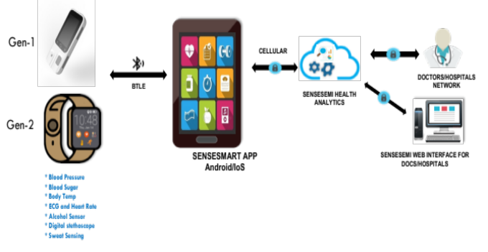
Figure 1 Sensesemi health eco system

The device is available in two generations of devices one for multi user handheld device (will be available in market soon) and the personal wearable device.

The heart rate is monitored frequently when ever a activity is sensed and any unexpected rate variation from the expected one as determined by the reference fed in by the machine learning mechanism/expert will be informed to the user guiding him to monitor Blood pressure and ECG monitoring. Both systolic and diastolic human blood pressure is captured by cuffless method which is very easy to use unhurting method.

Similar mechanism for patients with diabetese guides them manage it by alerting them to measure blood glucose and checks if it is withing the bounds as defined by the medical expert/machine learnt over time for the user thus enabling the user to track his/her parameter trends as he/she lives in different styles. The non invasive method of HbA1C measurement near realtime indicates how well the blood sugar is controlled which is tracked continuously. Any abnormal values are analysed by the algorithm and user is guided to measure the blood glucose and data is presented to medical expert who can intervene to provide the care. This enables the subscription model to the clinicians or general practitioners. Any effects of the care intervention/medication causing other side effects like allergies, temperature rise, fitness variations are guided to be monitored or fed in periodically by the user to form the electronic health record with proper time stamp. The collected health record is structured, analysed and tracked with state of the art artificial intelligence based algorithms at the cloud. The analysed health record is presented to the medical expert or user himself in a friendly way for him/her to manage himself or getting adviced by the expert. This helps anybody to manage his/her health themselves by knowing their own health data and plan for care seeking or expert intervention as the case may be.

Sensesemi’s second generation device smart integrated health watch concept is patent pending in US and India and uses advanced Artificial intelligence based algorithms in its solution for more reliable and trusty worthy data collection.

Smart Health eco system can be easily integrated to any hospital management system to have a common platform for all the hospital stake holders.

Users through this ECO system can access their own wellness and illness data, their analysis any time and anywhere, Doctors get access to the historic health data of the patient and guided for diagnostic decisions through statistical data analysis thus can provice fast access to treatment and care.

Sensesemi solution makes remote health monitoring, geriatric care, home care and post hospitalisation care as shown in Figure 2 very easy and expert intervention is supported as the need arises.

- Sensesemi technologies Smart Health ECO system Use Cases:

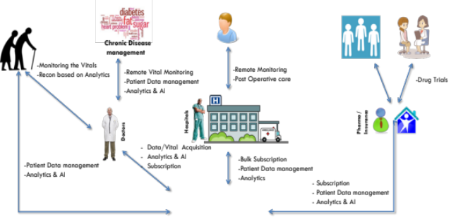
Figure 2. Use cases of sensesemi health eco system

- Biography:
Dr. Veena S Chakravarthi, has completed her PhD in Electronics from Bangalore University and has extensively worked in VLSI and semiconductor industry for three decades before co founding healthcare company Sensesemi technologies Pvt. Ltd in 2014. She is vice chair of Nano technology council of IEEE, Bangalore Section.
Mr. Vijaykumar Muktamath, Founder and CEO of Sensesemi Technologies Pvt. Ltd. holds masters in electronics and has worked in Bionic project in the University of Melbourne, Australia. He has worked in VLSI companies like NEC, LSI and co founder of Asarva chips and Technologies,Bangaore before he Founded Sensesemi technologies Pvt. Ltd.,Bangalore in 2014.
- Presenting author details

Dr. Veena S Chakravarthi is Co-founder and CTO of Sensesemi Technologies Pvt. Ltd.,Bangalore which is developing next generation Health care eco system. She in the previous past, was the Vice President in Asarva Chips and Technologies Pvt. Ltd., Bangalore where she architected 60Ghz. WLAN 802.11 ad chip. She is Research Professor (on sabbatical) in the department of ECE, BNM Institute of Technology, Bangalore and Previously, She has served companies like ITI Ltd., Mindtree Consulting Pvt. Ltd., Centillium India Pvt Ltd., Transwitch India Pvt. Ltd., in various capacities with more than six- multimillion gate System on chip (SoC) developments to her credit. She has worked on Wireless Technologies like Bluetooth, WiFi, Ethernet, GigEPON and Communication. She was the Chairperson, IEEE Nanotechnology Council, IEEE Bangalore section for the last two successive terms and now the vice chair of the same. She has published over 35 technical papers and filed 2 patents in VLSI and Healthcare fields. She is Senior IEEE member.

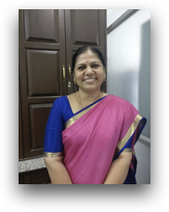
Full Name: Dr. Veena S Chakravarthi
Contact number: +91-9845980607
Twitter account: @veena_sc
Linked In account: in.linkedin.com/in/veenasc/
Session name/ number: Recent Advances in Nanotechnology for Diabetes
Category: Oral presentation
Passport Number: M3883107

