Association between soft drink consumption and asthma among Qatari students
Tamara Al Abdi , RDN
Human Nutrition Department
Qatar University, Doha Qatar

Abstract (300 word limit)

We aimed to examine the association between soft drink consumption and asthma and lung function among Qatari adults. In the cross-sectional study, we used data from 986 Qatari participants aged 20 years and above attending the Qatar Biobank Study. Usual consumption of soft drink was assessed using a food frequency questionnaire. Lung function was measured by spirometry and asthma was based on self-report. The associations between soft drink consumption and asthma and lung function were assessed using multivariable logistic and linear regression, respectively. In total, 65 participants out of 986 (6.6%) reported having asthma. A clear dose-response relationship between soft drink consumption and asthma was found. High soft drink consumers (≥7 times/week) were 2.60 (95% CI 1.20–5.63) times more likely to have asthma as compared to non-consumers. The association was partly mediated by BMI and inflammation. Diet soft drink consumption was positively associated with asthma (OR 1.12 (95% CI 1.02–1.23)) but not with lung function. Regular soft drink consumption was inversely associated with FEV1, but not with FVC. In conclusion, soft drink consumption is positively associated with asthma in Qatari adults. The association is partly mediated by obesity and inflammation. Limiting soft drink consumption should be taken into consideration for asthma prevention
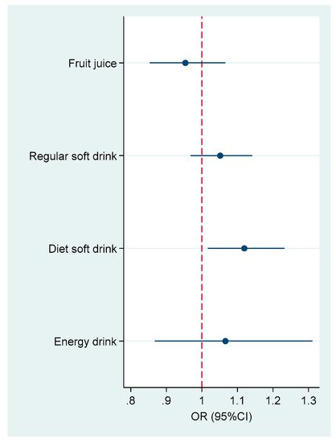
Figure 1. Association between different types of soft drink consumption and asthma. Model adjusted for age, gender, smoking, education, leisure time physical activity, intake of fruit and vegetable, and BMI (normal, overweight and obese). All the soft drinks were mutually adjusted. Soft drinks were used as continuous variables (times/week) in the logistic model

Recent Publications (minimum 5)
  - Kerkadi A., Hassan AS., Al Chetachi W., Al Abdi T., Al Thani AA. Et al. Dietary Habits and sedentary behaviors of adolescents in Qatar: The effect of Gender and Nationality, presented in the 12th Asian Congress of Nutrition, Yokohama, Japan (2015)
  - Wilby K., Al Abdi et al., Attitudes of Pharmacy and Nutrition students towards team based care after first exposure to Inter professional Education in Qatar. Journal of Inter professional Care (2015).
  - Wilby K., Al Abdi et al., Changes in student perceptions after a semester long inter professional education activity in Qatar. Journal of Taibah University Medical Sciences. 2016

Tamara Al Abdi has completed her postgraduate studies in 2006 from Leeds Metropolitan University in the U.K and is a qualified state registered dietitian with the Academy of nutrition and dietetics and the British Dietetic Assoication. She has been the lecturer and clinical coordinator of the supervised practice program at the human nutrition department in college of health sciences at Qatar university since 2010. Her research interest is in clinical dietetics and practice in the Middle East as well as promoting the role of dietitians in Qatar.
.
Email: tamara.alabdi@qu.edu.qu

