Abstract Template

Title: The preference of eyebrow apex positions on different facial shapes among Malaysian population.

Vasanthakumar Packirisamy
King Saud Bin Abdulaziz University for Health Sciences (KSAU-HS), Al Ahsa, Saudi Arabia

Keywords: Brow apex, facial Shape, aesthetic preference.

- Abstract Body (up to 300 words)
To study the preference of eyebrow apex positions on different facial shape, photograph of a female model (oval facial shape) was morphed into square, round and long facial shapes. Four types of brow apex were created on each facial shape. Online questionnaire was created in google forms; it included four groups of facial shape (oval, round square and long) photograph and each group included 4 photographs of the same facial shape with 4 types of brow apex position; A. above the midpupil (A-MP), B. above the lateral limbus (A-LL), C. halfway between the lateral limbus and lateral canthus (A-HF) and D. above the lateral canthus (A-LC). Out of 4 types the respondent has to choose one aesthetically appealing apex on each facial shape. A total of 441 Malaysians completed the survey and the preference for brow apex was analyzed by Chi squared test. Among Indians (MI) and Malays (MM), significant gender difference in the preference for apex position was noted on oval and round face, but among Chinese (MC), significant difference was noted on the square face. In male group, significant ethnic difference was found in the preference for apex position in oval, square and round face. Among the female group, the difference was noted in oval, round and long face. Even though the apex at A-LL was most preferred, but on round face the preference for apex at A-HF was greater in MI (Male-44.3%, female-36.3%) and MM (Male-50%, female-35.7%), on long face preference for apex at A-HF was greater in MM (Male-41.7%, female-42.9%) and MC males preferred more A-MP and A-LL position (33.3%) on square face. The ideal eyebrow apex position differs from the classical models when applied to square, round and long shape. There is gender and ethnic difference in the preference of apex positions.

Image:
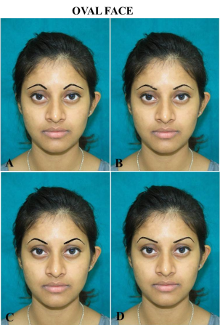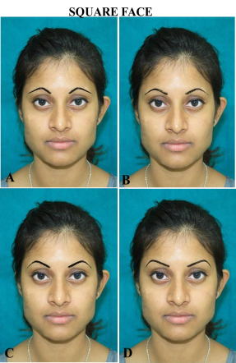
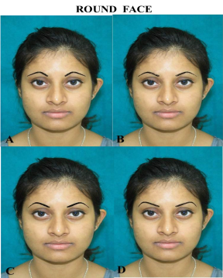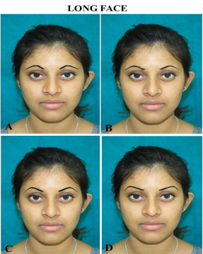
Types of brow apex position on different facial shape: A. above the midpupil (A-MP), B. above the lateral limbus (A-LL), C. halfway between the lateral limbus and lateral canthus (A-HF) and D. above the lateral canthus (A-LC)
Reference:
- Baker SB, Dayan JH, Crane A, Kim S. The influence of brow shape on the perception of facial form and brow aesthetics. Plast Reconstr Surg. 2007;119:2240-2247.

- Westmore, M.G. Facial cosmetics in conjunction with surgery. Course presented at the Aesthetic Plastic Surgery Society Meeting, Vancouver, British Columbia, May of 1975.

- Sclafani AP, Jung M. Desired position, shape, and dynamic range of the normal adult eyebrow. Arch Facial Plast Surg. 2010;12:123-127

- Gunter JP, Antrobus SD. Aesthetic analysis of the eyebrows.Plast Reconstr Surg. 1997;99:1808-1816.

- Biller JA, Kim DW. A contemporary assessment of facial aesthetic preferences. Arch Facial Plast Surg. 2009;11:91- 97.

- Roth JM, Metzinger SE. Quantifying the arch position of the female eyebrow. Arch Facial Plast Surg. 2003;5:235- 239.

- Angres GG. Blepharopigmentation and eyebrow enhancement techniques for maximum cosmetic results. Ann Ophthalmol. 1985;17:605-611.

- Freund RM, Nolan WB. Correlation between brow lift outcomes and aesthetic ideal for eyebrow height and shape in females. Plast Reconstr Surg. 1996;97:1343-1348.

Biography:
I am Dr. Vasanthakumar Pakirisamy currently an Assistant professor of Anatomy, King Saud Bin Abdulaziz University for Health Sciences-Al-Ahsa Saudi Arabia. I received M.Sc. degree in Human medical Anatomy and a Ph.D. degree from Manipal University, India. I have published my research outputs in various Surgical and Facial aesthetic journals. I am also a certified peer reviewer for various facial research journals like Aesthetic Plastic surgery, Ophthalmic Plastic and Reconstructive Surgery, Journal of Cosmetic Dermatology. I was the recipient of the gold medal award for excellence in Facial anatomy research for the year 2014.

Presenting author details
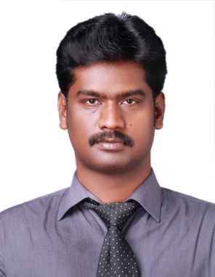

Full Name: Dr. Vasanthakumar Pakirisamy
Contact number: +966(0)534236158
Twitter account: NIL
Linked In account: https://www.linkedin.com/in/dr-p-vasanth-k-3b89041a/
Session name/ number:
Category: POSTER PRESENTATION
Passport Number: S7955521

