Role of 11 beta hydroxysteroid dehydrogenase type 1 (11β HSD1) rs12086634 & rs846910 single nucleotide polymorphisms in metabolic related skin diseases: A clinical, Biochemical and Genetic Study.
Azza GA Farag*, Eman AE Badr**, Abdel Monem A Eltorgoman ***, Mohamed FA Assar,****. Hossam EA Aboutaleb****
*Department of Dermatology, Andrology and STDs, Faculty of Medicine – Menoufia University, Egypt
**Department of Medical Biochemistry and Molecular Biology , Faculty of Medicine – Menoufia University, Egypt
***Department of organic chemistry, Faculty of science – Menoufia University, Egypt
****Department of Medical Microbiology and Immunology, Faculty of science – Menoufia University, Egypt

Keywords: Skin tags, acne vulgaris, metabolic syndrome, 11 beta hydroxysteroid dehydrogenase, Single-nucleotide polymorphism.

- Abstract Body
11β HSD1 generates cortisol from cortisone. 11β HSD1 single nucleotide polymorphism (SNP) was associated with metabolic syndrome. Although the relation of acne vulgaris (AV) and skin tags (ST) with metabolic syndrome was reported, the relationship between 11β HSD1 SNP and cortisol activity in those patients was not studied till now. Therefore, we investigated lipid profile, serum cortisol levels and 11β-HSD1 rs846910 and rs12086634 SNP using RT- PCR in 50 AV and 50 ST patients. We observed that AV and ST patients had significant higher BMI, cholesterol , LDL, serum cortisol levels and lower HDL levels. rs846910 A allele and GA genotype carriers had significant high risks for developing AV and ST by (3.1& 4.4)and (3.4& 4.9) folds, respectively. While, rs12086634 G allele and TG genotype increases the risk of AV and ST by (3.2 & 7), and (3.2 & 3.5) folds respectively. In AV and ST patients, rs846910 GA genotype demonstrated significant associations with elevated BMI, cholesterol, LDL and cortisol, and decreased HDL, however, rs12086634 GG genotype was significantly associated with increased BMI, cholesterol and LDL serum levels, and number of ST and cortisol levels in ST cases only. We concluded that 11β-HSD1 rs846910 and rs12086634 gene polymorphisms may contribute in AV and ST pathogenesis in Egyptian population, that may be mediated through enhanced its enzymatic activity and increased cortisol levels. We confirmed that AV and ST are associated with obesity and atherogenic lipid profile. Patients have these diseases need suitable interventions as weight reduction and dietary habits.
- Image:

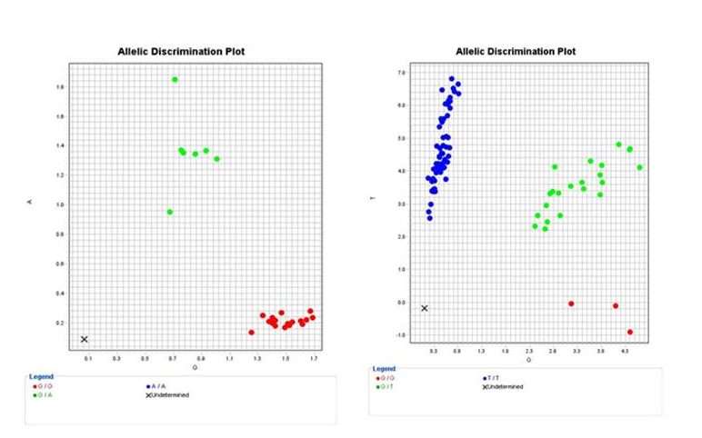
Allelic Discrimination Plot of HSD11B1rs846910 (A/G) (a) and rs12086634 (G/T) (b).
- Reference:
- Melnik BC. Acne vulgaris: The metabolic syndrome of the pilosebaceous follicle. Clin Dermatol. 2018;36(1):29-40.
- Shah R, Jindal A,1 and Patel NM. Acrochordons as a Cutaneous Sign of Metabolic Syndrome: A Case-Control Study. Ann Med Health Sci Res. 2014; 4(2): 202–205.
- Devang N, Nandini M, Rao S, Adhikari P. HSD11B1 gene polymorphisms in type 2 diabetes and metabolic syndrome—Do we have evidence for the association? Int J Diabetes Dev Ctries. 2016; 36(1):95–102.

- Biography:
Azza Gaber Antar Farag has completed her PhD at the age of 24 years from Menoufia University and Postdoctoral Studies from Menoufia University, Egypt. She is assistant professor, Dermatology, Andrology & STDs department, Faculty of Medicine, Menoufia University. She has published more than 20 papers in reputed journals and has been serving as an editorial board member of repute.
- Presenting author details:



Full Name: Azza Gaber Antar Farag
Contact number: 002/ 01097787204
Linked In account: azzagaber92@yahoo.com
Session name/ number:
Category: Poster presentation
Passport Number: A20043658

