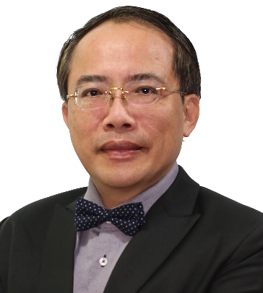
Autologous Fat Grafting in Aesthetic Mammoplasty and Breast Reconstruction Post-mastectomy: 500+ Cases Review for How I do It

Tsai-Ming Lin MD, PhD^{1,2}, Chih-Kong Chou MD, MS¹

¹Charming Institute of Aesthetic and Regenerative Surgery

²Kaohsiung Medical University Hospital

Kaohsiung, Taiwan
Abstract:
Breast cancer was ranked third of the ten leading causes of death in the US in 2019. Substantial physical insults and tremendous psychological influence highlight the importance and necessity of reconstructive breast surgery for patients post-mastectomy. Excellent contouring of female breasts is always regarded as essential for self-esteem. Both issues necessitate mammoplasty, a hot topic for decades.
Lin et al. first proposed micro-autologous fat transplantation (MAFT) in 2007; clinically, the feasibility of facial recontouring and rejuvenation has been proven. An innovative surgical instrument provided surgeons with precise and micro-delivering of tiny fat parcels by enhancing the fat survival/retention rate and eliminating potential complications.
The authors have performed more than 500 cases of aesthetic and reconstructive with the MAFT technique under total intravenous anesthesia in the past ten years personally. The authors will demonstrate an evolutionary surgical technique in detail in this presentation.
Though huge debates exist concerning the strategies for aesthetic and reconstructive mammoplasty, a ten-year MAFT personal experience offers an alternative for surgeons looking for a better resolution in aesthetic and reconstructive mammoplasty.
Biography:
Tsai Ming Lin, M.D., Ph.D. is a board-certified plastic surgeon in Taiwan specializing in plastic, reconstructive and cosmetic surgeries and the director of the Charming Institute of Aesthetic & Regenerative Surgery (CIARS) in Kaohsiung, Taiwan, and an assistant professor of Kaohsiung Medical University. He is best known for his theory of Micro-Autologous Fat Transplantation (MAFT), and he is also the inventor of MAFT-GUN, a micro-scale injector. Lin has published over twenty SCI articles or textbook chapters related to the clinical applications of the MAFT technique. He is now a member of the Taiwan Surgical Association, Taiwan Society of Plastic Surgery, Taiwan Society of Aesthetic Plastic Surgery, International Society of Aesthetic Plastic Surgery (ISAPS), American Society of Plastic Surgeons (ASPS), and the International Society of Plastic and Regenerative Surgery (ISPRES). Dr. Lin is an editorial board member of the journal of Aesthetic Plastic Surgery.

