UTILITY OF DIFITAL VOLUME TOMOGRAPHY IN MAXILLO-FACIAL RADIOLOGY
Anuraag B. Choudhary BDS. MDS, Associate Professor
Department of Oral Medicine & Radiology, VSPM Dental College, Nagpur Maharashtra, India

Abstract (300 word limit)
Imaging is an important diagnostic adjunct to the clinical assessment of the dental patient. The currently used imaging modalities include intra-oral radiographs, panoramic radiographs, magnetic resonance imaging (MRI), computed tomography (CT) including cone-beam (CB) CT, ultrasonography (US), and nuclear medicine including positron
Emission tomography (PET). The introduction of panoramic radiography in the 1960’s and its widespread adoption throughout the 1970’s and 80’s heralded major progress in dental radiology - providing clinicians with a single comprehensive image of both jaws and maxillofacial structures. However both intraoral and extraoral procedures, used individually or in combination, suffer from the same inherent limitations of all planar two dimensional (2D) projections - magnification, distortion, superimposition and misrepresentation of structures. The cone-beam technique (CBCT or DVT) is the most recent advance in computer-assisted tomography. Initial studies using phantoms have confirmed a geometric accuracy of upto tenths of millimeters. Advanced cross-sectional imaging techniques are used in dento-maxillofacial imaging to solve complex diagnostic and treatment- planning problems, such as those encountered in craniofacial fractures, endosseous dental-implant planning, and orthodontics, among others. With the advent of Cone Beam Computed Tomography (CBCT) technology, cross-sectional imaging that had previously been outsourced to medical CT scanners has begun to take place in dental offices. CBCT or Digital volume tomography is a novel technique for maxillofacial imaging at a lower radiation dose and lower cost than CT. The introduction of CBCT specifically dedicated to imaging the maxillofacial region heralds a true paradigm shift. The unprecedented interest in CBCT from all fields of dentistry is because it has created a revolution in maxillofacial imaging - facilitating the transition of dental imaging from 2D to 3D images and expanding the role of imaging from diagnosis to image guidance of operative and surgical procedures via third party applications software. The purpose of this paper is to provide an overview of this CBCT technology and review its capabilities with specific applications in clinical practice.
Image
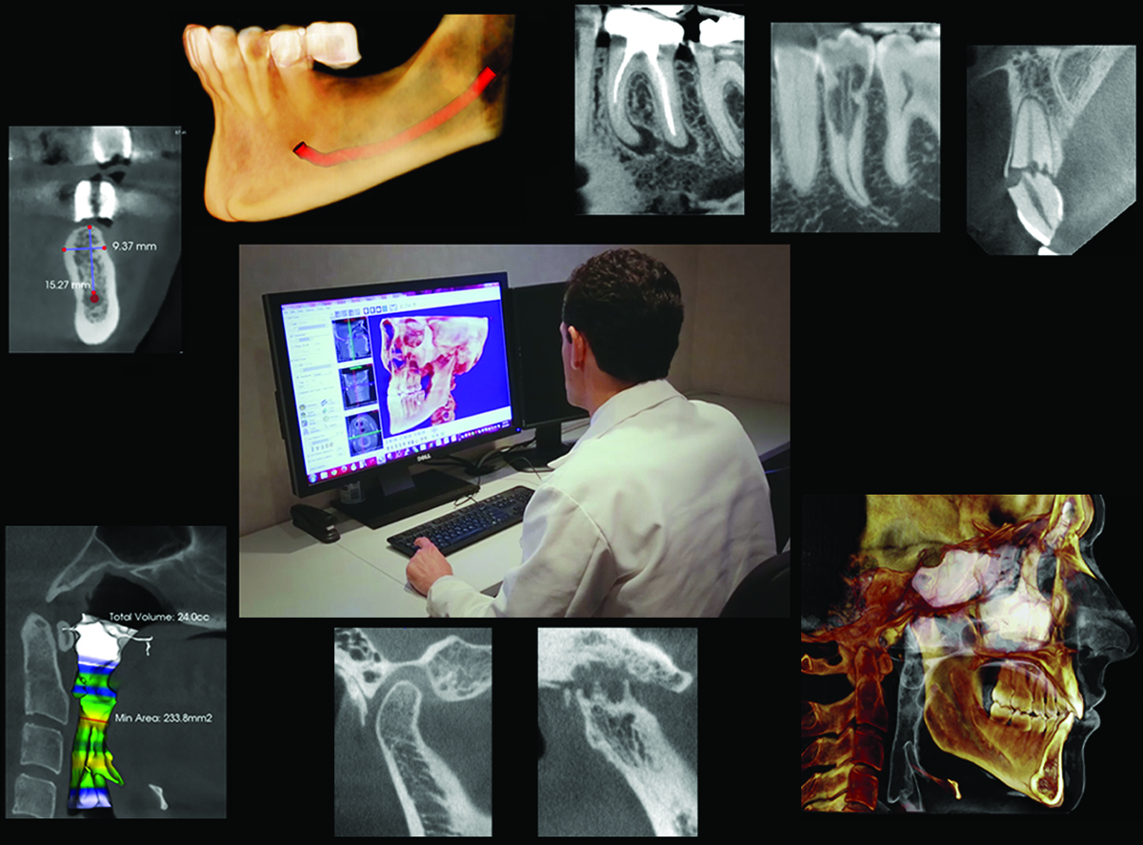
Recent Publications (minimum 5)
- Anurag Choudhary Utility of Digital Volume Tomography in maxillofacial Trauma. Journal Oral and Maxillofacial Surgery, 2011; 69: e135-e140
- UTILITY OF CONE BEAM CT IN MAXILLO-FACIAL RADIOLOGY Int J Dent Case Reports 2013; 3(1): 134-145 © IJDCR 2013. All rights reserved www.ijdcr.com
- Pleomorphic Adenoma of Palate- A Case Report with CT and CBCT Features. IOSR Journal of Dental and Medical Sciences (IOSR-JDMS) e- ISSN: 2279- 0853, p-ISSN: 2279- 0861.Volume 13, Issue 8 Ver. I (Aug. 2014), PP. 83-89
- Hashimoto K, Yoshinori A, Kazui I, et al: A comparison of a new, limited cone beam computed tomography machine for dental use with a multi– detector row helical CT machine. Oral Surg Oral Med Oral Pathol Oral Radiol
- JB Ludlow, LE Davies-Ludlow, SL Brooks and WB Howerton-Dosimetry of 3 CBCT devices for oral and maxillofacial radiology: CB Mercuray, NewTom 3G and i-CAT. Dentomaxillofacial Radiology 2006; 35: 219–226.

Biography (150 word limit)
Dr. Anuraag B. Choudhary is currently working as an Associate Professor of Oral Medicine & Radiology Department at the Vidya Shikshan Prasarak Mandal’s Dental College & Hospital, Nagpur, Maharashtra. He is also a consultant Maxillo-facial Radiologist at Phoenix Imaging CBCT centre Nagpur. He has done his BDS and MDS from Sharad Pawar Dental College Wardha, Maharashtra. In his academics, he won prize for best poster in National IAOMR Conference, Nellore in 2008. He also won first prize in paper presentation in National IAOMR PG Convention, Mathura, U.P. in 2009 and also in IDA Nagpur 2010. He has presented scientific papers on CBCT in several National specialty conferences and has been accredited with numerous publications in various indexed journals on the same. He is a Co-Author in Text book of Essential’s of Pediatric Oral Pathology. He is presently a reviewer of various indexed journals. Recently he has been invited as a Guest Speaker in IDA Baitul MP, SDK Dental College, Nagpur, IDA Yeotmal branch, State IDA Manipur, Imphal, Sharad Pawar Dental College Wardha and various national & International conferences. He also delivers lectures on various topics like TMJ disorders, Oro-Facial Pain as well as on Muco-cutaneous lesions.
Email: anuraag_c2@yahoo.co.in

Notes/Comments:

