A retrospective evaluation of the treatment of palatally impacted upper canine teeth in two district general hospitals

Osborne, R et al UK

Oral presentation submission

Abstract
In the absence of early diagnosis and successful interceptive management of palatal canines, surgical exposure and orthodontic alignment is the treatment of choice.

Aim to determine whether there is any difference in treatment duration or quality using a sectional arch-wire (FR) or a ‘piggy-back’ wire (FF) to orthodontically align an ectopic canine, following surgical exposure (Figure1). Currently, the full fixed appliance with ‘piggy-back’ (FF) is the most commonly used; therefore, this is determined to be the control.

A retrospective cohort study. All subjects with palatally displaced canines referred to the orthodontic departments in York and Scarborough Teaching Hospital NHS Foundation Trust from January 2007 to December 2017, who have completed their orthodontic treatment.

Sample size calculation: power set at 0.9 (90%) (β = 0.10) and we have chosen a 5% significance level (α = 0.05) to ensure good sensitivity. By setting the treatment length average difference at 6 months (the known clinically significance detectable root resorption from literature), the standard deviation as 0.3, and autocorrelation is assumed to be 0.5. Current literature also suggests that the average total treatment time for full fixed appliance is approximately 20 months. There is no estimate published for the sectional appliance. By allowing the failure to complete rate as 15%, the sample size required for each group would be less than 100.

Interim-Results
T-test used to compare for duration (0.108), number of visits (0.312) and % change in PAR score (0.131), between treatment with sectional archwire FR and treatment with full fixed FF appliances. This showed little significance difference between FF and FR treatment at this stage in data collection.

The degree of impaction of the ectopic canine as per Kurol and Ericson. Use g1/2 v g123. 1 g1 and 18 g4 treated by FF. 2 g1 and 6 g4 treated by FR. Comparing like with like, of the grade one, FF took 23 m and 82.5% and FR 26.7m and 86.36%. Grade 4 FF took 30m and FR 25. With FF 82.8% and FR 78.82%.

The results at this stage suggest no statistical significance between the two appliances, however further data collection and analysis is required.

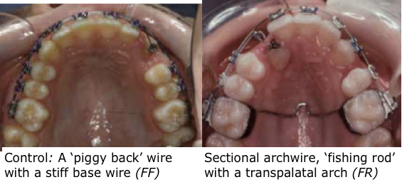

References
1.Al-Musfir TM, Morris DO. Orthodontic treatment of a stubborn palatally ectopic canine: a case report. Journal of Orthodontics, 2014; 41(1):46-50
2.Husain J, Burden D, McSherry P. The management of the palatally ectopic maxillary canine. National Clinical Guidelines, Faculty of Dental Surgery, Royal College of Surgeons of England, 2016.
3.Stewart JA, Heo G, Glover KE, Williamson PC, Lam EWN, Major PW. Factors that relate to treatment duration for patients with palatally impacted maxillary canines. Am J Orthod Dentofacial Orthop 2001; 119: 216−225.
4.Stewart JA, Heo G, Glover KE, Williamson PC, Lam EWN, Major PW. Factors that relate to treatment duration for patients with palatally impacted maxillary canines. Am J Orthod Dentofacial Orthop 2001; 119: 216−225.

Biography (150 word limit)
Rachel Osborne: Graduated from Newcastle University 2016 before completing foundation training in York. Following this completed dental core training years in oral and maxillofacial surgery, pediatric and special care dentistry.
Email: Rachel.osborne6@nhs.net

