Unexpected diagnosis of a neck lump
Osborne, R et al UK

Oral presentation submission

Abstract (185 word limit)
A case report of a patient with a right‐sided neck lump initially presenting to his dentist who was subsequently diagnosed with a rare mycotic carotid artery aneurysm. Following referral by the patient’s general dental practitioner, clinical examination in York out‐patient department led to a high index of suspicion of metastatic squamous cell cancer (SCC). A malignant process was suspected due to the combination of a fixed level 2 neck lump, otalgia and vocal cord palsy. However, a differential diagnosis of an aneurysm became more likely following an MRI scan. The patient subsequently underwent urgent debridement of the carotid artery aneurysm and ligation of the internal carotid artery. Mycotic aneurysms involving the carotid arteries are rare with only around 20 reported cases every decade with a small number of cases reporting dental infection as a potential cause. The definitive diagnosis of a mycotic aneurysm demonstrates how similar the presenting features of a metastatic SCC can be to that of a carotid aneurysm. Despite the low incidence, the importance of considering an aneurysm in the differential diagnosis of neck lumps is highlighted due to possible catastrophic consequences.

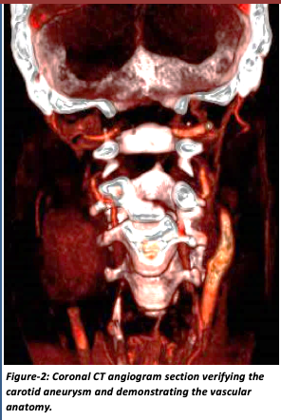
Image

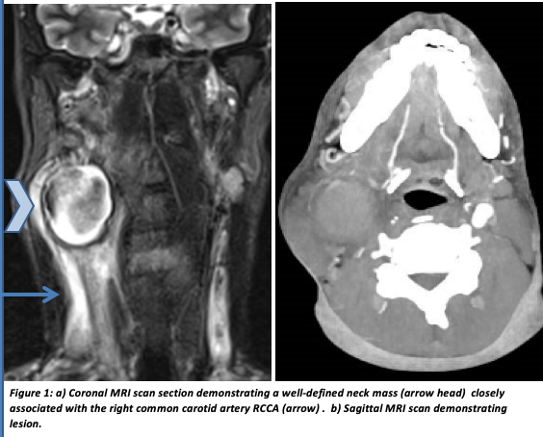

References
1. Bouchet C, Garibotti FM, Haupert S, Pirvu A, Sessa C. Mycotic Aneurysm of the Internal Carotid Artery. Annals of Vascular Surgery , Volume 27 , Issue 6 , 826 – 830
2. Rosset E, J.N. Albertini, P.E. Magnan, B. Ede, J.M. Thomassin, A. BranchereauSurgical treatment of extracranial internal carotid artery aneurysms. Journal of Vascular Surgery. 2000; Volume 31: 713-723
3. León LR Jnr, Mills JL. Diagnosis and Management of Mycotic Aneurysms. Curr Infect Dis Rep (2009) 11: 274. https://doi.org/10.1007/s11908-009-0041-3
4. Fisk M, Pek LF, Miyagi K, Steward MJ, Lee SF, Macrae MB, Morris-Jones S, Zumla AJ, Marks DJB. Mycotic aneurysms: a case report, clinical review and novel imaging strategy. QJM: An International Journal of Medicine. 2012; Volume 105, Issue 2: 181–188
5. Li Z, Chang G, Yao C, Guo L, Liu Y, Wang M, Liu D, Wang S. Endovascular Stenting of Extracranial Carotid Artery Aneurysm: A Systematic Review. European Journal of Vascular and Endovascular Surgery. 2011; Volume 42, Issue 4: 419-426
6. Crawford RS, Durand ML, LaMuraglia G. Extracranial infected carotid artery aneurysm. Journal of Vascular Surgery. 2009; Volume 50, Issue 56: 1484-1486

Biography (150 word limit)
Rachel Osborne: Graduated from Newcastle University 2016 before completing foundation training in York. Following this completed dental core training years in oral and maxillofacial surgery, pediatric and special care dentistry.
Email: Rachel.osborne6@nhs.net

