Laser in the daily practice , a step forward

Dr Anas karkout, MSc, Damascus university, Syria

Abstract
It's a great time for dentists to consider an update to their practices! This can be achieved through using new technologies such as Laser. Unlike traditional tools, dental lasers can improve their patients’ experiences by eliminating anesthesia, pain, bleeding and fear, as well as accelerating the healing.
In this lecture we will talk about different laser’s wavelengths and discuss all their advantages and disadvantages, and the importance of using laser in Biostimulation, Veneer removal, Periodontal pocket disinfection, Root canal disinfection, cavity preparation, Depigmentation, Gingivectomy, Frenectomy, Orthodontics, Fibroma excision, Impacted canine exposure, Coagulation, tooth whitening, pain relief and Periimplantitis.

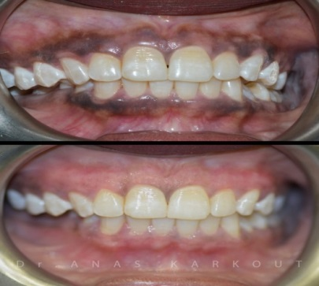

Figure 3 : Laser depigmentation ,810nm

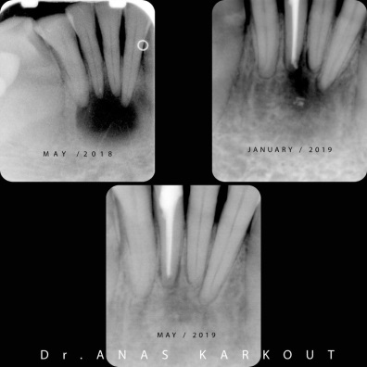

Figure 4 : Root canal disinfection , diode 980nm
Recent Publications
- Huber G., Kränkel C., Petermann K. Solid-state lasers: Status and future. JOSAB. 2010;27:B93–B105.doi: 10.1364/JOSAB.27.000B93.
- Molardi C., Poli F., Rosa L., Selleri S., Cucinotta A. Mode discrimination criterion for effective differential amplification in Yb-doped fiber design for high power operation. Opt. Express. 2017;25:29013–29025. doi: 10.1364/OE.25.029013.
- Niemz M.H. Laser-Tissue Interactions: Fundamentals and Applications. Springer Science & Business Media; Berlin/Heidelberg, Germany: 2013.
- Matsumoto K, Hossain M. Frenectomy with the Nd:YAG laser: A clinical study. J Oral Laser Appl. 2002;2:25–305.
- 5.Sarkar S, Kailasam S, Iyer VH. Effectiveness of Er,Cr:YSGG laser in the excision of different oral soft tissue lesions. J Indian Acad Oral Med Radiol. 2013 Jan-Mar;25(1):10–12.

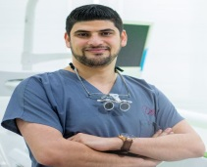
Biography
Dr. Anas Karkout has been practicing Dental Laser since 2012. He has published on this subject in the Asia, euoroup and the Middle East.He is an international laser trainer .
Dr. Karkout was a guest lecturer in Italy,France,Spain,South africa ,Japan,Kuwait, Lebanon ,United arab of emirates and Syria. He holds a master degree in Dental Laser (Damascus University).
.
Email: anas.karkout@hotmail.com

