Abstract Template

Title: Dental restorations according to Rayo 3DToothFill

TARVONEN P-L ^{1,2}
¹ Institute of Dentistry, Faculty of Health Sciences, University of Eastern Finland, Kuopio, Finland
² Department of Oral Maxillofacial Diseases. Medical Faculty, University of Helsinki, Helsinki, Finland

Keywords: Dental filling, 3D printing

- Abstract Body
Direct filling technique with composite has several shortcomings. Especially larger fillings in posterior teeth are challenging. As result, most restorations need repetitive repair or replacement within a couple of years¹. Indirect restorations are used to overcome the challenges linked with direct restorations. Subtractive CAD/CAM (computer-aided design and computer-aided manufacturing) milling technology has been generalized along with the expanding role of digitalization. Additive CAD/CAM technique called 3D printing Additive manufacturing may be used to pass challenges linked with milling: material waste, milling accuracy that is dependent on the machining tools, and undercuts or locations that are inaccessible to end-mills cannot be milled.^{2,3} Accuracy of the technology makes it suitable for manufacturing of several dental applications, like surgical guides, aligners and dental implants.^{4,5}

RAYO 3DToothFill is a novel technique utilizing digital imaging and 3D printing to fabricate tooth fillings and other dental restorations. Based on our in vitro study⁶, the accuracy of 3D printing technique overcomes that of milling technique in the fabrication of dental inlay and onlay fillings. Additional clinical investigations are planned to carry out during 2019 to confirm the findings. The 3D printing process is fast and likely to be used chairside at the dental office in the future.

The technique has been developed by a team of professors and experts from the University of Eastern Finland and University of Oulu. International patent pending.

Funding Source
In vitro study by Business Finland – the Finnish Funding Agency for Innovations, clinical study by Rayo 3D-Toothfill Ltd.

- Image
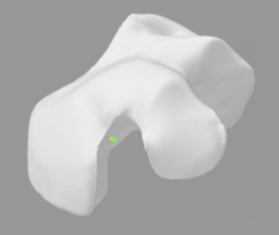
- Reference:
1. A. Nihtilä. Adult heavy and low users of dental services: treatment provided. Swed Dent J. 2016;40(1):21-32.
- F. Beuer, J. Schweiger, D. Edelhoff, Digital dentistry: An overview of recent developments for CAD/CAM generated restorations. Br Dent J. 2008:505-511.
- Ebert J, Ozkol E, Zeichner A, Uibel K, Weiss O, Koops U, et al. Direct inkjet printing of dental prostheses made
of zirconia. J Dent Res 2009; 88:673-676.
- Shaheen E, Sun Y, Jacobs R, Politis, C. Three-dimensional printed final occlusal splint for orthognathic surgery: design and validation. Int J Oral Maxillofac Surg. 2017;46(1):67-71
- Dawood A, Marti Marti B, Sauret-Jackson V, Darwood A. 3D printing in dentistry. Br Dent J. 2015; 219(11):521-9
- Ahlholm P, Sipilä K, Vallittu P, Kotiranta U, Lappalainen R. Accuracy of inlay/onlay fillings based on 3D printing versus CAD/CAM milling technique, an in vitro study. Acta Biomaterialia Odontol Scand 2018 (submitted).

- Biography:
Dr. Pirkko-Liisa Tarvonen has a specialist degree in Dental Public Health from the University of Turku, Finland, and a PhD degree from the University of Eastern Finland. She acts as Dental Marketing Director at Rayo 3D-Toothfill Ltd and as University Lecturer at the University of Helsinki and at the University of Eastern Finland. As a voluntary project coordinator for ten years she has had a remarkable contribution in the support of primary dental care and dental education in the Democratic People’s Republic Korea.

- Presenting author details

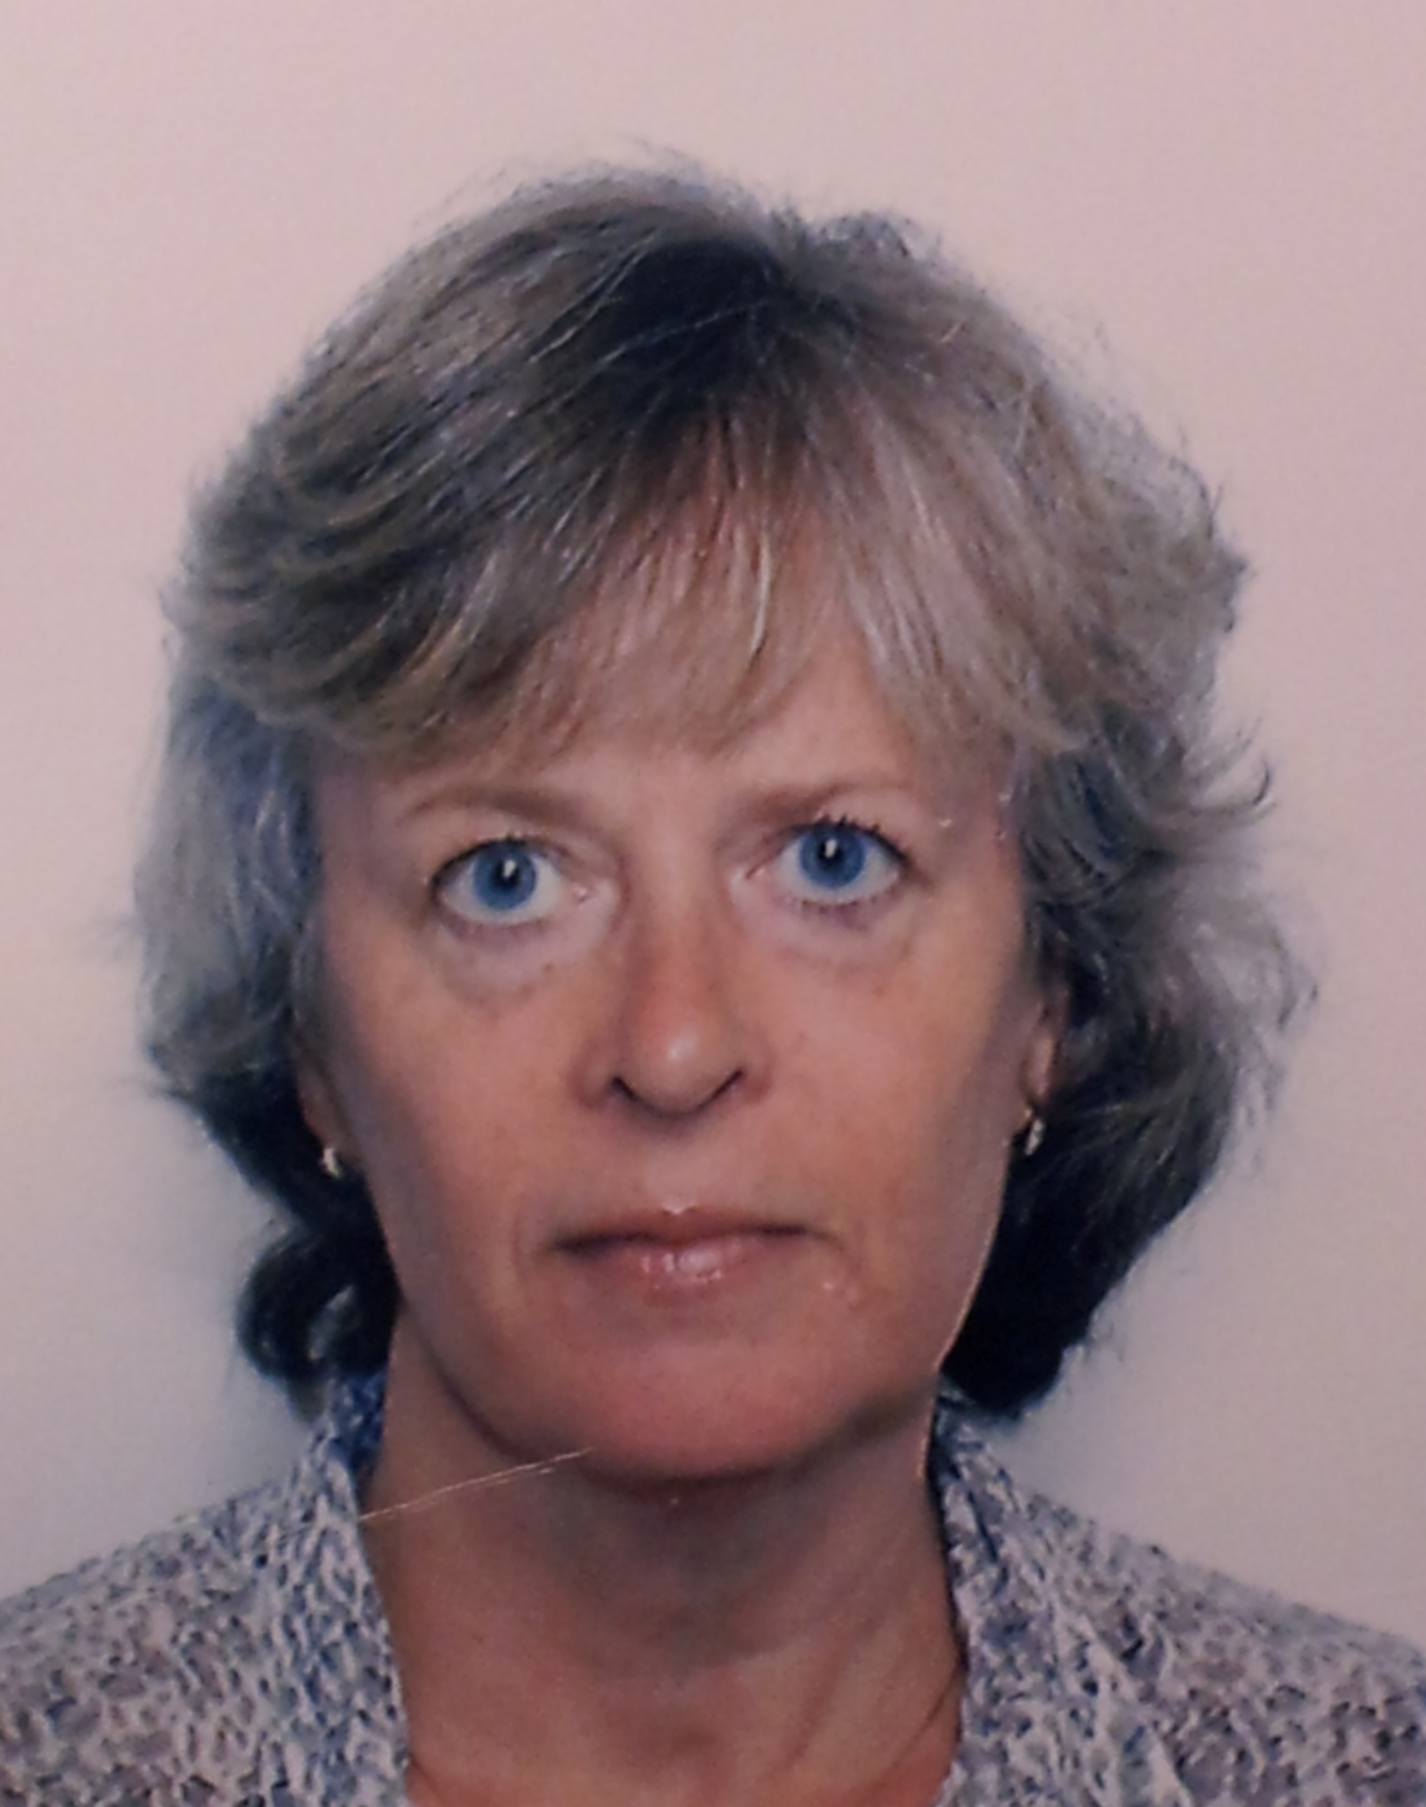
Full Name: Pirkko-Liisa Tarvonen
Contact number: +358 40 7500 764
Twitter account: -
Linked In account: Pirkko-Liisa Tarvonen
Session name/ number: 3D printing in Dentistry
Category: (Oral presentation/ Poster presentation)
Passport Number: FP12755440

