Abstract Template
Title: NETWORKING: THE FUTURE OF DIGITAL DENTISTRY APPLICATION.
BARBERA L^{1 MD DDS}, HAFEEZ K ES¹, TRAPANI E³,
¹Private practice- Monza _ IT PG Cert Med Ed Cairo
²Private Practice Bristol UK , Regional Dental Advisor, Royal College of Surgeons Edinburgh
³Private Practice Turin IT Digital Sistem Consultant MDT

Keywords: NETWORK DIGITAL WORKFLOW DENTISTRY,
- Abstract Body (up to 250 words)
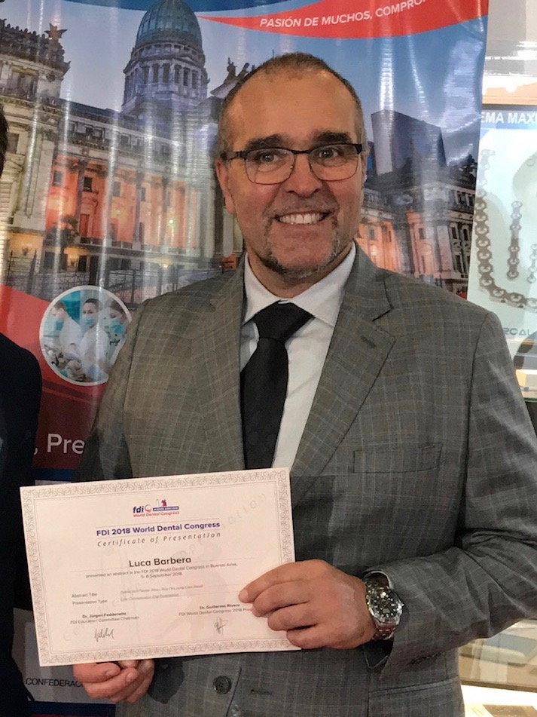
Digital technology is imposing itself in dental clinical practice thanks to EFFICACY, SAFETY and PREDICTABILITY of technologies used to rationalize the work flow. Due to the characteristic of the data used and their digital format, it is easy for the clinician to move the data through the computer network, save them and make virtual storage in the cloud, especially to share with other colleagues for technical / cultural comparisons and with digital storing and processing centres that today are able to provide all the needs of the clinician from the simple technical advice, the design processing, the production of the required materials and also to the technical assistance in the operating room. Aim of our work is to evaluate the work flow of one of these networks, according to the needs of two types of experienced dental professionals: the one with a consolidated experience on digital and the novice and one with only the basic experience in this field. Both have used the network incorporating their cases in the cycle to be rehabilitated and evaluate the final results, the difficulties encountered in entering and receiving data and then establishing a personal judgement based mainly on their intention to continue with this mode of "virtual" work. The results obtained were positive for both classes of professionals chosen. Both appreciated the efficiency of the work flow, the ease of access to the processed data and the ease of application of the materials produced. Both have recognized their firm intention to continue with this type of approach to digital therapeutic flow. This work confirms the versatility of Networks in digital systematics, operational effectiveness, together with the possibility to use them even if there is not a very wide "machinery fleet" available by clinicians of basic experience level.
Image:

Reference:
- P. L. Dordal An Introduction to computer network: Rel 1.9.16
- C. Severance Introduction to Networking 2015- May-25 Original Printing: Create Space
- T. Bakerdjieva Introduction to Computer Networking V F University C. Hrabar I of technology
- Biography:
Dr L BARBERA Graduated in Medicine & Surgery in 1991 University of Milan. Since Degree he practiced exclusively Oral Surgery. Graduated 2lev Master in Digital Dentistry University ov Varese 2018. Actually he is Consultant for different Companies for Digital technology and Implant Dentistry. he direct different Private dept of surgery and his own Clinic. Vis Prof univ of Cairo (EGYPT)
Dr K.HAFEEZ is a member and a Fellow of Royal College of Surgeons Ireland and a Fellow of Royal College of Surgeons Edinburgh. He works as an examiner for these Royal Colleges as well. He lectures internationally and is a visiting Implantologist of different practices in England.
- Presenting author details

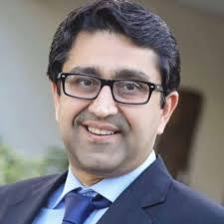
Full name:Kashif Hafeez
Contact Number:+447460387738
hafeezkashif@yahoo.co.uk
Category:Oral presentation
Passport number 548090021

Full name:Luca Barbera
Contact Number:+393920182765
luc.barbera@tiscali.it
Category:Oral presentation
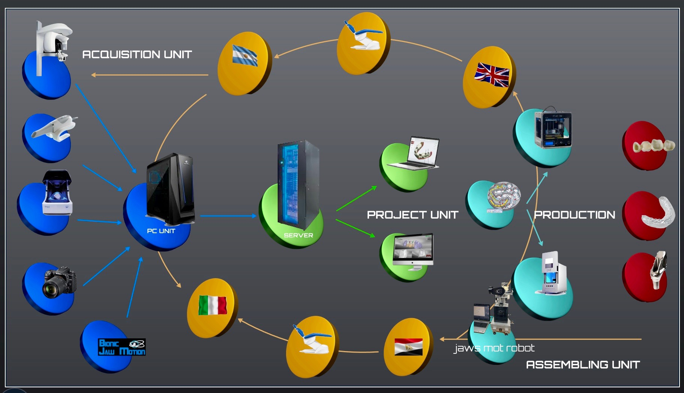
Passport number YB1660904

