Dynamic jaw’ s motion. A new approach for prosthetic rehabilitations
N. Barbera DMD (1) K. LODHI DMD (2)
- ^{Private Practice Monza ITALY}
- ^{Private Practice Bristol UK}

Abstract

Prosthetic rehabilitation, of whatever type, is always subject to the technical difficulties of detecting the patient's position and therefore, referring to the description of the movements themselves, always referred to the individual patient.
Up to now we have not had available systems that could acquire the mandibular dynamics on the patient and in return that could transfer such information both to an analysis software and to a robot which physically repeated on models as accomplished. aim of the research program is to asses THE RELIABILITY OF THE DYNAMIC ACQUISITION SYSTEM OF MANDIBULAR MOVEMENTS on a patient subject to aesthetic prosthetic rehabilitation.
The registrations performed before the aforementioned rehabilitation allowed to evaluate the prosthetic congruity before its installation on the patient.
This evaluation was also performed on diagnostic wax up packaged using a digital workflow.
The chair-side adaptation work after the cementation of the prosthetic rehabilitation was absolutely light and short considering the settings that the robot allowed to perform in the laboratory. We consider this method to be profitable and worthy of further studies.

Image

Recent Publications
- E. Solaberrieta et al. VIRTUAL FACEBOW TECHNIQUE J Prost Dent 2015
- R:S.Gugwad VIRTUAL ARTICULATOR IN PROSTHODONTIC. Int J of Detal Clinic 2011:3(4) 39-41
- A.Pandita. VIRTUAL ARTICULATORS A DIGITAL EXCELLENCE IN PROSTHETIC AND RESTORATIVE DENTISTRY J Applied Dental and Medical Science 2016:2(3)
- L.M Ferrin VIRTUAL ARTICULATOR FOR THE ANALYSIS OF DENTAL OCCLUSION:AN UPDATE Med Oral Patol Oral Cir Bucal 2012 1:17 160-163

- B.J.Pandaja VIRTUAL ARTICULATOR IN DENTISTRY- A REVIEW International journal of medical and Applied Science 4(2) 2015
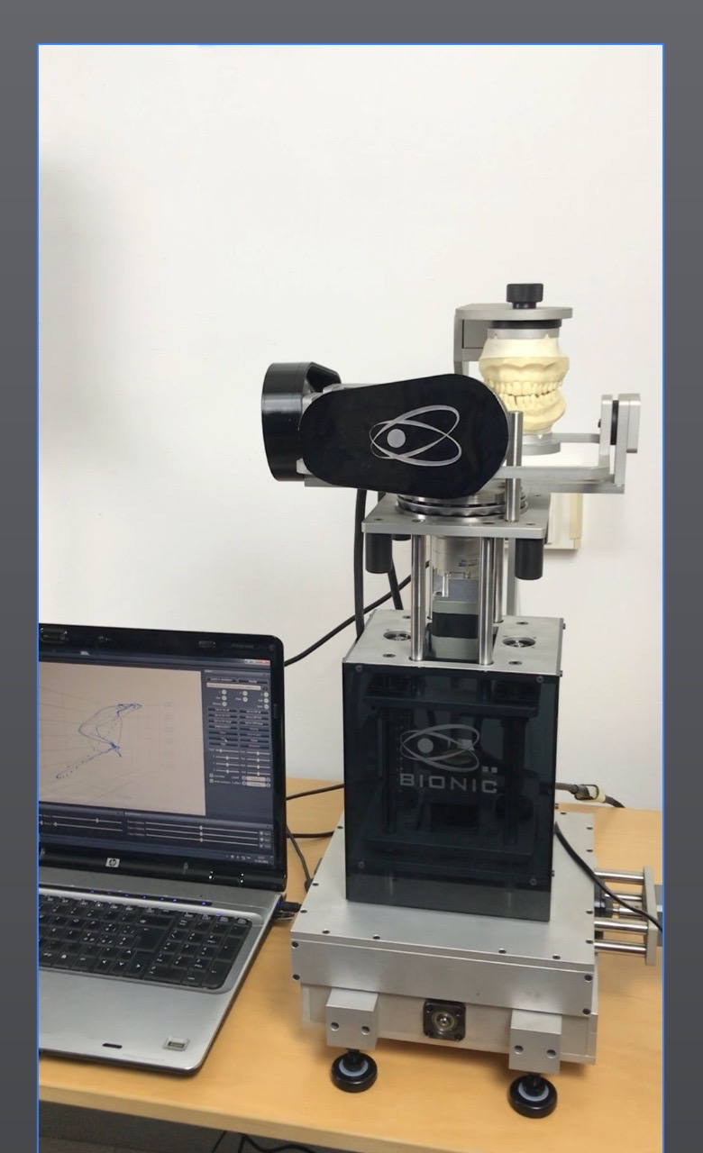
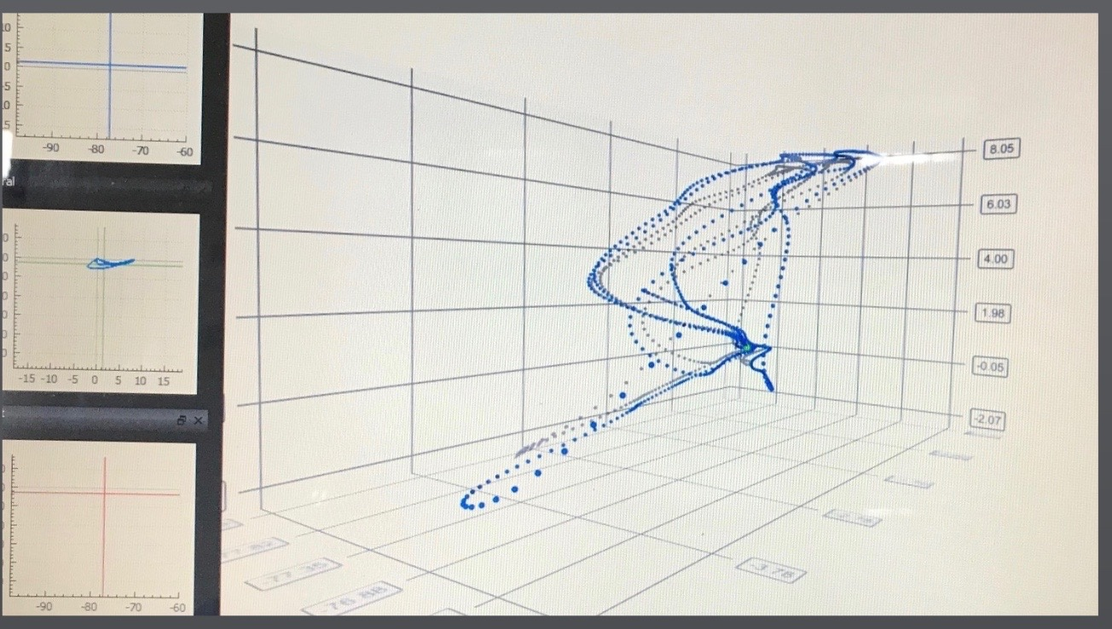

Dr BARBERA NICOLò Graduated in Dentistry Univ of Milan 2018. Actually he attend a fellow in Digital Dentistry and research program on Jaw Dynamic movements and Guided Implantology Procedure. Active member of the Italian federation of Posture, Master in micro Invasive Esthetic Dentistry ESCD Milan-, International Esthetic Master 2017 IEM. ECM Accr teacher for Digital Dentistry & Posturology Courses in Milan.

Email: barberanicolomed@gmail.com

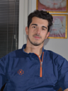
Notes/Comment
Full Name: Nicolò Barbera
Contact number: +39 3896968343
Linked In account: https://www.linkedin.com/in/nicoló-barbera-930187157/
Session name/ number:
Category: (Oral presentation)

