Evaluation between mandibular position and stabilometric parameters (LFS; VarVit) modification.
Michele Barbera MD, DMD ¹,
E. Barbera,
A. Fregoni, Actuary
N. Barbera DMD

Abstract (300 word limit)
Background and aim
In this randomized study it is analyzed if the modification of some stabilometric parameters, such as LFS (length function surface) and VarVit (speed variation), occurs to the modification of the mandibular position, with the stretching of the ligaments, the roto-traslation of the mandibule and the increase of vertical dimension controlled through a standardized device.
Materials and methods
50 random patients in a population are analyzed on a force sensor stabilometric platform.
Two recordings of 51.2 seconds are performed, the first with closed eyes, the second with closed eyes with oral stimulation through the ortoOS device. The difference in absolute value between the first and second registration of the LFS and VarVIT parameters is analyzed.
Results
VarVIT: in 100% of patients the value varies, in 95.37% the difference between the two recordings is statistically significant, the average of the variation is 23.877 mm/s.

LFS: in 100% of patients the value varies, in 66.91% the value is statistically significant, the average of the variation is 0.171 1/mm.
Conclusion
The modification of the mandibular position through the standardized device seems to change in a reproducible and standardized manner some stabilometric parameters such as LFS and VarVit, in light of having isolated the mouth influx, performing the tests with eyes closed to exclude the eye receptor and without noiseless distractions.
The study will continue on a larger number of patients to have a larger sample of the population under investigation and confirm the value.


Image
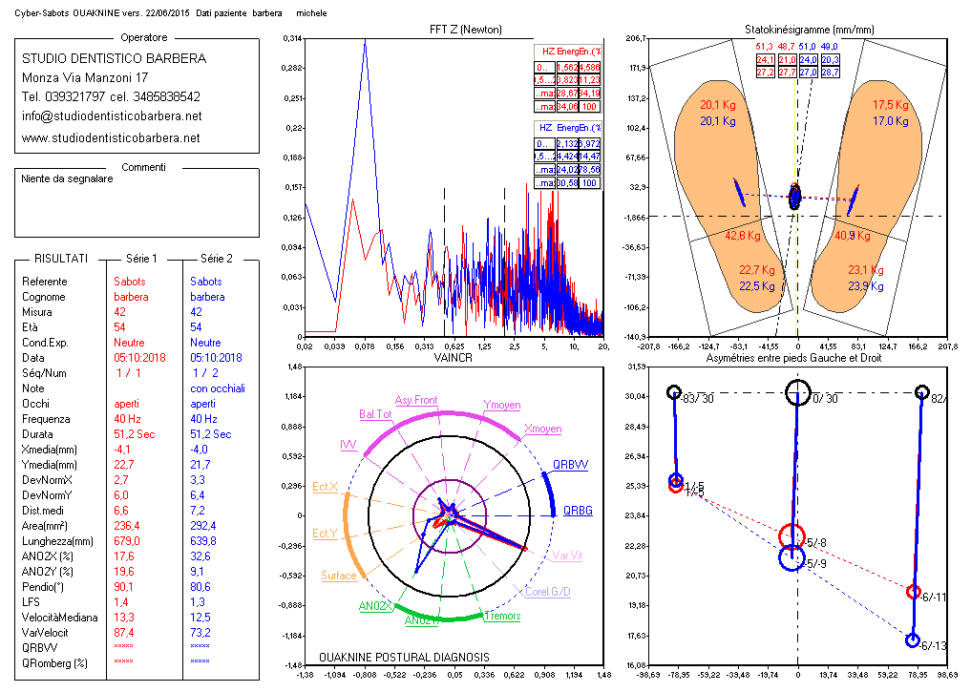
Recent Publications (minimum 5)
- Aitt Abbass 1992 Occlusion et posture de l’enfant . Toutouse. Memoire pour le diplome universitaire d’ocllusodontologierice.
- Moher D, Jadad AR, Tugwell P. (1996). Assessing the quality of randomized controlled trials. Current issues and future directions. Int J Technol Assess Health Care, 12,195-208.
- ï Wilczyński, J. (2006). The most common faulty postures among boys aged 13-16 years measured
- by Moiré's photogrammetric method. Medycyna pracy, 57(4), 347-352. ï http://www.snlg-iss.it/cms/files/LG_prevenzione_manuale.pdf
- Tecco, S., Caputi, S., Teté, S., Orsini, G., Festa, F. (2006). Intra-articular and muscle symptoms and subjective relief during TMJ internal derangement treatment with maxillary anterior repositioning splint or SVED and MORA splints: A comparison with untreated control subjects. CRANIO®, 24(2), 119-129.
- ï Yu, M., Silvestre, C., Mouton, T., Rachkidi, R., Zeng, L., Roussouly, P. (2013)

Dr BARBERAMICHELE Graduated in Medicine Univ of Milan 1990. Doctor Odontologist. Clinical Posturology. II level Master in Orthodontics and Gnathology, Univ. Bicocca Milan.
Masters in Osteopathy Univ. Milan
Active member of the Italian federation of Posture, ECM Accr teacher for Posturology and Mouth and Posture Courses in Milan.
Email: mik.barbera@gmail.com

Notes/Comment
Full Name: Michele Barbera
Contact number: +39 3485838542 Linked In account: https://www.linkedin.com/in/michele-barbera-b80a79144/
Session name/ number: Category: (Oral presentation/ Poster presentation)

