Ayurved apparition towards deterrence and management of nicotine addiction
w.s.r to Oral health and hygiene
Dr. Sushant Sud, I/c HOD & Asso. Prof, Dept of Agad Tantra (Toxicology), Shri Gulabkunverba Ayurved Mahavidyala, Gujarat Ayurved University, Jamnagar, Gujarat, India

Abstract (300 word limit)

Ayurved is the ancient Indian system of health-care and longevity. Oral hygiene is not described as a separate chapter in Ayurved but it comes under the different chapters of Ayurvedic literatures. Ayurved is known to be a complete medical system that comprises of physical, psychological, philosophical, moral and spiritual health. It is also called as a science of self-healing, an oldest healing system in the world because each individual and each cell is considered to be inherently an essential expression of pure intelligence.

Addiction is defined as the continuous obsessive use of drugs regardless of adverse health or social consequences and withdrawal is the physical and/or psychotic disorders developed by drug addicts after they stop taking drugs or reduce their dose. Drug addiction is very frequent in our society and it crosses all races, ethnic groups, and social modules. All the Ayurved treatises have given emphasis on personal hygiene which should be followed by each individual strictly. Dhanta dhavan (Ayurvedic herbal toothpowder), Jihwa nirlekhana (Tongue scrapping), Kavala (Gargling) and Gandoosha (Holding fluid inside the mouth) are the procedures told by Ayurved for maintenance of oral hygiene. Ayurved is helpful in the reduction of side-effects of nicotine by various ways including the use of Rasayana (Rejuvination) such as Ashwagandha (Withania somnifera), Shatavari Asperagus racemosa), Bala (Sida cordifolia) etc. Moreover, Yoga can help in releasing tension and stress and increase the strength and vitality without using any form of nicotine. In a nutshell, change in lifestyle, adoption of Ayurved treatment principles, control on intellectual blasphemy, and environmental issues are directly concerned to deal with addiction problems.
Image
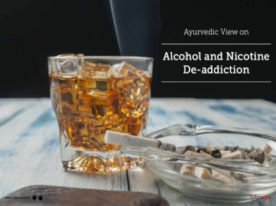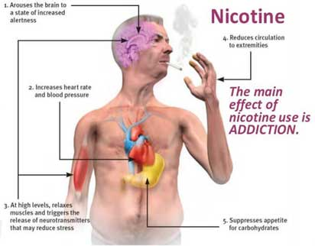
Recent Publications (minimum 5)
- Rathi RB, Rathi BJ (2020) Ayurveda perspectives toward prevention and management of nicotine and alcohol dependence: A review. J Indian Sys Medicine;8:14-20.
- Vipul Tanaji Gurav, Varsharani Sanjay Patil (2019) Ayurved Aspect of Nicotine (Tobacco) w.s.r Agadtantra & Vyavhar Ayurved. PARIPEX - INDIAN JOURNAL OF RESEARCH | Volume-8 | Issue-12| DOI : 10.36106/paripex.
- Markose A, Krishnan R, Ramesh M (2016) Management of Oral Health through Ayurvedic Methods. J Dent App; 3(2): 319-321.
- Deepak Kumar Semwal, Satyendra Prasad Mishra, Ashutosh Chauhan and Ruchi Badoni Semwal (2015), Adverse Health Effects of Tobacco and Role of Ayurveda in their Reduction, J. Med. Sci., 15 (3): 139-146. DOI: 10.3923/jms.2015.139.146
- Sharad M. Porte, Anshu Malviya (2015) Drug Addiction and Ayurvedic methods of De- Addiction, J Res Educ Indian Med 2015;21(0):0-0 doi:10.5455/JREIM.82-1435295257.

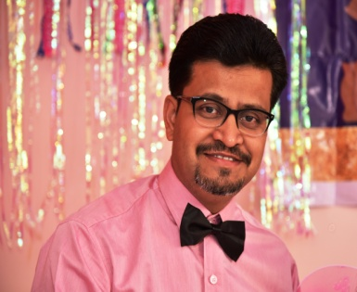 Biography
Dr. Sushant Sud, graduate of Shri Gulabkunverba Ayurved Mahavidyalaya, Jamnagar is presently working as Asst Professor in the department of Agad Tantra Vyavahar Ayurved Evum Vidhivaideyak, Shri Gulabkunverba Ayurved Mahavidyalaya, Gujarat Ayurved University, Jamnagar, Gujarat, India. He has completed M.D in the subject of Rasashastra from SDM College of Ayurved and Hospital Udupi, Karnataka. He is recipient of “Charaka Award”-2020 as an excellence in Ayurved teaching by the Association of Ayurvedic Profession of North America, INC (AAPNA), USA, September 2020. Also felicitated by Bharat Vikas Award by the Institute of Self Reliance Bhuveneshwar, Odisa for the Loyalty, Diligence & Outstanding Performance in the field of Ayurveda Aushadha Nirmaan Shastra on the occasion of “Citizen’s Day 2017. After perusing is course from Indian Institute of Public Health (IIPH) Gandhinagar he is working as Health safety Consultant for many corporate companies and has delivered many guest lecturers and awareness camps on Role of Ayurved in chronic diseases and lifestyle related disorders, Ayurved at national as well as international platforms including corporate sectors too. He has done his Fellowship in Multidisciplinary approaches in Osteoarthritis management from Federation of Royal College of Physicians of United Kingdom, London He has represented Gujarat Ayurved University by taking a lecture on Role of Ayurved-Yoga and Health for cadets going to be posted at Indo-Bhutan and Indo-China Borders at Sashastra Seema Bal, ATC, Jamnagar, Gujarat, India. He has 3 referral books under his belt. He has presented several papers and delievered talks in different international, national and state level seminars/conferences in the subject of Rasashastra and Agad Tantra. He has received best papers awards in many seminars and has published more than 40 papers in different peer reviewed international journals and around 5 articles in peer reviewed international magazines. He is Editorial Member for IJRAP, JAYUSH, WJPPS, Ayushdhara, JONAM and is working as Peer Reviewer for Pharma Ayurved Journal for Research in Pharmacy and Ayurved, IJAPC, Saudi Medical Journal. He is Life Member of International Academy of Ayurved, Pune, All India Ayurved Congress, New Delhi and Ayush Medical Association, India- A National Organization of AYUSH Doctors.
Email: drsushantsud@gmail.com/ drsud@ayurveduniversity.com
Notes/Comments:

For Speaker at the Webinar on Dental and oral health which aims for “HIGHLIGHTING THE NEW TECHNIQUES IN DENTISTRY AND ORAL CARE’’

