The use of "Mask R-CNN" deep learning algorithm with a small training database for fast teeth detection in CBCT
Talia Yeshua, PhD, Jerusalem College of Technology, Israel, Asher Alexander, Jerusalem College of Technology, Israel, David Salem, Jerusalem College of Technology, Israel, Ragda Abdalla-Aslan, DMD, Hadassah Medical Center, Rambam Health Care Campus, Israel, Isaac Leichter, PhD, Jerusalem College of Technology, Israel, Chen Nadler, DMD PhD, Hadassah Medical Center, Israel
B

Abstract
A
Statement of the Problem: Accurate teeth segmentation is an essential step for reconstructing three-dimensional teeth models used in various clinical applications. However, manual segmentation is time-consuming and prone to intra- and inter-observer variability. Teeth segmentation can be performed automatically by convolutional neural network (CNN) algorithms, but most CNN algorithms require also manual marking on a large training database and extreme computational power. Methodology & Theoretical Orientation: This study evaluates the ability to use a transfer learning algorithm, called "Mask R-CNN", which requires a small training database and low computational power, in order to detect teeth contour in Cone Beam Computerized Tomography (CBCT) imaging. This algorithm produces a bounding box around the detected teeth and simultaneously produces an instant high-quality contour of each tooth. In The contours of the teeth were marked manually only 6 CBCT slices from different cases, and the training process was performed with a standard CPU of an Intel Core i7 laptop. The performance of the trained neural network was tested on 383 CBCT slices with various fields of view obtained for several patients by different imaging protocols. Findings: Each training epoch, with standard computational power, lasted less than 1 hour. Using only one epoch, the trained "Mask R-CNN" neural network detected the teeth on the CBCT slices, with sensitivity of 90.7% and a specificity of 98.3%. When The training process was performed with 16 epochs, the detection sensitivity was improved to 95.1% and the specificity was improved to 99.1%. Conclusion & Significance: The use of the “Mask R-CNN” algorithm with a very small training database and standard computational power produces high-quality teeth detection within a reasonable train duration. This can eliminate subjective errors and enables more precise diagnosis and treatment planning.

Image
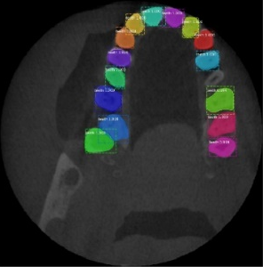
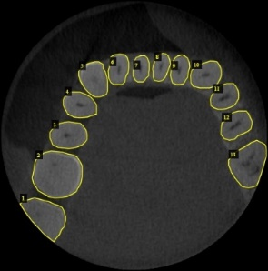
Figure 1: Mask R-CNN algorithm for teeth detection in CBCT. A. Manual marking of the teeth in the training process. B. Detecting the teeth on a tested slice by the trained algorithm.

Recent Publications
- Lee, S, Woo, S, Yu, J, et al. (2020) Automated CNN-Based tooth segmentation in cone-beam ct for dental implant planning. IEEE Access, 8:50507-50518.‏
- Chen, Y, Du, H, Yun, Z, Yang, S, et al. (2020) Automatic Segmentation of Individual Tooth in Dental CBCT Images From Tooth Surface Map by a Multi-Task FCN. IEEE Access, 8:97296-97309.‏
- Cui, Z, Li, C, & Wang, W (2019) ToothNet: Automatic tooth instance segmentation and identification from cone beam CT images. In Proceedings of the IEEE Conference on Computer Vision and Pattern Recognition 6368-6377.‏
- Rao, Y, Wang, Y, Meng, F, et al. (2020) A Symmetric Fully Convolutional Residual Network With DCRF for Accurate Tooth Segmentation. IEEE Access, 8: 92028-92038.‏
- Yeshua T, Mandelbaum YA, Abdalla-Aslan R, et al. (2019) Automatic detection and classification of dental restorations in panoramic radiographs. Issues in Informing Science and Information Technology 16:221-234.

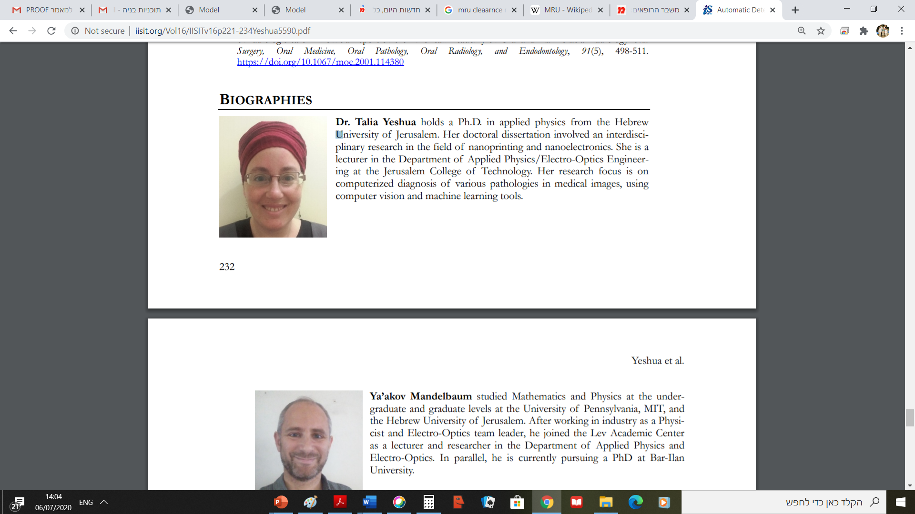Biography
Dr. Talia Yeshua holds a Ph.D. in applied physics from the Hebrew University of Jerusalem. She is a researcher and a lecturer in the Department of Applied Physics/Electro-Optics Engineering at the Jerusalem College of Technology. Her research activities include the use of computer vision, machine learning and deep learning tools for automatic diagnosis of pathologies in CT and CBCT imaging, and in radiographic, fluoroscopic and panoramic images. The focus of the research is on the early diagnosis of osteoporosis and of kidney disfunction and on mapping of dental restorations and of oromaxillofacial lesions.
Email: yeshua@g.jct.ac.il

Notes/Comments

Dental cone beam computed tomography (CBCT), a diagnostic imaging technique, is widely used for dental diseases and dental problems researching [1]. The segmentation of
individual tooth in CBCT images facilitates the observation
of slices or volumes of the target tooth by dentists, thereby
enabling more precise diagnostic decision-making and treatment planning. Moreover, individual tooth segmentation is a
necessary step to form a digital tooth arrangement, simulate
tooth movement, and build the tooth setup. However, manual
segmentation of tooth is tedious, time-consuming and prone
to intra- and inter-observer variability. A method to automatically segment individual tooth can eliminate subjective errors
The associate editor coordinating the review of this manuscript and
approving it for publication was Ting Li .
in tooth boundary delineation and reduce the workload of
/

