Can Support Vector Machine algorithm be used to automatically map dental restorations in panoramic images?
Talia Yeshua, PhD, Jerusalem College of Technology, Israel, Ragda Abdalla-Aslan, DMD, Hadassah Medical Center, Rambam Health Care Campus, Israel, Issac Leichter, PhD, Jerusalem College of Technology, Israel, Chen Nadler, DMD PhD, Hadassah Medical Center, Israel

Abstract
Statement of the Problem: Panoramic imaging is very often used to demonstrate the oromaxillofacial structures in a single image, with minimal patient discomfort and low radiation dose. However, there is currently no universal practice for generating a specific radiographic report for panoramic imaging. The use of artificial intelligence may facilitate the production of such a report, which will further promote patient management and communication. Methodology & Theoretical Orientation: A Support Vector Machine (SVM) algorithm was used for mapping dental restorations in panoramic images. Eighty-three panoramic anonymized images were analyzed. The images contained altogether 738 dental restorations, grouped into 8 categories, i.e. fillings, crowns, root canal treatments and implants. A computer-vision algorithm, based on adaptive thresholds was developed to automatically segment the restorations, which have high radiopacity. Then, the algorithm extracted vectors of numerical features characterizing the contour and the texture of each segmented restoration. Using these vectors, SVM algorithm was trained to classify the restorations by the unique features characterizing each restoration type. The classification performance was evaluated, using a cross-validation approach. Findings: The algorithm segmented 1305 findings, including 698 of the 738 dental restorations (94.6%) and other radio-opaque regions, which were erroneously segmented. Following the SVM classification, all these radio-opaque regions were not displayed on the image since they were correctly classified as false marks. However, a few restorations were also classified as false marks, and therefore the algorithm finally displayed 90.6% of the restorations. The displayed dental restorations were correctly classified into the 8 various categories with an overall accuracy of 93.6%. Conclusion & Significance: Based on the unique shape and gray-level distribution characterizing each type of dental restoration in panoramic images, the SVM algorithm successfully mapped the restorations with high accuracy. This algorithm can be applied for patient diagnosis, treatment planning, student's education and forensic dentistry.

Image
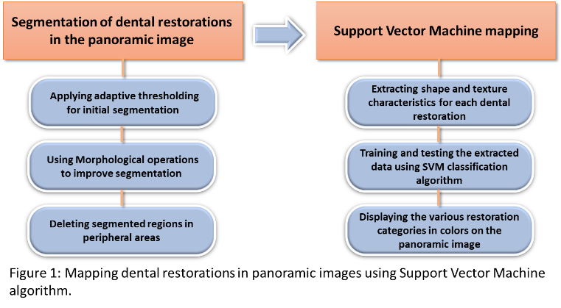
Recent Publications
- Yeshua T, Mandelbaum YA, Abdalla-Aslan R, et al. (2019) Automatic detection and classification of dental restorations in panoramic radiographs. Issues in Informing Science and Information Technology 16:221-234.
- Amer YY, Aqel MJ. (2015) An efficient segmentation algorithm for panoramic dental images. Proc Comp Sci. 65:718-725.
- Oliveira J, Proenca H. (2011) Caries detection in panoramic dental X-ray Images. Computational Vision and Medical Image Processing. Dordrecht, Germany: Springer Press :175-190.
- Chang HJ, Symkhampha K, Huh KH, et al. (2017) The development of a learning management system for dental radiology education: atechnical report. Imaging Sci Dent 47:51-55.
- Heinrich A, Guttler F, Wendt S, et al. (2018) Forensic odontology: auto-matic identification of persons comparing antemortem and post-mortem panoramic radiographs using computer vision. Rofo. 190:1152-1158.

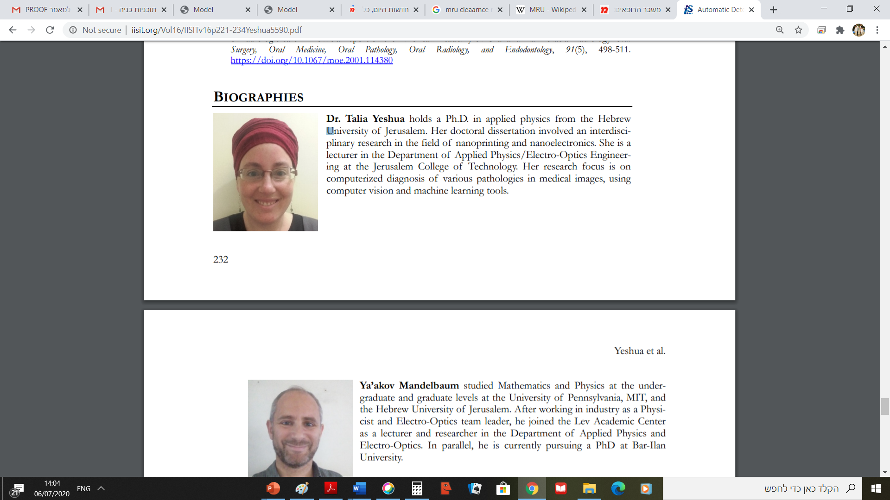Biography
Dr. Talia Yeshua holds a Ph.D. in applied physics from the Hebrew University of Jerusalem. She is a researcher and a lecturer in the Department of Applied Physics/Electro-Optics Engineering at the Jerusalem College of Technology. Her research activities include the use of computer vision, machine learning and deep learning tools for automatic diagnosis of pathologies in CT and CBCT imaging, and in radiographic, fluoroscopic and panoramic images. The focus of the research is on the early diagnosis of osteoporosis and of kidney disfunction and on mapping of dental restorations and of oromaxillofacial lesions.
Email: yeshua@g.jct.ac.il

Notes/Comments:

